**C++ Cheat Sheet**

|  |  |
| --- | --- |
| CHAR_BIT | 8 |
| SCHAR_MIN | -128 |
| SCHAR_MAX | +127 |
| UCHAR_MAX | 255 |
| CHAR_MIN | -128 |
| CHAR_MAX | +127 |
| MB_LEN_MAX | 16 |
| SHRT_MIN | -32768 |
| SHRT_MAX | +32767 |
| USHRT_MAX | 65535 **(because no bit reserved for sign)** |
| INT_MIN | -2147483648 |
| INT_MAX | +2147483647 |
| UINT_MAX | 4294967295 **(because no bit reserved for sign)** |
| LONG_MIN | -9223372036854775808 |
| LONG_MAX | +9223372036854775807 |
| ULONG_MAX | 18446744073709551615 **(because no bit reserved for sign)** |

**Use <climits> header file**: This header defines constants with the limits of fundamental integral types for the specific system

MAX = 1e9+7 or **1000000007**

|  |
| --- |
| **MAX value of N Time complexity** |
| 10^9 O(log N) or Sqrt(N) |
| 10^8 O(N) Border case |
| 10^7 O(N) Might be accepted |
| 10^6 O(N) Perfect |
| 10^5 O(N * log N) |
| 10^4 O(N ^ 2) |
| A * 10^2 O(N ^ 3) |
| <= 160 O(N ^ 4) |
| <= 18 O(2N*N2) |
| <= 10 O(N!), O(2N) |

|  |
| --- |
| **NOTE: Short names include DT (Data Type)** |

**Containers**

1. **Vectors: Implementation by dynamic array.**

|  |  |  |
| --- | --- | --- |
| Member Functions | Return Values | Command Brief |
| vector<DT> v |  | Default, Empty vector |
| vector<DT>v{ } |  | Initializer List |
| vector<DT>v={ } |  | Initializer list |
| vector<DT> v(size) |  | Fill constructor |
| vector<DT> v(size, init_value) |  | Filled constructor |
| vector<DT> v2(itr1, itr2) |  | Deep copy, range based |
| vector<DT> v1(v2) |  | Deep copy, copy constructor |
| vector<DT>() | Returns Empty vector |  |
| v.assign(size, value) |  | Same as filled constructor but a function |
| v.assign(itr1, itr2) |  | Range based filling |
| vector<DT> v = { ________ } |  | Initialization |
| v.begin() | Iterator pointing to first element |  |
| v.end() | Iterator pointing to the post last element |  |
| v.rbegin() | Reverse Iterator pointing to the last element and this iterator traverse in reverse. |  |
| v.rend() | Reverse Iterator pointing to the element preceding first element and this iterator traverse in reverse. |  |
| v.size() | Unsigned Integer |  |
| v.max_size() |  | Maximum potential size of container |
| v.capacity() | Unsigned Integer | Init_size^n size (usually 2^n) |
| v.resize(size, value) |  | Makes and vector to the given size while filling empty spaces with value |
| v.shrink_to_fit() |  | Resizes to accommodate available elements. Capacity=Size. |
| v.at(index) | DT value | Returns value at index |
| Iterator loop, *itr is the element | *itr=value and itr is address location |  |
| v[index] |  |  |
| v.data() | A pointer to the first element in the array used internally by the vector. |  |
| v.front() | Returns leftmost element |  |
| v.back() | Returns rightmost element |  |
| v.clear() | Void | Removes all elements in the container. Size = 0. Capacity is intact. |
| v.emplace(itr, value) | Returns iterator to newly inserted element. | Inserts value before the location pointed by itr. |
| v.emplace_back(value) | Void | Similar to push_back(value) |
| v.empty() | Boolean | If container is empty or not |
| v.erase(itr1, itr2) | Returns iterator pointing to element after the one which was erased | If one argument is given, one element will be erased at location pointed by it. In case of 2, range is erased as [itr1, itr2). |
| Member Functions | **Return Values** | **Command Brief** |
| v.insert(itr, value) | Returns random access iterator pointing to first of newly inserted element(s). | Pushes before itr with value |
| v.insert(itr, count, value) | Returns random access iterator pointing to first of newly inserted element(s). | Pushes before itr with count number of values |
| v.insert(itr, itr_1, itr_2) | Returns random access iterator pointing to first of newly inserted element(s). | Pushes before itr with ellements between [itr_1, itr_2) |
| v.push_back(value) | Void | Appends value on right |
| v.pop_back() | Void | Pops value from right, size--; |

1. **List: Doubly Linked List**

|  |  |  |
| --- | --- | --- |
| Member Functions | Return values | Command Brief |
| list<DT> l |  | Empty list init. |
| list<DT> l(size) |  | Fill Constructor |
| list<DT> l(size, init_value) |  | Filled Constructor |
| list<DT> l(ptr1, ptr2) |  | Deep Copy, range based |
| list<DT> l( list2 ) |  | Deep Copy, copy constructor |
| l.assign(size, value) |  | Overriding |
| l.assign(itr1, itr2) |  | Overriding |
| list<DT> l = { ____ } |  | Initialization |
| list<DT>() | Returns Empty list | Used for returning empyu list |
| l.pop_back() | Void | Removes the last element in the list container, effectively reducing the container size by one |
| l.pop_front() | Void | Removes the first element in the list container,effectively reducing the conatiner size by 1. |
| l.push_back(value) | Void | Adds a new element at the end of the [list](https://cplusplus.com/list) container, after its current last element. Size++ |
| l.push_front(value) | Void | Adds new element at the front of the continer list, before current first element. Size++. |
| l.sort( comparator ) | Void, modifies | Sorts elements (increasing by default) as per comparator |
| l.size() | Unsigned Integer, size_type | Number of elements in the container list |
| l.unique( comparator ) | Void | **Notice** that an element is only removed from the list container if it compares equal to the element immediately preceding it. Thus, this function is especially useful for sorted lists. By default it will remove all duplicates in **sorted** list. A comparator function can be provided to reduce list via pair wise comparison |
| l.swap( list2 ) |  | Swaps all contents of container l with list2 container |
| l.begin() | Iteraor | Pointer to beginning element. |
| l.end() | Iterator | Iterator pointing to post last element. |
| l.empty() | Boolean | Returns true if there are no elements in the list conatiner. |
| l.front() | DT | Returns first element reference (alue but can be modified), not pointer/iterator. |
| l.back() | DT | Returns last element reference, not pointer/iterator. |
| l.clear() | Void | Deleted all nodes and reduces size to zero |
| l.insert( itr, times, value) | An iterator that points to the first of the newly inserted elements. | Inserts n (by default 1) times the value before location pointed by itr in the list conatiner l. |
| l.insert (itr, itr1, itr2) | An iterator that points to the first of the newly inserted elements. | Inserts elements in another container in range **[ itr1, itr2 )** before location pointed by **itr** in target list conatiner l. |
| l.erase(itr, itr2) | Returns iterator pointing to the elements past last removed element. | Removes element pointed by itr or all elements in **[ itr ,itr2 )** |
| l.max_size() | Unsigned Integer | Maximum number of elements a list can hold. |
| l.remove(val) | Void, modify | Erase by value. All occurences. Removes from the container all the elements that compare equal to val. |
| l.remove_if(comparator) | Void, modify | Removes from the container all the elements for which **Comparator** returns true. Comparator here has argument = &val (1 reference value of list) |
| l.reverse() | Void, modifies |  |
| l.splice(itr, list2) | Void, modifies | Transfer all from list2 in l before itr. |
| l.splice(itr, list2, itr2) | Void, modifies | Transfer one element at itr2 into l before itr. |
| l.splice(itr, list2, itr_start, itr_end) | Void, modifies | Transfer elements between [ itr_start, itr_end ) into l from list2 before itr. |

1. **Pair: Size 2 array**

|  |  |  |
| --- | --- | --- |
| Member Functions | Return Value | Command Brief |
| pair<DT, DT> p; | Reference to a pair, currently empty |  |
| pair<DT, DT> p(p2); OR = operator |  | Deep copy, copy constructor |
| pair<DT, DT> p(value1, value2); |  | Initialization |
| p = make_pair(value1, value2); |  |  |
| p.first | First member |  |
| p.second | Second Member |  |
| == operator | Boolean | Returns if content of both pair are same or not. |
| != operator | Boolean |  |
| Comparison Operators (>, <, >=, <=) | Boolean | Compares first element first and then if false checks second element as per the operator. For example, for < comparison is (a.first<b.first || (!(a.first<b.first) && a.second<b.second))  For a<=b, it is a.first<=b.first || (!(a.first<=b.first) && a.second<=b.second), OR simply !(b<a). |

1. **Stack: Linked List**

|  |  |  |
| --- | --- | --- |
| Member Function | Return Value | Command Brief |
| stack<DT> st |  | Creates an empty stack container |
| stack<DT> st(another_container) |  | Creates new stack from elements of another stl container with same DT |
| st.push(value) | Void | Pushes element on stack, size++ |
| st.pop() | Void | Removes top element, size-- |
| st.top() | Reference to top element | Element on top reference. Can be modified with st.top(). |
| st.empty() | Boolean | Is the stack container empty? |
| st.size() | Unsigned Integer | Number of elements in stack |
| st.swap(st2) | Void | Swap references to the containers |
| Comparison operator (==, !=, >, <, <=, >=) | Boolean | Returns on comparison with each element from bottom to top. If Camparison holds true throughout then returns true else false. |

1. **Queue: Linked List**

|  |  |  |
| --- | --- | --- |
| Member Function | Return Value | Command Brief |
| queue<DT> q |  | Creates an empty queue container |
| queue<DT> q(another_container) |  | Creates new queue from elements of another stl container with same DT |
| q.push(value) | Void | Pushes element into the queue at last, size++ |
| q.pop() | Void | Removes front element, size-- |
| q.front() | Reference to front element | Element on front reference. Can be modified with q.front(). |
| q.back() | Reference to last element, last added | Element at last reference. Can be modified with q.back(). |
| q.empty() | Boolean | Is the queue container empty? |
| q.size() | Unsigned Integer | Number of elements in queue |
| q.swap(q2) | Void | Swap references to the queues |
| q.emplace(value) | Void | Same as push(value) |
| Comparison operator | Boolean | Returns on comparison with each element from front to back . If Camparison holds true throughout then returns true else false. |

1. **Deque: 2 Queue**

|  |  |  |
| --- | --- | --- |
| Member Funcion | Return Value | Command Brief |
| deque<DT> dq |  | Constructs an empty container (o size) |
| deque<DT> dq(<size>, <value=0>) |  | Fill type, by default value is zero |
| deque<DT> dq(itr1, itr2) |  | Range constructor from another container |
| deque<DT> dq(<dq2>) |  | Copy constructor |
| deque<DT>dq { } |  | Initializer list initialization |
| = operator, dq = d2 |  | Assigns new contents to the container, replacing its current contents, and modifying its size accordingly. |
| dq.size() |  | Unsigned int = size_type |
| dq.begin() | Iterator pointing to the first element of the container |  |
| dq.end() | Iterator pointing to the 1 + last poistion of the conatiner |  |
| dq.assign(<size>,<const_value>) |  |  |
| dq.assign(itr1,itr2) |  |  |
| dq.at(index) | Returns reference to value at position n in the container | This is different from [] operator because it throws out_of_range exception when index run out of bound |
| dq.front() | Reference to the first eleemnt in the queue |  |
| dq.back() | Reference to the last element |  |
| [<index>] operator |  | Accesses value at index. Mutable |
| dq.emplace(itr,<value>) | Returns iterator pointing to the newly inserted elements | Inserts element with <value> at the poirion pointed by itr. |
| dq.emplace_back(<value>)  dq.push_back(<value>) | Constant order complexity |  |
| dq.emplace_front(<value>)  dq.push_front(<value>) | Constant order complexity |  |
| dq.empty() | Boolean |  |
| dq.erase(itr) //one element  dq.erase(itr1,itr2) //range based | An iterator pointing to the new location of the element that followed the last element erased by the function call. |  |
| dq.insert(itr,value)  dq.insert(itr, size, value)  dq.insert(itr, itr1,itr2)  dq.insert(itr, { … } ) | An iterator that points to the first of the newly inserted elements. | The deque container is extended by inserting new elements before the element at the specified position. |
| Out of range elements holds value zero. |  |  |
| dq.swap(dq2) |  | Swaps refernces to the containers |

1. **Bitset**

**Size=bitset string size. It converst integer into binary and captures bit values from msb. Same goes for initialization from binary c string.**

**NOTE: Indexing for position is from right to left.**

|  |  |  |
| --- | --- | --- |
| Member Funcion | Return Value | Command Brief |
| Bitset<size> x; |  | Bitset string initialized with zeros |
| Bitset<size> x(<Integer value>) |  | Bitset string initailauzed with integer value given |
| Bitset<size> x(binary c string) |  | Bitset string initailauzed with given **binary** string |
| x.set()  x.set(<position>, <with value>)  x.set(<position>) |  | Set all to 1  Set <with value> at position  Set 1 at position |
| x.all() | Boolean | All values set |
| x.any() | Boolean | Any value set |
| x.none() | Boolean | No value set |
| x.count() | Boolean | Count set values |
| x.size() | Size_t: unsigned integer | Size of Bitset |
| x.flip()  x.flip(<position>) |  | Flip the bit at position or flip all bits |
| x[<position>] |  | Access bit at position |
| x.reset()  x.reset(<position>) |  | Reset bit to zero at <position> or reset all bits to zero. |
| x.test(<position>) | Boolean | Checks if he bit at position is set |
| x.to_string<char,std::string::traits_type,std::string::allocator_type>(); |  | Converst bitset to string type |
| x.to_ullong()  x.to_ulong() |  | Converts bitset to corresponding decimal representation. |

1. **Map -> Sorted by keys**

|  |  |  |
| --- | --- | --- |
| Member Funcion | Return Value | Command Brief |
| map<DT,DT> mp | Const time | Initialize an empty map |
| map<DT,DT> mp(mp2) |  | Copy constructor |
| map<DT,DT> mp(map_itr1, map_itr2) |  | Range based |
| map<DT,DT>mp{ { … } … } |  | Initializer list initialization  Values are inserted according to the map DTs. |
| mp.begin() | Iterator to first element in the map |  |
| mp.end() | Iterator to the position after the last element in the map. |  |
| mp.rend() | Reverse end pointing iterator |  |
| mp.rbegin() | Reverse beginning pointing iterator |  |
| mp.clear() |  | Emptys the map. |
| mp.count(<key>) | 1 present /0 | Searches for the key (unique & sorted hear) |
| mp.emplace(<key>,<value>) | Returns pair of iterator pointing to the newly inserted k-v pair and true else if the key was already present it resturns corresponding iterator and false. | Inserts if the key is unique |
| mp.emplace_hint(<pos>,<key>,<value>) | Generally, logarithmic in the container size.  Amortized constant if the insertion point for the element is position.  Returns a bidirectional iterator to new/existing k-v pair. | Inserts a new element in the map if its key is unique, with a hint on the insertion position. |
| mp.empty() | Boolean | Checks if map is empty or not |
| mp.erase(itr)  mp.erase(<key>)  mp.erase(itr1, itr2) //remove within . //this range | Constant, log and linear time complexities.  Returns iterator to next k-v if removed via iterator. If removed via key, returns number of items erased. |  |
| mp.find(<key>) | Return iterator to found key or mp.end() if not found. |  |
| mp.size() |  |  |
| mp.swap(mp2) |  |  |
| mp.insert(pair)  mp.insert(map_itr1, map_itr2) | Returns pair of (iterator to newly inserted element/existing element and true/false). False if not inserted. |  |
| mp[<key>]=value  mp[<key>] | If key matches the key of an element in the container, the function returns a reference to its mapped value.  If k does not match the key of any element in the container, the function inserts a new element with that key and returns a reference to its mapped value. Notice that this always increases the container size by one, even if no mapped value is assigned to the element | Note: This always inserts and increase size by 1. |
| mp.at(<key>) | map::at, has the same behavior when an element with the key exists, but throws an exception when it does not. | Returns A reference to the mapped value of the element with a key value equivalent to <key>. |
| Mp.lower_bound(<key>) | Iterator pointing to the k-v pair in ordered map in which k is just equal to or greater than <key> |  |
| Mp.upper_bound(<key>) | Iterator pointing to the k-v pair in ordered map in which k is just equal to or greater than <key> |  |
| Mp.equal_range(<key>) | Returns the bounds of a range that includes all the elements in the container which have a key equivalent to k. | Because the elements in a map container have unique keys, the range returned will contain a single element at most.  **If no matches are found, the range returned has a length of zero** |

1. **Set (associative/ordered/key=value/unique)**

|  |  |  |
| --- | --- | --- |
| Member Funcion | Return Value | Command Brief |
| set<DT> s  set<DT> s() | Const time | Initialize an empty set |
| set<DT> s(s2) |  | Copy construction. |
| set<DT> s(itr1 , itr2) |  | Range based initialization |
| set<DT> s{ … }  set<DT> s ={ … } |  | Initializer list initialization |
| set<DT, comp_class> s  set<DT, comp_func_ptr> s |  | Ordering based on comp_class only bool function or bool function pointed by the function pointer. |
| = operator (s1=s2) |  | Assigns new contents to the container, replacing its current content. |
| s.begin() | Iterator pointing to the first element |  |
| s.end() | Iterator pointing to the element after the last one in the set. |  |
| s.empty() | Bool |  |
| s.count() | Unsigned int (1/0) |  |
| s.find() | Iterator to the element or set::end/s.end(). |  |
| s.clear() |  | Emptys the set |
| s.emplace(<value>) | If successfully inserted, returns a pair <itr to new element, true> else return a pair <itr to existing element, false> |  |
| s.insert(<value>)  s.insert(itr , itr2)  s.insert({ … })  s.insert(<hint_pos> , <value>) | For single valu insertion, If successfully inserted, returns pair<itr to new element in the container, true> else returns pair<itr to existing element, false>.  In case of insertion with hint it returns itr to new element in the set or existing element. |  |
| s.erase(<value>) | Log(n), returns number of elements erased. That is always 1 if present. |  |
| s.erase(<itr>) | Constant |  |
| s.erase(itr1, itr2) | Linear |  |
| s.upper_bound(val) | Returns itr to a value in set which is just greater than “val” |  |
| s.lower_bound(val) | Returns itr to a value in set which is equal to or graeter than val |  |

1. **Multiset (Set allowing multiple occurances of same values) (Uniqueness is compromised)**

|  |  |  |
| --- | --- | --- |
| Member Funcion | Return Value | Command Brief |
| multiset<DT> mset  multiset<DT> mset() | Const time | Initialize an empty multi set |
| Multiset<DT> mset(itr1 , it2) |  | Range based initialization |

|  |  |  |
| --- | --- | --- |
| Member Funcion | Return Value | Command Brief |
| multiset<DT> mset(mset2) |  | Copy construction-> Deep copy |
| multiset<DT, class_comparator>  Struct class_comp{  bool operator()(DT var1, DT var2) const { return var1 < var2; }  } | Returns mset with elements set according to user chosen order through class comparator |  |
| multiset<DT, bool(*)(DT, DT)>mset (func_name)  bool func_name(DT lhs, DT rhs) {  return lhs < rhs;  } | Returns mset with elements set according to user chosen order through comparator function. |  |
| multiset<DT> mset{ … }  multiset<DT> mset = { … } |  | Initializer List initialization |
| mset.begin() | Iterator |  |
| mset.end() | Iterator |  |
| mset.rend() | Iterator |  |
| mset.rbegin() | Iterator |  |
| mset.clear() |  | Empty the multiset |
| mset.count( val ) | Returns the number of elements in the multiset who are equal to **val**. |  |
| mset.emplace( val ) | Iterator (Bidirectional) pointing to the new element |  |
| mset.empty() | Boolean | Tels if the multiset is empty or not |
| mset.equal_range( val ) | Returns pair of 2 iterators. First pointing to the lower bound of val in mset and second pointing to the upper bound of val in the mset. |  |
| mset.find( val ) | Returns iterator to the val in mset else mset.end(). |  |
| mset.erase(val) //erases all occurances of val  mset.erase(itr) //erases value at itr, single  mset.erase( itr1, itr2 ) //erases from[ itr1, itr2 ) | Mset.erase(val) returns the number of elements deleted/erased. |  |
| mset.insert(val)  mset.insert(itr, val) //with hint  mset.insert(itr1,itr2) //range based insert from // another container | an iterator pointing to the newly inserted element in the multiset. |  |
| mset.upperbound( val ) | Returns iterator pointing to element (first) which is just greater than val. |  |
| mset.lowerbound( val ) | Returns iterator pointing to element in mset which is = or greater than val |  |
| mset.size() | Returns size_t, unsigned int | Size of mutiset container |

1. **MultiMap (Associative container allowing 1 Key holding multiple values. One to Many mapping)**

|  |  |  |
| --- | --- | --- |
| Member Funcion | Return Value | Command Brief |
| multimap<DT, DT> mmp  multimap<DT, DT> mmp() | Const time | Initialize an empty multi set |
| multimap<DT, DT> mmp(mmp2) |  | Copy construction |
| multimap<DT, DT> mmp(mmpitr1, mmpit2) |  | Range based initialization |
| multimap<DT1, DT2, class_comparator>  Struct class_comp{  bool operator()(DT1 var1, DT1 var2) const { return var1 < var2; }  } | Returns mmp with elements set according to user chosen order through class comparator |  |
| multimap<DT1, DT2, bool(*)(DT1, DT1)>mmp (func_name)  bool func_name(DT lhs, DT rhs) {  return lhs < rhs;  } | Returns mmp with elements set according to user chosen order through comparator function. |  |
| multimap<DT,DT> mmp{ {,}{,}{,}… } |  | Initializer List initialization |
| multimap<DT,DT> mmp = {{,},{,},{,}…} |  | Initializer List initialization |
| mmp.end() | Iterator |  |
| mmp.rend() | Reverse Iterator in beginning |  |
| mmp.begin() | Iterator |  |
| mmp.rbegin() | Reverse Iterator in the end+1. |  |
| mmp.clear() |  | Clears multimap contents |
| mmp.count(k) | number of elements in the container contains that have a key equivalent to k |  |
| mmp.emplace(val1, val2) | An iterator to the newly inserted element. | Logarithmic |
| mmp.erase(itr) // single erase by position (based on FIFO)  mmp.erase(key_val) // erase by key_val  mmp.erase(itr1, itr2) //range based erase | For the key-based version (2), the function returns the number of elements erased.  The other versions return an iterator to the element that follows the last element removed |  |
| mmp.find(key_val) | Searches the container for an element with a key equivalent to k and returns an iterator to it if found, otherwise it returns an iterator to multimap::end. |  |
| mmp.empty() | Boolean | Checks if the multimap container is empty. |
| mmp.equal_range(key_val) | The function returns a pair, whose member pair::first is the lower bound of the range (the same as lower_bound), and pair::second is the upper bound (the same as upper_bound). |  |

|  |  |  |
| --- | --- | --- |
| Member Funcion | Return Value | Command Brief |
| mmp.insert(pair<DT,DT>(key,val))  mmp.insert(mmpitr1, mmpitr2)  mmp.insert( {{ , }, { , }, { , }……} ) | Only the first one retuens the iterator pointing to the newly insserted element. |  |
| mmp.size() | Unsigned Int | Size of the conatiner. No. of elements in the conatiner |
| mmp.upper_bound(key_val) | Returns an iterator pointing to the first element in the container whose key just greater than key_val |  |
| mmp.lower_bound(key_val) | Returns an iterator pointing to the first element in the container whose key = or greater than key_val. |  |

1. **Unordered_set:** Equivalent to Hash table with V-V mapping.

|  |  |  |
| --- | --- | --- |
| Member Funcion | Return Value | Command Brief |
| unordered_set<DT> uset  unordered_set<DT> uset() | Const time  (For move const. as well) | Empty initialization |
| unordered_set<DT> uset(uset2) | WC=quadratic |  |
| unordered_set<DT> uset({ … })  unordered_set<DT> uset={} | WC=quadratic | Initializer list |
| unordered_set<DT> uset(itr1,itr2) | WC=quadratic | Range based Initialization |
| uset.begin() |  | Pointers pointing to the beginning element |
| uset.end() |  | Pointer pointing to the element after the end element. |
| uset.empty() | Boolean |  |
| uset.size() | Size_t | Number of values in the unordered set container. |
| uset.insert(val) //single value insertion  uset.insert(itr1, itr2) //range based insertion  uset.insert({ … }) //insert via init list | First return a pair of <itr bool> bool is true if insertion is successful. If inserted itr points to the newly inserted element, else it points to the the existing element, with bool=false. | WC for single value = linear  WC for range based or init list insertion is size*N+1 |
| uset.bucket(k) | Returns the bucket number where the element with value k is located.  A bucket is a slot in the container's internal hash table to which elements are assigned based on their hash value. Buckets are numbered from 0 to (bucket_count-1). |  |
| uset.bucket_count() | Returns the number of buckets in the unordered_set container.  A bucket is a slot in the container's internal hash table to which elements are assigned based on their hash value. | Usigned Int |

|  |  |  |
| --- | --- | --- |
| Member Funcion | Return Value | Command Brief |
| uset.bucket_size(<bucket_number>) | Returns the number of elements in bucket <bucket_number>. | The number of elements in a bucket influences the time it takes to access a particular element in the bucket. |
| uset.erase(itr)  uset.erase(<val>)  uset.erase(itr1, itr2) | Versions (1) and (3) return an iterator pointing to the position immediately following the last of the elements erased.  Version (2) returns the number of elements erased | WC=linear |
| uset.count(val) | Returns 1 or 0 |  |
| uset.find(val) | Iterator to the searched value | WC=linear or AC=constant |

1. **Unordered_map: Assocative conatiner equivalent to a hashmap.**

|  |  |  |
| --- | --- | --- |
| Member Funcion | Return Value | Command Brief |
| unordered_map<DT, DT> ump  unordered_map<DT, DT> ump() |  | Empty initialization. TC: const |
| unordered_map<DT, DT> ump(ump2) | WC: quadratic | Copy construction |
| unordered_map<DT, DT> umap(itr1, it2) | Note: itr are pointing to the content in the for of k-v pair | Range based initialization |
| unordered_map<DT, DT> ump={{k,v},{k,v} … }  unordered_map<DT, DT> ump({{k,v},{k,v}, … }) |  | Initializer List Initialization |
| ump.begin() | Iterator pointing to the first k-v pair |  |
| ump.end() | Iterator pointing to the location after the last K-V pair in the container |  |
| ump.bucket(k) | Returns the number of bucket where the k is located. K is the key. Returns the unsigned int |  |
| ump.bucket_count() | Unsigned int. Number of buckets in the container. It is not necessary that each bucket must contain something |  |
| ump.bucket_size(<bucket_number>) | Number of k-v pairs in the <bucket_number> bucket |  |
| ump.clear() |  |  |
| ump.count(key) | 1 if an element with a key equivalent to k is found, or zero otherwise. |  |
| ump.empty() | Boolean |  |
| ump.erase(itr)  ump.erase(<key>)  ump.erase(itr1, itr2) | Versions (1) and (3) return an iterator pointing to the position immediately following the last of the elements erased.  Version (2) returns the number of elements erased |  |
| ump.find(<key>) | An iterator to the element, if the specified key value is found, or unordered_map::end if the specified key is not found in the container. |  |
| ump.insert(<key>)  ump.insert({{k,v},{k,v}, ... })  ump.insert(itr1, itr2) | Version 1 Return pair <itr,bool> as expected and the other 2 versions returns nothing. | Inserts new elements in the unordered_map. |

|  |  |  |
| --- | --- | --- |
| Member Funcion | Return Value | Command Brief |
| ump[<key>] | If <key> matches the key of an element in the container, the function returns a reference to its mapped value. | Accessing method with insertion |
| ump.at(<key>) | Returns a reference to the mapped value of the element with key k in the unordered_map.  If k does not match the key of any element in the container, the function throws an out_of_range exception. | Accessing without insertion |
| ump.size() | Number of k-v pairs in the unordered map container. |  |
| ump.swap(ump2) | Exchange references to the 2 conatiners. That is ump points to ump2 and ump2 points to ump. |  |

1. **Unordered_multiMap: Same as Unordered map but this allows non-bijective relations. 1 key can point to multiple values.**

|  |  |  |
| --- | --- | --- |
| Member Funcion | Return Value | Command Brief |
| unordered_multimap<DT, DT> ummp  unordered_map<DT, DT> ummp() | Constant time complexity | Empty initialization. TC: const |
| unordered_multimap<DT, DT> ummp(ummp2) | TC: worst case is Quadratic construction | Copy construction. Deep copy |
| unordered_multimap<DT,DT> ummp(itr1,itr2) | TC: worst case is Quadratic construction | Range based initialization |
| unordered_multimap<DT,DT> ummp={{k,v},{k,v}…..}  unordered_multimap<DT,DT> ummp({{k,v},{k,v}….}) | TC: worst case is Quadratic construction | Initializer List construction. |
| ummp.bucket(key) | A bucket is a slot in the container's internal hash table to which elements are assigned based on the hash value of their key. Elements with the same key are located in the same bucket. Buckets are numbered from 0 to (bucket_count-1). | Constant complexity |
| ummp.bucket_count() | Returns number of buckets in the container’s internal implementation. Unsigned int | Constant complexity |
| ummp.bucket_size(<bucket_index>) | Note that bucket index cab be from 0 to bucket_count-1. It returns number of elements filled in the bucket with index = <bucket_index> | Linear |
| ummp.clear() | Truncate the container | Linear |
| ummp.count(key) | Unsigned Int. Linear | Searches the container for elements whose key is k and returns the number of elements found. |
| ummp.size() | Unsigned Int | Number of elements.pairs in this container. |
| mmp.empty() | Boolean: is empty? | Constant |

|  |  |  |
| --- | --- | --- |
| Member Funcion | Return Value | Command Brief |
| ummp.emplace(key,value) | Inserts the value to the corresponding key. A forward iterator to the newly inserted element is returned. | This may trigger rehash |
| ummp.insert(pair<DT,DT>(key,value))  ummp.insert(make_pair<DT,DT>{ key, value } )  ummp.insert({{key,value}, { } ….. })  ummp.insert(itr1, itr2) | Initializer list and ranges based insertion return no value. Else it returns the iterator to the newly inserted element. | Single element insertions:  Average case: constant.  Worst case: linear in container size.  Multiple elements insertion:  Average case: linear in the number of elements inserted.  Worst case: N*(size+1): number of elements inserted times the container size plus one. |
| ummp.find(key)  //ummp.find(key)->second will return first value inserted corresponding to the given key. | An iterator to the element, if the specified key value is found, or unordered_multimap::end if the specified key is not found in the container. |  |
| ummp.erase(itr)  ummp.erase(<key>)  ummp.erase(itr1, itr2) // range based removal. Itr must point to element in the conatiner. | Versions (1) and (3) return an iterator pointing to the position immediately following the last of the elements erased.  Version (2) returns the number of elements erased. | TC: Linear in the conatiner size |
| ummp.begin() | Bidirectional iterator |  |
| ummp.end() | Bidirectional iterator |  |

1. **Unordered_multiset: Same as the unordered set associative container but this allows the insertion of duplicates.**

|  |  |  |
| --- | --- | --- |
| Member Funcion | Return Value | Command Brief |
| unordered_multiset<DT> umset;  unordered_multiset<DT> umset(); | TC: constant | Returns an empty unordered multi set conatiner |
| unordered_multiset<DT> umset(itr1,itr2) | WC: Quadratic | Range based initialization |
| unordered_multiset<DT> umset(umset2) | WC: Quadratic | Deep Copy construction |
| unordered_multiset<DT> umset({k1,k2,k3….})  unordered_multiset<DT> umset={k1,k2,k3…} | WC: Quadratic | Initializer list initialization. |
| umset.bucket_count() | TC: constant , Unsigned Integer | Number buckets in the multi set conatiner. |
| umset.bucket(key) | TC: constant (based on hash). Unsigned Integer | Bucket number, the corresponding key belongs to. |
| umset.bucket_size(index) | TC: Linear, Unsigned integer | Number of elements in the bucket on the index = index |
| umset.begin() | Bidirectional iterator to start |  |
| umset.end() | Bidirectional iterator to last element + 1 |  |
| umset.clear() | Trancates the conatiner. |  |
| umset.count(key) | Gives the count of the element = key | Linear complexity |

|  |  |  |
| --- | --- | --- |
| Member Funcion | Return Value | Command Brief |
| umset.emplace(key) | An iterator to the newly inserted element.  Member type iterator is a forward iterator type. | Linear complexity in the worst case if hash hits. |
| umset.insert(key)  umset.insert(itr1, itr2)  umset.insert( {k1,k2,k3 ….} ) | Range based and initializer list insertion do not return anything. Else will return the iterator (foraward) to the newly inserted element. | Single element insertions:  Average case: constant.  Worst case: linear in container size.  Multiple elements insertion:  Average case: linear in the number of elements inserted.  Worst case: N*(size+1): number of elements inserted times the container size plus one. May trigger rehash. |
| umset.find(key) | Searches the container for an element with k as key and returns an iterator to it if found, otherwise it returns an iterator to unordered_multiset::end |  |
| umset.erase(itr)  umset.erase(key)  umset.erase(itr1,itr2)  // range based itr must point to elements in the conatiner. | Versions (1) and (3) return an iterator pointing to the position immediately following the last of the elements erased.  Version (2) returns the number of elements erased. | WC: Linear. |

1. **String**

|  |  |  |
| --- | --- | --- |
| Member Funcion | Return Value | Command Brief |
| string str()  string str |  | Empty Initialization |
| string str(itr1,itr2) |  | Range based initialization where iterators points to indices in another string. |
| string str(str2) |  | Copy contructor |
| string str(size , char)  string str(size, ascii_int) |  | Fill initialization |
| string str(c-string)  string str(c-string, int) |  | From c-string  From buffer |
| string str({characters list})  string str={character list} | NOTE: string str({string}) will work fine, but initializer list of string will either terminate the program or it will store unexpected value. | Initializer list initialization. |
| str.append(str2)  str.append(str2, index, length)  str.append(c-string)  str.append(c-string, length) //from strat  str.append(number_of_characters, char)  str.append(itr1, itr2)  str.append({ character list }) | Same as constructor but for append operation.  Add behind the existing value in the string. |  |
| str.size() | Size_t, unsigned integer | Length of the string |
| str.begin() | Iterator to the string position of str |  |

|  |  |  |
| --- | --- | --- |
| Member Funcion | Return Value | Command Brief |
| str.end() | Iterator to the ending +1 position in str. |  |
| str.assign(str2)  str.assign(str2, index, length)  str.assign(c-string)  str.assign(c-string, length) //from strat  str.ssign(number_of_characters, char)  str.ssign(itr1, itr2)  str.assign({ character list }) |  | Assigns a new value to the string, replacing its current contents. |
| str.at(index) | Return the character at the specified index or throws an out_of_range exception |  |
| str.back() | Reference to the last character in the string. | NOTE: Should not be called on an empty string |
| str.front() | Reference to the first character of string. | NOTE: Should not be called on an empty string |
| str.c_str() | Return a char * to the string maintained by the str reference |  |
| str.clear() |  | Erases the content of the string |
| str.compare(str2)  str.compare(c-string)  str1.compare(index1, length1, str / c-string)  str1.compare(index1, lenght1, str2, index2, lenght2) | Return 0 if equal, negative value if str1 has mismatching character smaller else positive value is str1 has mismatching character bigger. | Compares the value of the string object (or a substring) to the sequence of characters specified by its arguments. |
| str.copy(s, length_to_copy, index_in_str) | Returns number of charaters copied to s from str. | Copies a substring of the current value of the string object into the array pointed by s |
| str.empty() | Return bool if the string is of size == 0 |  |
| str.erase(index, charcters = ALL)  str.erase(itr) //single char  str.erase(itr1, itr2) | 1 returns this string itself  2,3 returns an iterator referring to the character that now occupies the position of the first character erased, or string::end if no such character exists. |  |
| str.find(str)  str.find(c-string)  str.find(str, from_index)  str.find(c-string, from_index) | The position of the first character of the first match.  If no matches were found, the function returns string::npos. | Searches the string for the first occurrence of the sequence specified by its arguments.  When index is specified, the search only includes characters **at or after** position “index” |
| str.find_first_not_of(str2 / c-string, index=0 ) | Returns index to such character else return string::npos | Searches the string for the first character that does not match any of the characters specified in its arguments.  When index is specified, the search only includes characters **at or after** position “index” |
| str.find_first_of(str2 / c-string, index = 0) | Returns index to such character else return string::npos | Searches the string for the first character that matches any of the characters specified in its arguments.  When pos is specified, the search only includes characters **at or after** position pos |
| str.find_last_not_of(str2 / c-string, index=0 ) | Returns index to such character else return string::npos | Searches the string for the last character that does not match any of the characters specified in its arguments.  When index is specified, the search only includes characters **at or before** position “index” |
| str.find_last_of(str2 / c-string, index = 0) | Returns index to such character else return string::npos | Searches the string for the last character that matches any of the characters specified in its arguments.  When index is specified, the search only includes characters **at or before** position “index” |
| str.insert(index, str2 / c-string)  str.insert(index, str2, index2, length2)  str.insert(index, c-string, first_n_characters)  str.insert(index, size_t, character) //fill  str.insert(itr, character)  str.insert(itr, itr1,itr2)  str.insert(itr, {charcter_list} ) | Iterator version return the iterator to newly inserted element. Rest returns *this. | Inserts additional characters into the string right before the character indicated by index |
| str[ index ] | Returns a reference to the character at position index in the string. |  |
| str+= str  str+= c-string  str+= character | Extends the string by appending additional characters at the end of its current value. Returns *this |  |
| str.pop_back() |  | Erases the last character |
| str.push_back(character) |  | Appends at last |
| str.replace(index, size, str / c-string)  str.replace(index, size, str, index2, size2)  str.replace(index, size, c-string, n_characters)  str.replace(index, size, length, character)  str.replace(itr1, itr2, {character_list})  str.replace(itr1, itr2, str / c-string)  str.replace(itr1, itr2, itr3, itr4)  str.replace(itr1, itr2, length, character) | String/c-string  Substring replace  Buffer replace in c-string  Fill replace with char  Initializer List replace | Replaces the portion of the string that begins at character “index” and spans size characters (or the part of the string in the range between [i1,i2)) by new contents |
| str.substr(index, length) | A string object with a substring of this object. |  |

1. **Tuple (Just like pair but can be variable size)**

|  |  |  |
| --- | --- | --- |
| Member Funcion | Return Value | Command Brief |
| tuple<DT1,DT2,DT3…..> tu | . | Empty init |
| tuple<DT1,DT2,DT3…..> tu(tu2) |  | Copy construction |

|  |  |  |
| --- | --- | --- |
| Member Funcion | Return Value | Command Brief |
| tuple<DT1,DT2,DT3……> tu(make_tuple(val1, val2, val3…..)) |  | Move initialization |
| tuple<DT1, DT2, DT3….> tu(val1,val2,val3……) |  | Initialization |
| tuple<DT1, DT2, DT3….> tu(DT4 val, DT2 val…..) | Implicit type conversion. DT4 to DT1 |  |
| Get<index>(tu) | Returns reference to the element at the index of tu tuple. |  |
| make_tuple(val1, val2, val3…..) | Generated tuple | Constructs an object of the appropriate tuple type to contain the elements specified in args. |
| tie(var1, std::ignore, var2) = tu  //tu has 3 elements and var1 will contain first element and var2 will contain 3rd element |  | Important if you need access to tu tuple elements in a single line. |
| tuple_cat(tu,tu2,tu3, casted(pair)) | Retuens new tuple containing all the elements of provided argument in a single tuple. |  |
| tuple_size< decltype(tu) >::value | Returns number of elements in a tuple whether they are declared or not. |  |

1. **Prority_Queue (Heap Implementation)**

|  |  |  |
| --- | --- | --- |
| Member Funcion | Return Value | Command Brief |
| priority_queue<DT> pq |  | Empty max heap initialization |
| priroty_queue<DT, vector<DT>, greater<int>> pq |  | Empty min heap initialization |
| priority_queue<DT, vector<DT>, comparator> pq  class comparator{  public:  bool operator() (DT lhs, DT rhs){  //lfh vs rhs comparison  }  }; |  | Coparator based Priority queue |
| priority_queue<DT> pq(itr1, itr2) //itr points to DT in some other container which are filled in here (this priority queue) |  | Range based initialization |
| pq.push(val) |  |  |
| pq.pop() |  |  |
| pq.top() | Peeks the top element in the daat structure |  |
| pq.empty() | Returns a boolean value if the heap is empty or not. |  |
| pq.size() | Return unsigned int (size_t) giving an idea about number of element in the heap |  |
| pq.emplace(val) | Effectively calls the member function emplace_back of the underlying container, forwarding args, and then reorders it to its location in the heap by calling the push_heap algorithm on the range that includes all the elements of the container. | Heap Insert. Same as push(). |

1. **Regex (Regular expression matching)**

|  |  |  |
| --- | --- | --- |
| Member Funcion | Return Value | Command Brief |
| #include<regex> |  | Header file |
| Regex re(“<pattern>”) |  | Initialize a regex pattern |
| Regex_match(“<search_str>”, re)  Regex_match(itr, itr2 , re) //itr points to string | Return boolean if there exist a match for the regex patter re in the search string. |  |
| Regex_replace(<search_str>, re, <replacing_str>) | Returns the new string made after replaing | We can use regex_matc flags to constraint our search. {ADV} |
| Std::smatch/cmatch sm; // based in search_str.  Bool found = Regex_search(search_str, sm, re)  If(found) cout<<sm.position(); | The std::regex_search function returns a Boolean value indicating whether a match is found. If a match is found, the match information is stored in the std::smatch object | This is how match index is found. |

1. **Chrono (Time Library)**

|  |  |  |
| --- | --- | --- |
| Member Funcion | Return Value | Command Brief |
| #include<chrono> |  | Header file |
|  |  |  |
|  |  |  |
|  |  |  |
|  |  |  |
|  |  |  |

1. **Algorithm (General container based algorithms)**

|  |  |  |
| --- | --- | --- |
| Member Funcion | Return Value | Command Brief |
| #include<algorithm> |  | Header file |
| make_heap(itr1,itr2,comparaor) | Void | Arranges the given container elements as er the comarator which initially arrages as per the rules of max-heap. |
| push_heap(itr1,itr2, comparator) | Void | First we need to append the new eleements to the conatiner and the call push_heap over all* the container. Inserts in heap order as per the comparator. |
| pop_heap(itr1,itr2) | Void | Same as remove_min/remove_max operation on a heap(inplace). The popped element is now located at the last index. |
| Is_heap(itr1,itr2, comparator) | Bool | Returns if the containers element arrangement is folowing the heap order/described by the container.s |
| sort(itr1, itr2) |  | sorts |
| partial_sort(ir1, itr2, itr3, comparator)  partial_sort(ritr1, ritr2, ritr3, comparator) | Void. Example: [3,2,5,1,7]  Partial sort(begin, begin+2,end)  Returns [1,2, _ , _ , _] as 5,3,7 can be in any order by first 2 are partially sorted. | Only arranges itr2-itr1 number of elements in sorted order if collection were to be sorted from itr1 to itr3. |
| nth_element(itr1, pos_itr, itr2, comparator) | DT in the collection | Returns nth elements after elements between [itr1, itr2) are sorted/arranged as per comparator. It is a single step of partining in quick sort algorithm. |
| inplace_merge(fitr, mid_itr, litr, comparator) | Void (happens within a single conatiner). | Merges 2 ranges [fitr,mid) ans [mid,litr) which are sorted initially. (by comparator requiements) |
| is_sorted(itr1, itr2, comp); | Bool | Checks if the elements in range [itr2, itr2) are sorted in non-descending order. Or by comparator ordering. |
| stable_sort(itr1, itr2, comaparator) | Void  It uses extra space in order to optimize the sorting complexity. If extra space is not available it uses O(N.log(N)^2). | Sorts the elements in the range [first, last) in non-descending order. The order of equivalent elements is guaranteed to be preserved. |
| partition(itr1, itr2, F) | Void  F can be the lambda fuction called unary predicate logic based on what the partition is done. | Reorders the elements in the range [itr1, itr2) in such a way that all elements for which the predicate F returns true precede the elements for which predicate F returns false. **Relative order of the elements is not preserved.** |
| partition_point(itr1,itr2,F) | The iterator past the end of the first partition within [first, last) or last if all elements satisfy p. |  |
| is_permutation(itr1, itr2, itr3, itr4) | Bool  O(N^2) complexity. | Return true of false based on ans if the range pointeed in between [itr1, itr2) is a permuation/shuffled arragement of range [itr3, itr4). |
| next_permuation(itr1, itr2) | Bool. Generates in the same container and return true if permutation was possible else false;  O(N): can be applied to string and linear containers. | Permutes the range [first, last) into the next permutation, where the set of all permutations is ordered lexicographically with respect to operator< or comp. |
| prev_permutation(itr1, itr2) | Bool. Generates in the same container and return true if permutation was possible else false;  O(N): can be applied to string and linear containers. | Permutes the range [first, last) into the previous permutation, where the set of all permutations is ordered lexicographically with respect to operator< or comp. |
| count(itr1, itr2, target)  count(itr1, itr2, F) | Retuen uint: numbeer of elements satisfying the given condition (F), equality by default. O(N). F is the Unary predicate logic. | Returns the number of elements in the range [first, last) satisfying specific criteria.  1) counts the elements that are equal to value (using operator==).  3) counts elements for which predicate p returns true. |
| accumulate(itr1,itr2, init_val) | DT of init_val. | Returns sum of all elemets in range [itr1, itr2) + init_val. |
| partial_sum(itr1,itr2) | Void | Evalutes prefix sum in the same space (modifying the container). |
| inner_product(itr1, itr2, itr3, init_val)  inner_product(itr1, itr2, itr3, init_val, F1, F2) | Void. It uses the same space to compute the answer. Plus we can use it for other purpose as well. For example, F2 is inter_element binary operation / function (arr1[i] ___ arr2[i]). Where as F1 is a inter_result binary operation / funtion whose initial operand is init_val. | Computes inner product (i.e. sum of products) or performs ordered map/reduce operation on the range [first1, last1) and the range beginning at first2. |
| adjacent difference |  |  |
| all_of() |  |  |
| any_of() |  |  |
| none_of() |  |  |

1. **Random**
2. **Wide String:** In the example above, we have declared two strings: normalString and wideString. The normalString is a normal string and contains ASCII characters. The wideString is a wide string, and the L prefix before the string literal indicates that it is a wide string.

Not all member functions of the std::string class apply directly to wide strings (std::wstring). The std::string class is specifically designed for narrow strings (sequences of char), while the std::wstring class is used for wide strings (sequences of wchar_t). Wide string uses “wcout” output stream operator to output the wide string unlike cout in normal/ narrow string.

**Files and I/O Streams:**

Header library involved: <fstream>

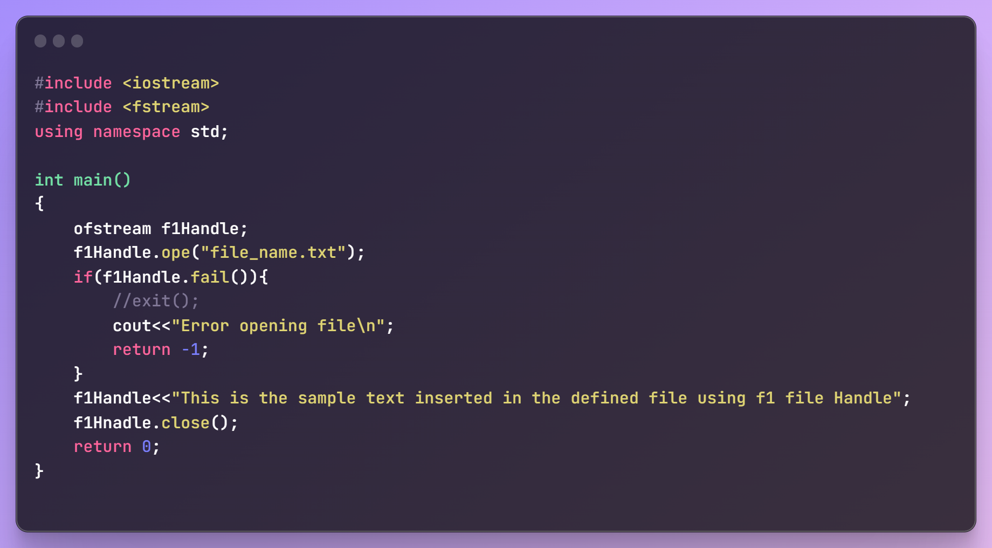

The above code show cases output handle in default (insert) mode. Hence whenver you are willing to add something to the output stream’s assciated file it will be added to it as expedcted but if we close this handle and try again adding a new content the output file’s content will be overriden. To avoid this we need to open the file with the handle in the append mode using ‘std::ios::app’ For example:

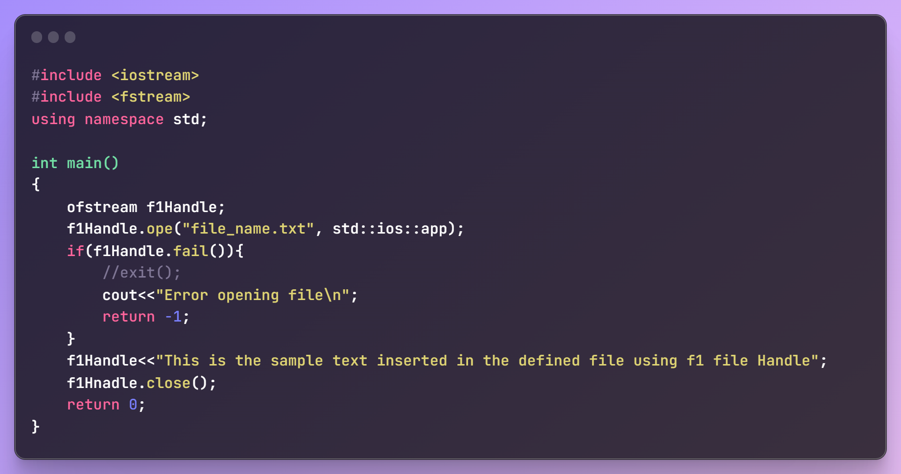

All the flags are mentioned below:

When opening a file in C++, you can specify various flags to control the file's behavior. The standard flags for opening a file in C++ are part of the std::ios_base::openmode enumeration. Here are some commonly used standard flags:

* **std::ios_base::in:**

Open the file for reading.

* **std::ios_base::out:**

Open the file for writing.

* **std::ios_base::binary:**

Open the file in binary mode.

* **std::ios_base::ate: Is like append mode but it requires out flag as well to work as append.** In summary, both app and ate flags can be used for appending data to a file, but the ate flag is more flexible as it allows you to control whether you want to perform input operations (std::ios::in) in addition to appending output (std::ios::out). Choose the flag that best fits your specific use case.

Set the initial position at the end of the file.

* **std::ios_base::app:**

Set the stream's position to the end of the file before each write operation.

* **std::ios_base::trunc:**

If the file already exists, truncate its size to 0. When you open a file with this flag and the file already exists, it will truncate (empty) the file, setting its size to zero. If the file does not exist, a new empty file will be created.

These flags can be combined using the bitwise OR (|) operator to achieve the desired behavior. Here's an example of opening a file for both reading and writing in binary mode:

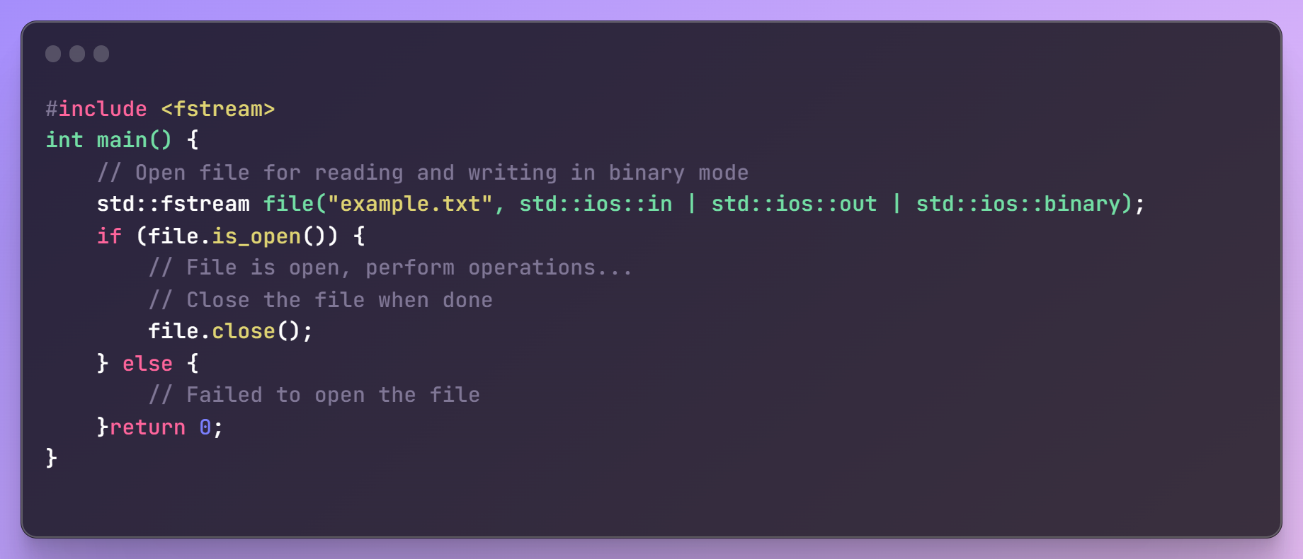

Below is the sample c++ code that will demonstrate both output and input file stream use case.

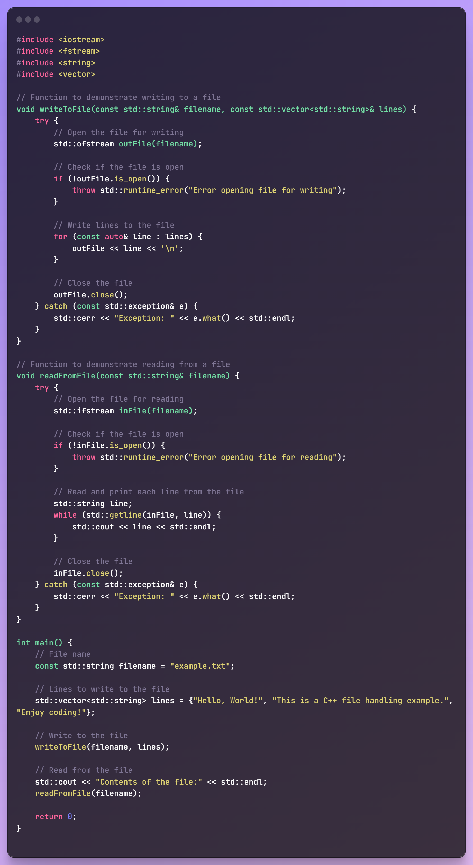

**Now what if we want to read only a part of the file written/present. Let us say till a specific line_number.**

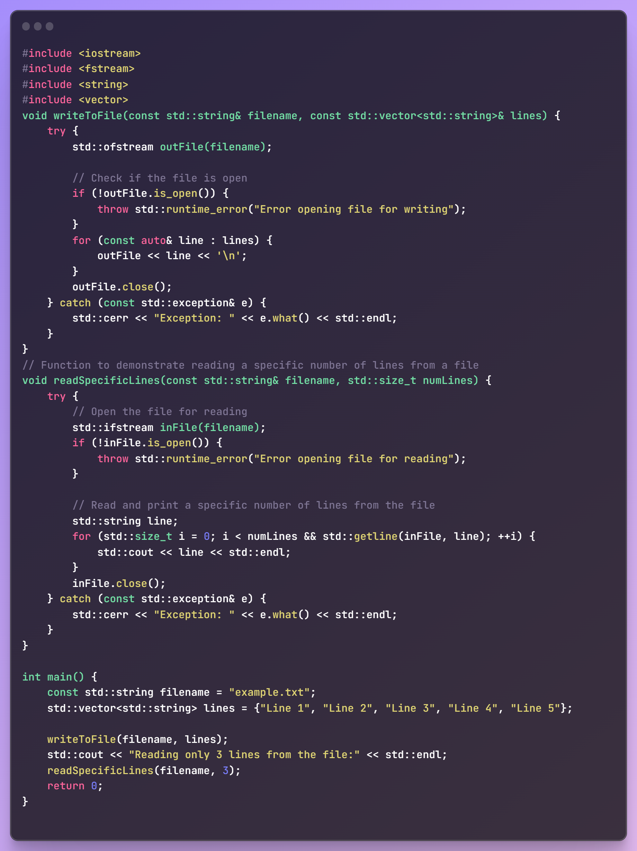

**We can also check if the handle is at the end of the file using: <handle>.eof()** It returns true if we are.

When you read a numeric value from a file using standard file input operations (operator>> or getline), the value is typically stored as its numeric type, not as a string. C++ streams will automatically convert the input into the appropriate numeric type.

NOTE: This is very important. When you are trying to read string (including spaces) from a file, line by line, you would use getline function to store the line to a string variable using: getline(<handle>, <str_var>). If not, you would simnply use “>>” operator to get each and every non-line variable as you do when getting standard input on console.

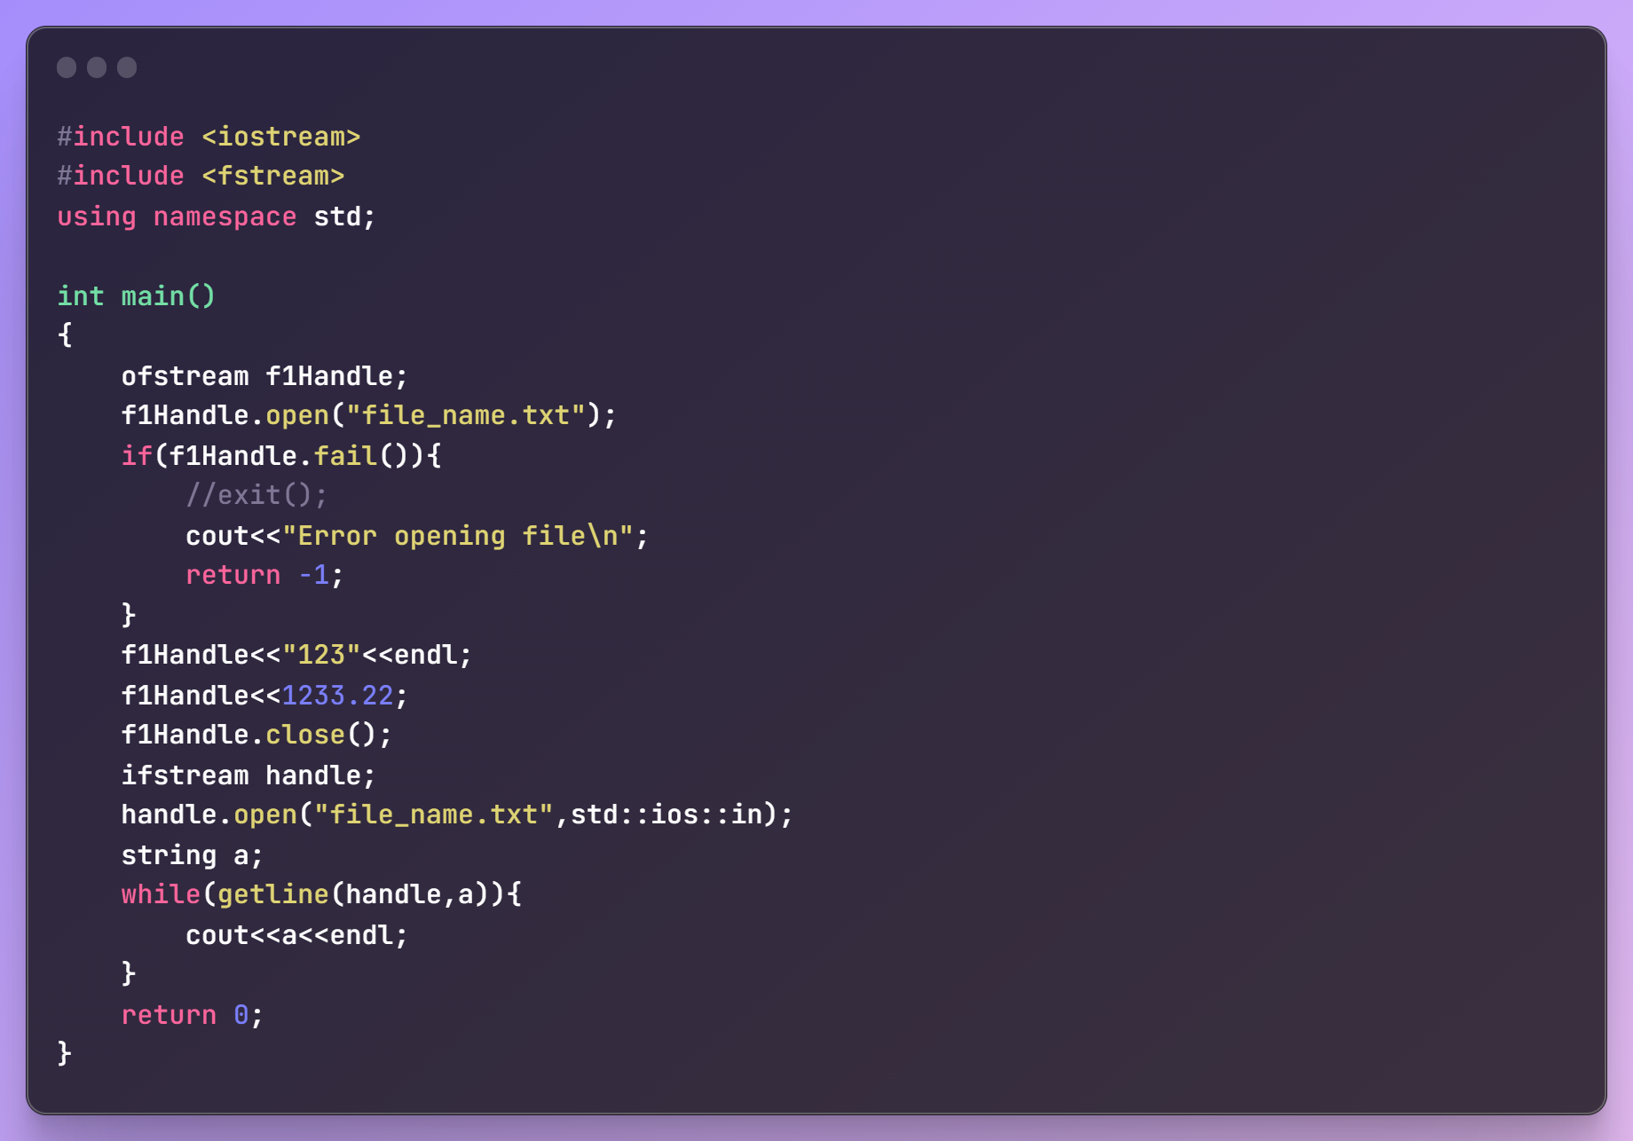

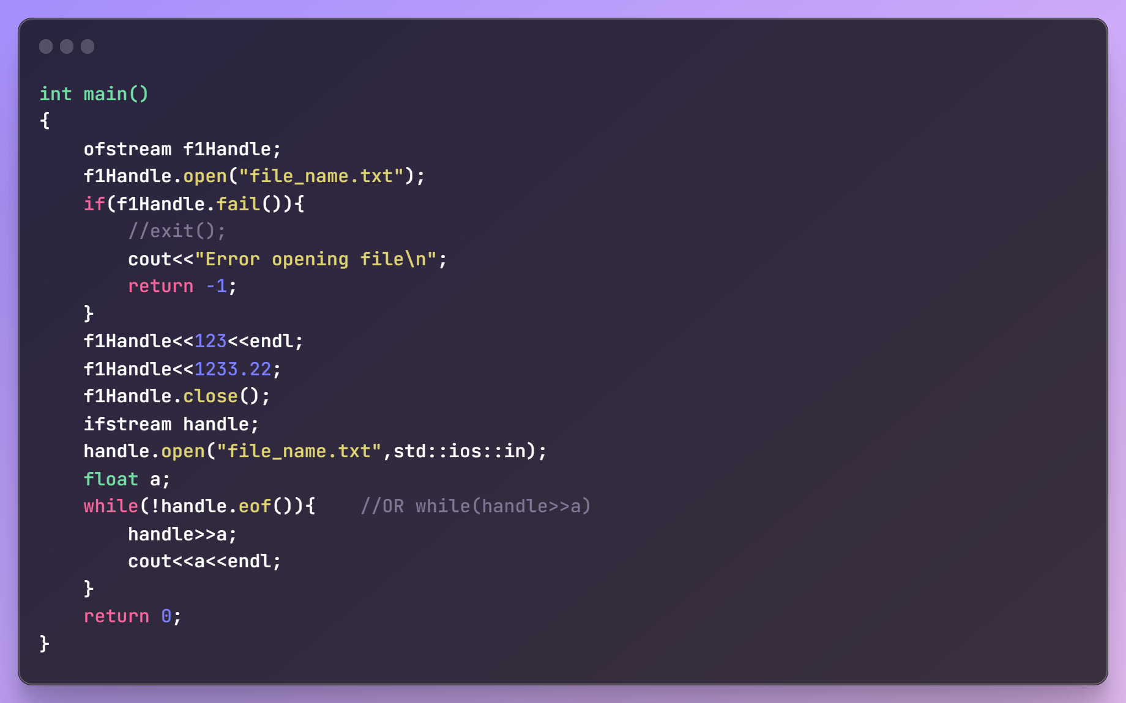

**StringStreams:**

**Important C++ features:**

* **Structural Padding and Packing:**

In C++, padding and packing are mechanisms related to memory alignment for struct and class members. These concepts are particularly important for performance optimization and memory utilization.

Why Padding Happens ?

Padding occurs due to alignment requirements of data types. Modern processors access memory more efficiently when data is aligned to certain boundaries. For instance, a 4-byte (32-bit) integer is accessed more efficiently if it is stored at a memory address that is a multiple of 4.

Consider a structure with different data types:

struct Example {

char a; // 1 byte

int b; // 4 bytes

char c; // 1 byte

};

On a 32-bit system, the memory layout might look like this:

| a | padding | b | c | padding |

| 1 | 3 (bytes) | 4 (bytes) | 1 | 3 (bytes) |

Thus, the size of the struct becomes 12 bytes instead of 6 bytes.

**Total size and alignment border is decided by the largest member of the struct/class (Except for the string)**

Packing

Packing is the process of removing the extra padding bytes, which can be useful to save memory. However, it can lead to performance penalties due to misaligned accesses.

Packing can be controlled using compiler-specific pragmas or attributes.

Examples on 32-bit and 64-bit Systems

Example 1: Without Packing

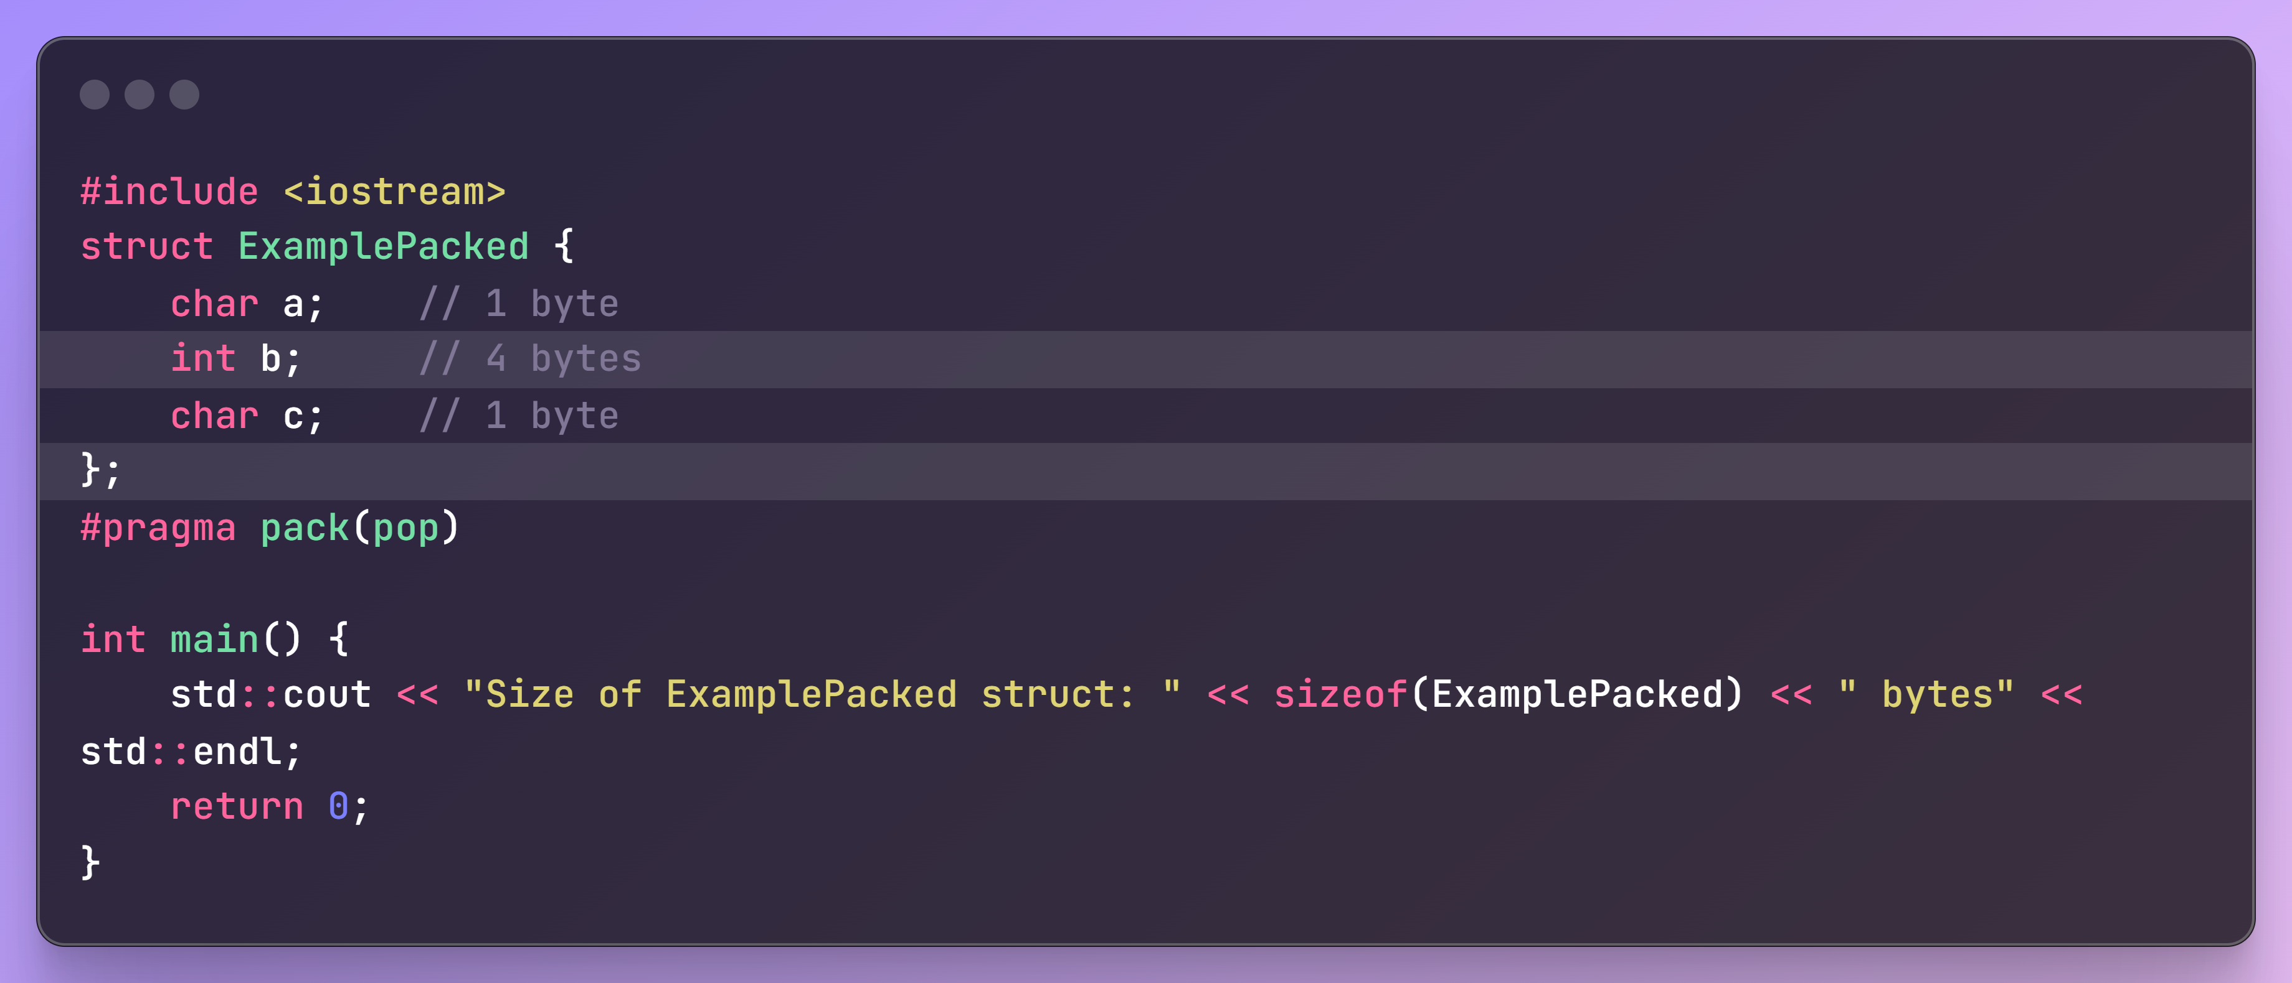

On a 32-bit system, the size would typically be 12 bytes.

On a 64-bit system, the size would also typically be 12 bytes.

Example 2: With Packing

To pack the structure, we can use compiler-specific directives. For GCC/Clang:

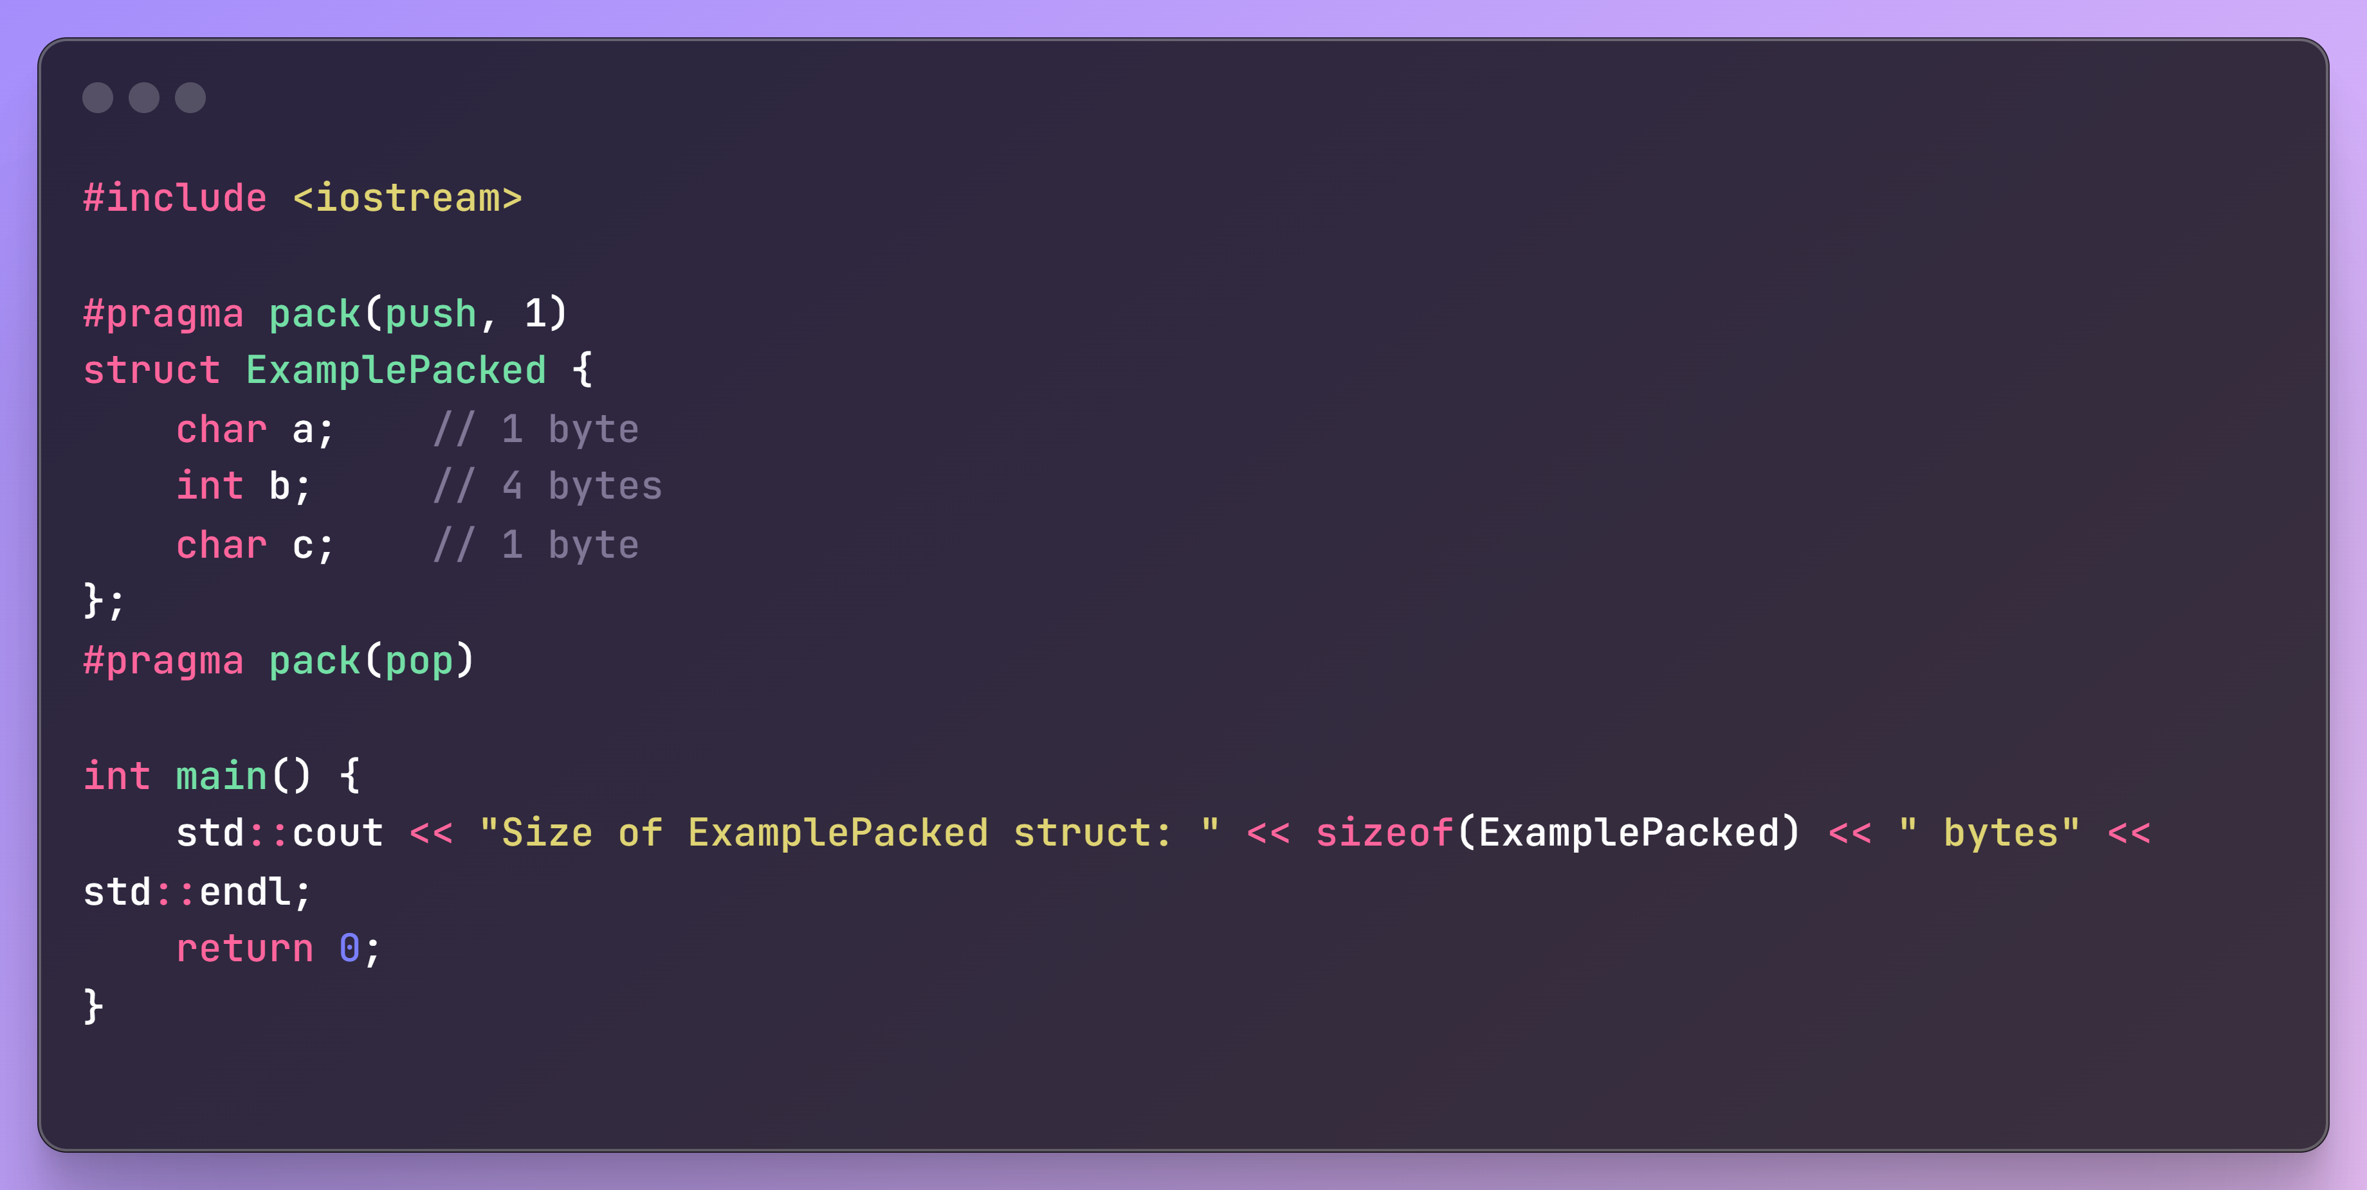

The size of the ExamplePacked struct would be 6 bytes on both 32-bit and 64-bit systems since no padding is added.

Padding: Increases structure size to align data members to natural boundaries for efficient access.

Packing: Reduces structure size by removing padding, potentially causing performance penalties.

Object/struct size depends on variable arrangement and largest Variable size over a particular CPU architecture.

NOTE: strings are fluid. They don’t follow the alignment constraints. It usually has a fixed size (In current system, it holds a size of 32 Bytes)

For Example: Let us say we have a struct a:

A{ char a, int b, long long c, float d, char a1}. Then our memory with padding will look like:

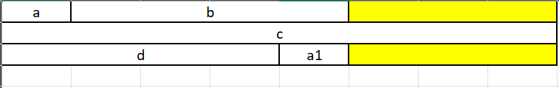

24 B

Some of the type memory to be aware of is:

int,float,long = 4B

long long, double, pointer and reference = 8B

char = 1B

short = 2B

string = 32B (fluid – not counted as max size).

* **Compile time Polymorphism V/S Runtime polymorphism. (Vtables and vpointers).**
* **Smart pointers: (In <memory> header)**

A smart pointer is an object that acts as a pointer but provides additional functionalities to ensure better memory management and to avoid common issues such as memory leaks, dangling pointers, and double deletions. Unlike raw pointers, smart pointers automatically manage the lifetime of the dynamically allocated memory they own. In C++, smart pointers are implemented as template classes, which are included in the Standard Library (<memory> header). The most commonly used smart pointers are:

1. std::unique_ptr
2. std::shared_ptr
3. std::weak_ptr

**Why Are Smart Pointers Needed?**

* 1. Automatic Memory Management: Smart pointers help in managing the lifecycle of dynamically allocated objects. When a smart pointer goes out of scope, it automatically deletes the object it points to, thus preventing memory leaks.
  2. Exception Safety: Smart pointers ensure that resources are properly released even if an exception is thrown. This is particularly important in complex functions where exceptions might occur.
  3. Avoiding Dangling Pointers: They help in avoiding dangling pointers by ensuring that the memory is not deallocated while it is still being used.
  4. Reference Counting: Some smart pointers like std::shared_ptr use reference counting to manage shared ownership of resources, ensuring that the resource is only released when the last owner is done with it.
  5. Simplified Code: Smart pointers simplify the code by eliminating the need for explicit delete statements and by handling memory management tasks automatically.
  6. Ensuring ownership and memory responsibility.

These are all the points and features of what a raw pointer lacks.

1. **std::unique_ptr**
2. **std::shared_ptr**
3. **std::weak_ptr**

* **RAII (Resource Acquisation in Intialization):**
* **Move Semantics:**

**Std::move**

`std::move` is a utility function in C++ that enables the moving of resources from one object to another. It converts its argument into an rvalue reference, which allows the transfer of ownership of resources, such as dynamically allocated memory or unique handles, to another object.

Here's how it works:

**1. Converts to an rvalue reference**: When you pass an lvalue (an object with a name) to `std::move`, it casts it to an rvalue reference. This essentially indicates that the object is a candidate for moving its resources, rather than copying.

**2. Allows move semantics**: By using `std::move`, you signal to the compiler that you are willing to move the resources owned by the object. This enables the use of move constructors or move assignment operators, if they are available for the object's type.

**3. Transfer of ownership:** After using `std::move`, the object that was passed to it is typically in a valid but unspecified state. The resources it owned are transferred to another object, which now has the responsibility for managing those resources.

Here's a basic example demonstrating the use of `std::move`:

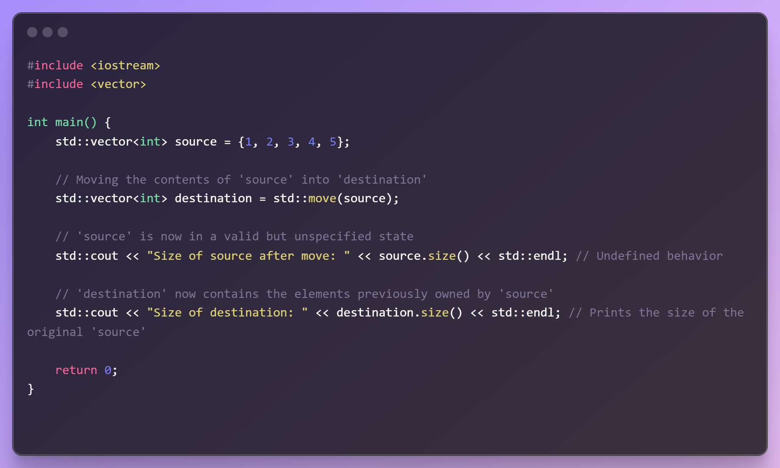

In this example, `std::move` is used to transfer the contents of the `source` vector into the `destination` vector.

* **Rule of 5:** Here's an example C++ code that demonstrates the Rule of 5 in action using a simple class that manages a dynamically allocated array of integers:

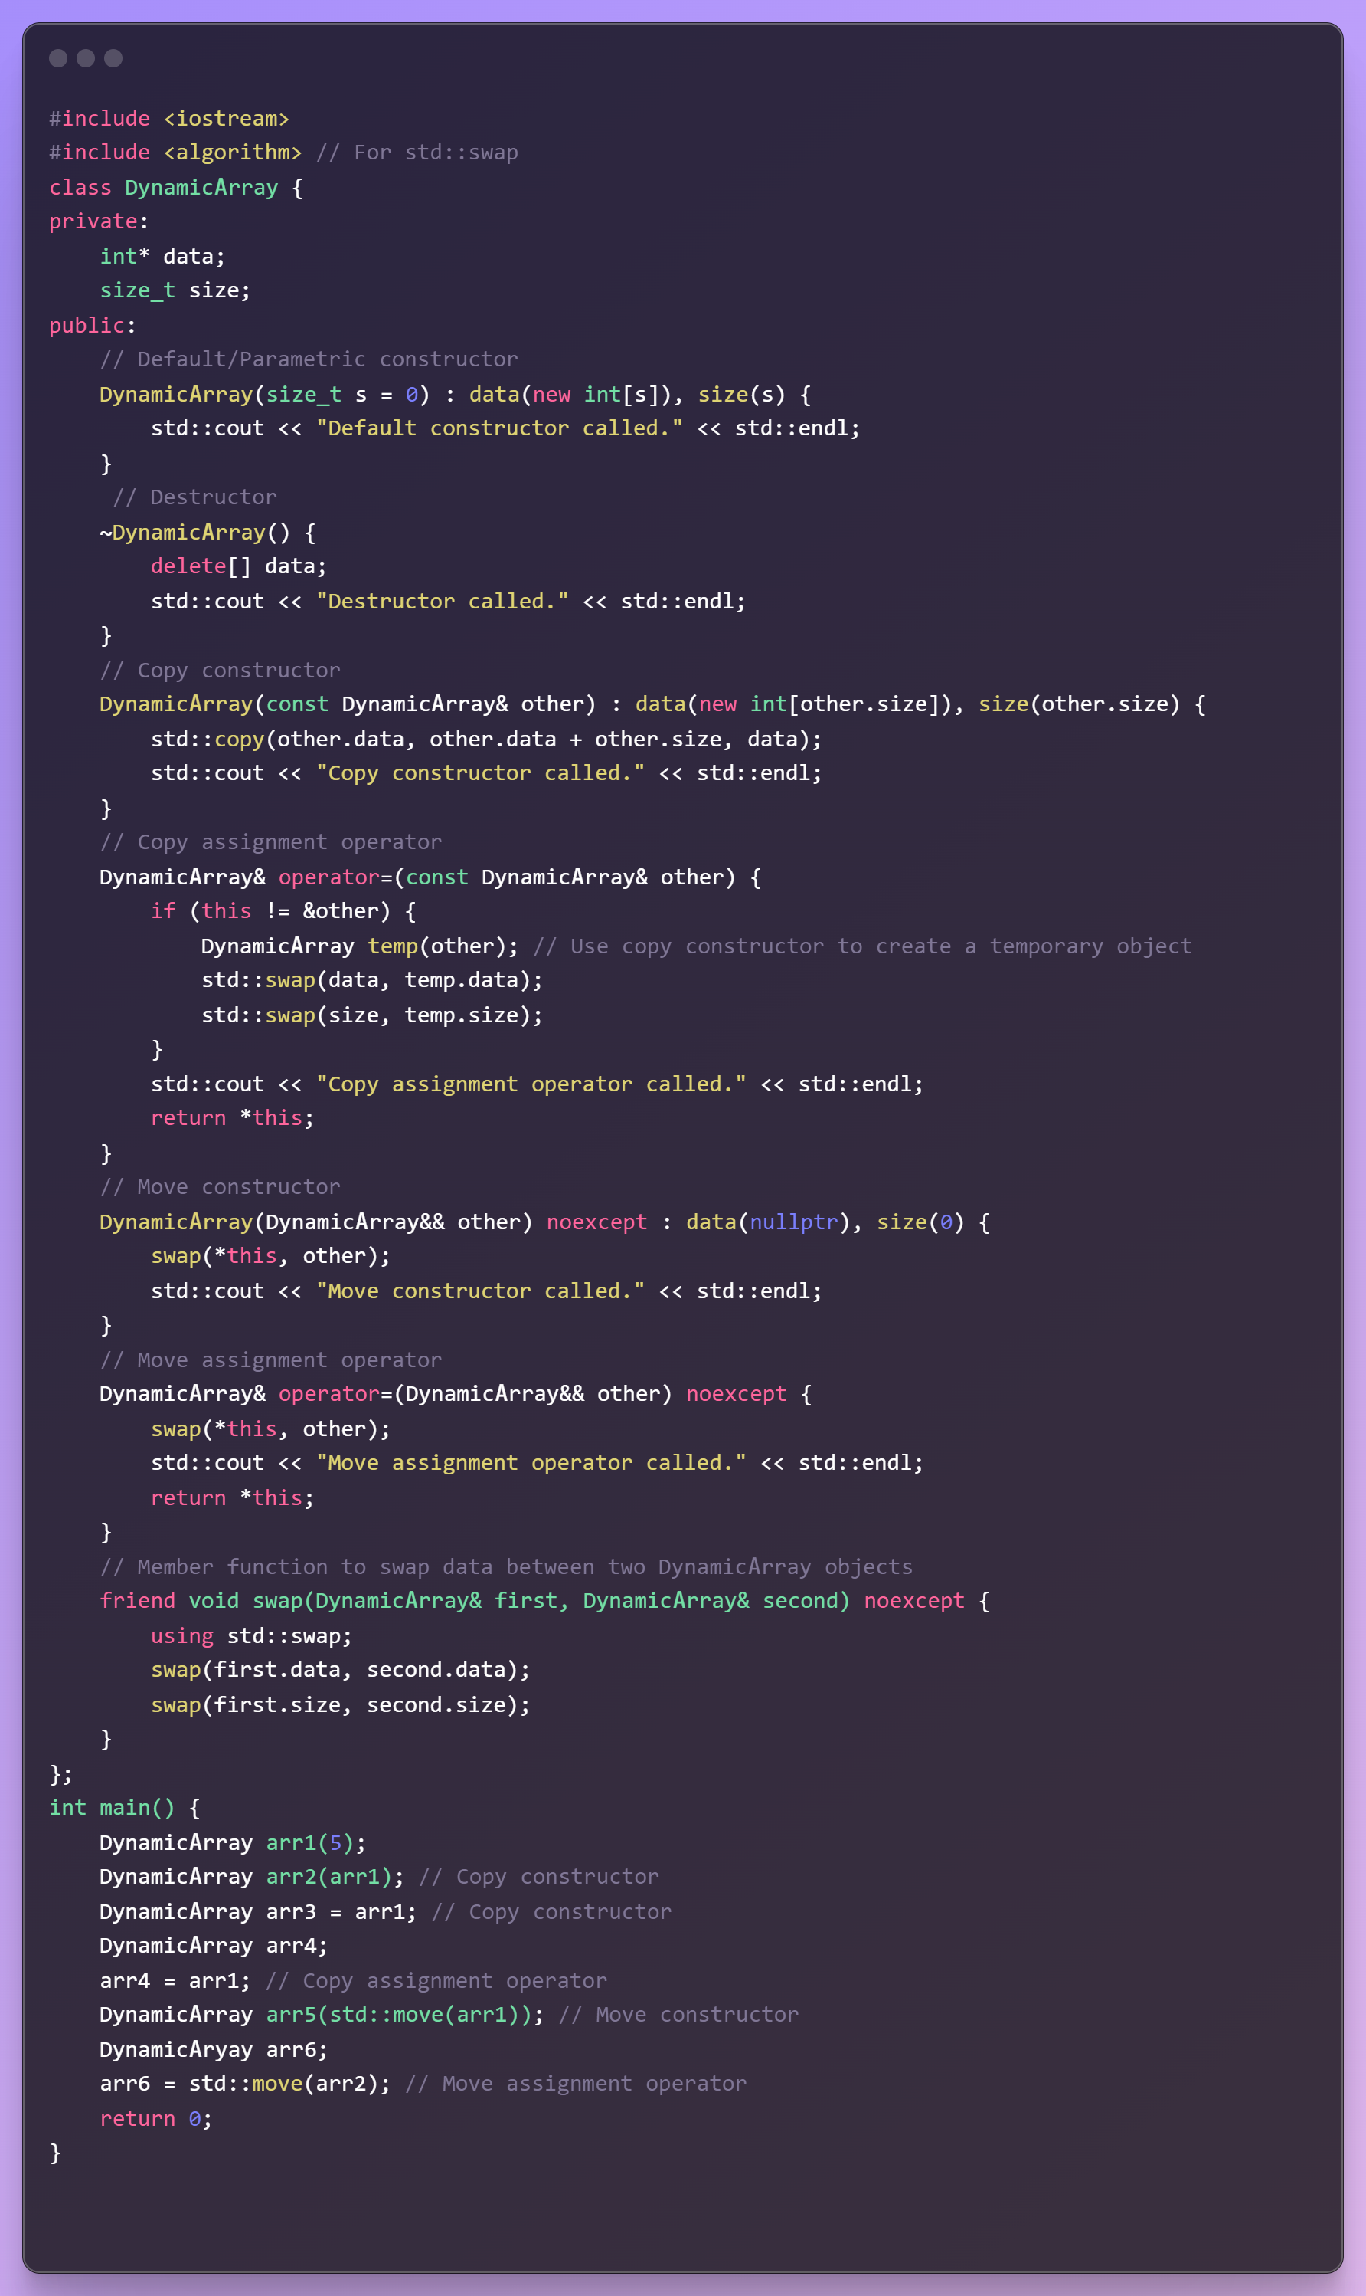

* **Memory leak vs Dangling pointer**:

Dangling pointers are those pointers that points to a memory location which now has been freed up. (Maybe earlier it was pointing to a useful info. But as we manage the memory and freedup the space, pointer) ptr 🡪 1024 (after free) ptr 🡪 XXXXXX //garbage

Memory leaks happens when memory is not freed up (but the pointer associated are dereferred/ modified) and now there is no way to refer to the memory location.

ptr 🡪 1024 (after pointer exits scope/dereferred/modified) no way to access 1024.

* **Union vs Struct**
* **How this pointer works internally.**
* **Member function does not belong to any instance.**
* **Function template is a compile time polymorphism.**
* **Weak symbol and strong symbols**
* **Attributes.**
* **#include<> vs #include “”**
* **new vs malloc()**

1. new is an operator, while malloc() is a function.
2. new returns exact data type, while malloc() returns void * which then needs explicit type conversion to a appropriate pointer.
3. On failure, malloc() returns NULL where as new throws bad_alloc exception.
4. In case of new, memory is allocated from free store where as in malloc() memory allocation is done from heap.
5. Required size of memory is calculated by compiler for new, where as we have to manually calculate size for malloc().

* **CTAD (class template argument deduction)**
* **Class vs struct:** by default access specifiers in genral and during inheritance.
* **Static functions vs Extern Functions:** When a function is declared as static, it means that the function's scope is limited to the translation unit (source file) in which it is defined. It is not accessible from other translation units. Static member functions cannot access non-static data members directly. Since static member functions are not associated with any particular instance of the class, they do not have access to instance-specific data members. A static function can have non-static parameters. There's no restriction on the types of parameters that a static function can have.

Static functions do not require object instantiation. Static functions are typically used to encapsulate functionality that is specific to a single file or translation unit, avoiding namespace pollution and potential naming conflicts.

When a function is declared as extern, it means that the function is defined elsewhere, and the compiler should look for its definition in other translation units. It serves as a declaration to indicate that the function is defined externally.

In C and C++, functions are by default extern when declared at global scope. This means that if you declare a function at global scope without explicitly specifying extern, it is considered as having external linkage by default.

* **Constant functions**: In C++, const functions are member functions of a class that are declared with the const keyword. These functions promise not to modify the state of the object on which they are called. This means that within a const member function, you cannot modify the member variables of the class unless they are declared as mutable.

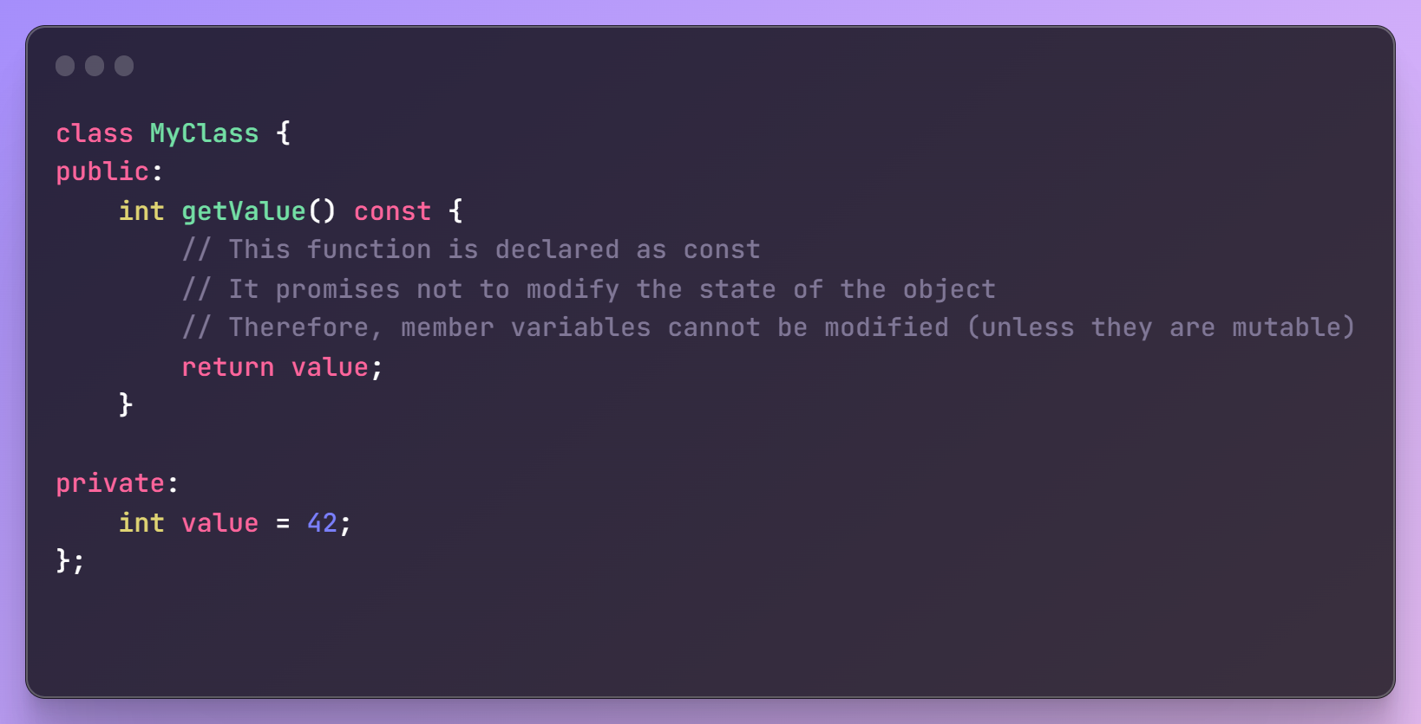

We can declare function parameters as const if you want to ensure that they are not modified within the function body. This is particularly useful for functions that take parameters by reference or pointer.

In non-OOP contexts, you can also declare functions as const to indicate that they do not modify any data. This is particularly useful when working with functions that operate on data but should not modify it.

Does a const function require its arguments to be const?

No, a const function does not require its arguments to be const. However, you can declare function parameters as const to ensure that they are not modified within the function body, similar to how it works in OOP contexts.

Can a const function access non-const arguments/variables?

Yes, a const function can access non-const arguments and variables. The const qualifier in the function declaration indicates that the function itself does not modify any data, but it does not restrict access to non-const data within the function body.

NOTE:

Like member functions and member function arguments, the objects of a class can also be declared as const. An object declared as const cannot be modified and hence, can invoke only const member functions as these functions ensure not to modify the object. A const object can be created by prefixing the const keyword to the object declaration. Any attempt to change the data member of const objects results in a compile-time error. Hence  
non-const object can call both const and non-const functions. But const oobject can only call const methods.

* **Why parameters of function cannot be static but local variables can be?**

Both local variables within a function and function parameters have automatic storage duration, meaning they are created when the function is called and destroyed when the function exits. In this sense, their lifetimes are similar. But we cannot assign a parameter as static as it would be logically incorrect, as passed arguments are supposed to be flexible for the caller.

The purpose of declaring a variable as static within a function is typically to retain its value across multiple function calls. This behavior is useful when you want a variable to maintain its state between function invocations, such as counting the number of times a function has been called or caching the result of a computation. Function parameters, on the other hand, are designed to represent the inputs to the function and are not intended to retain their values between function calls.

* **Implicit and Explicit conversions:** Wider type (small to big) is implicit conversion and is done by the compiler automatically. While narrow type conversion (big to small) is done manually by casting. More about casting is discussed below.
* **Constructor Delegation:** Constructor delegation in C++ refers to the ability of one constructor in a class to invoke another constructor of the same class, allowing for code reuse and initialization flexibility. This feature was introduced in C++11. This is how it looks:

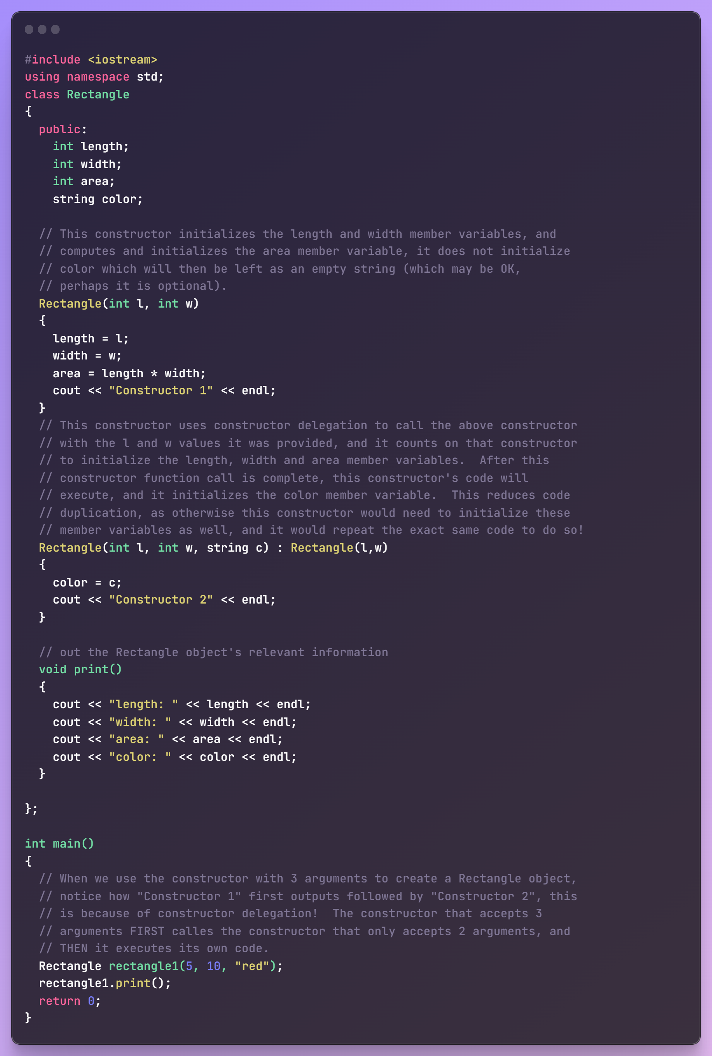

* **Problems with Default copy constructor and Object asignemnt:** In C++, when you create a class or structure and don't explicitly define a copy constructor or an assignment operator, the compiler generates default implementations for you. These default implementations perform a shallow copy, meaning they copy the values of each member from one object to another. **Only First level copy is done.** That is, first level variables are copied by value.

**For example:**

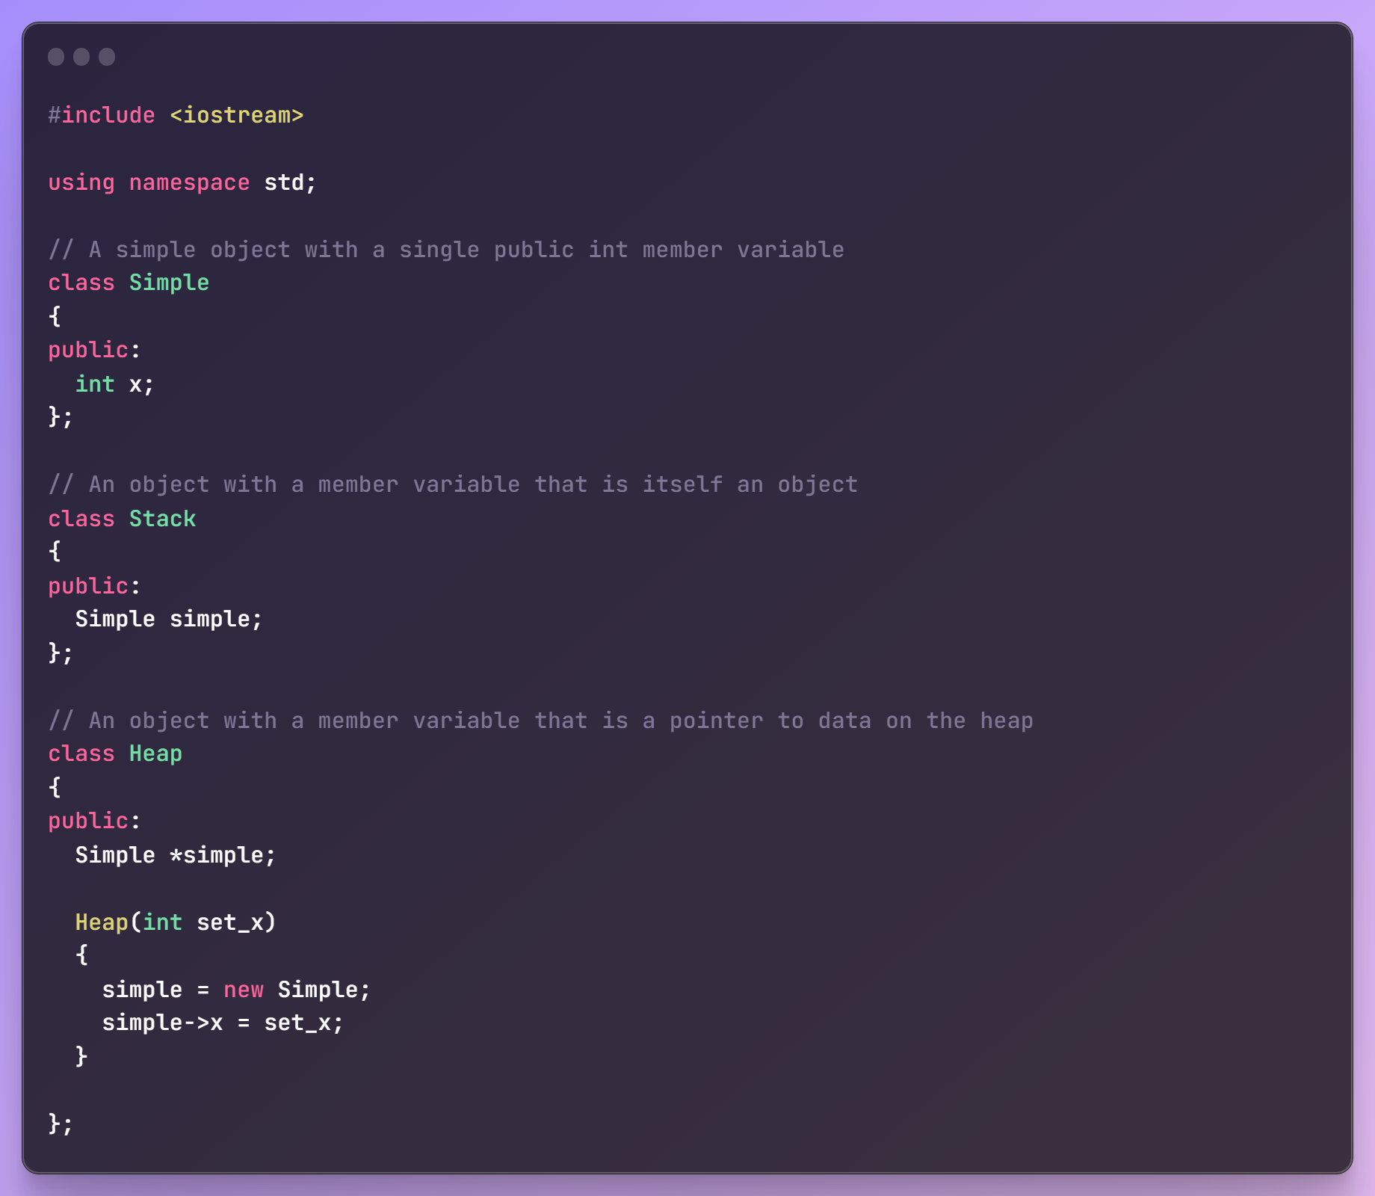

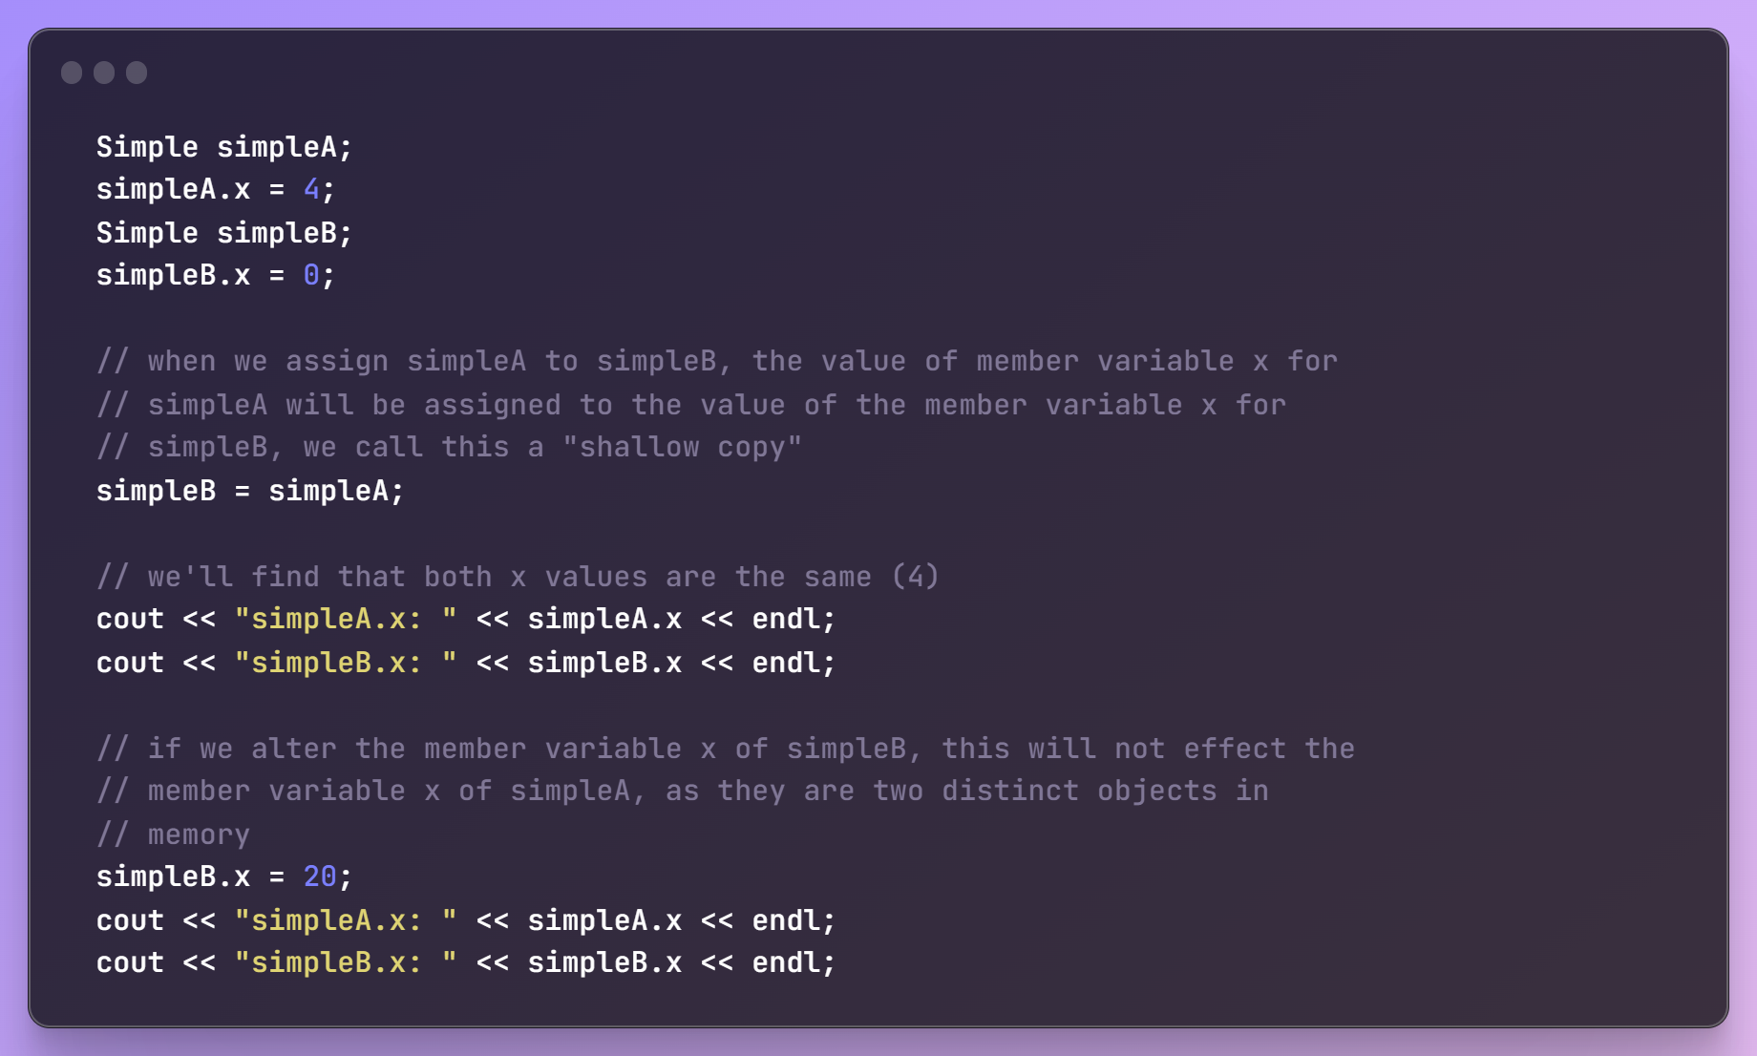

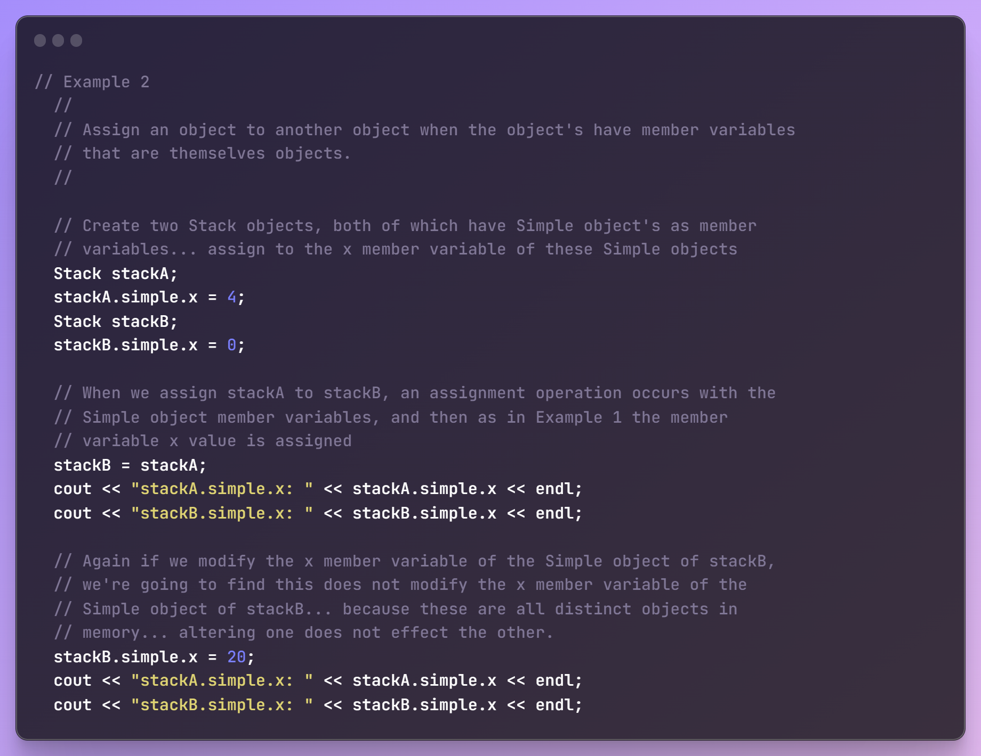

**Memory view:**

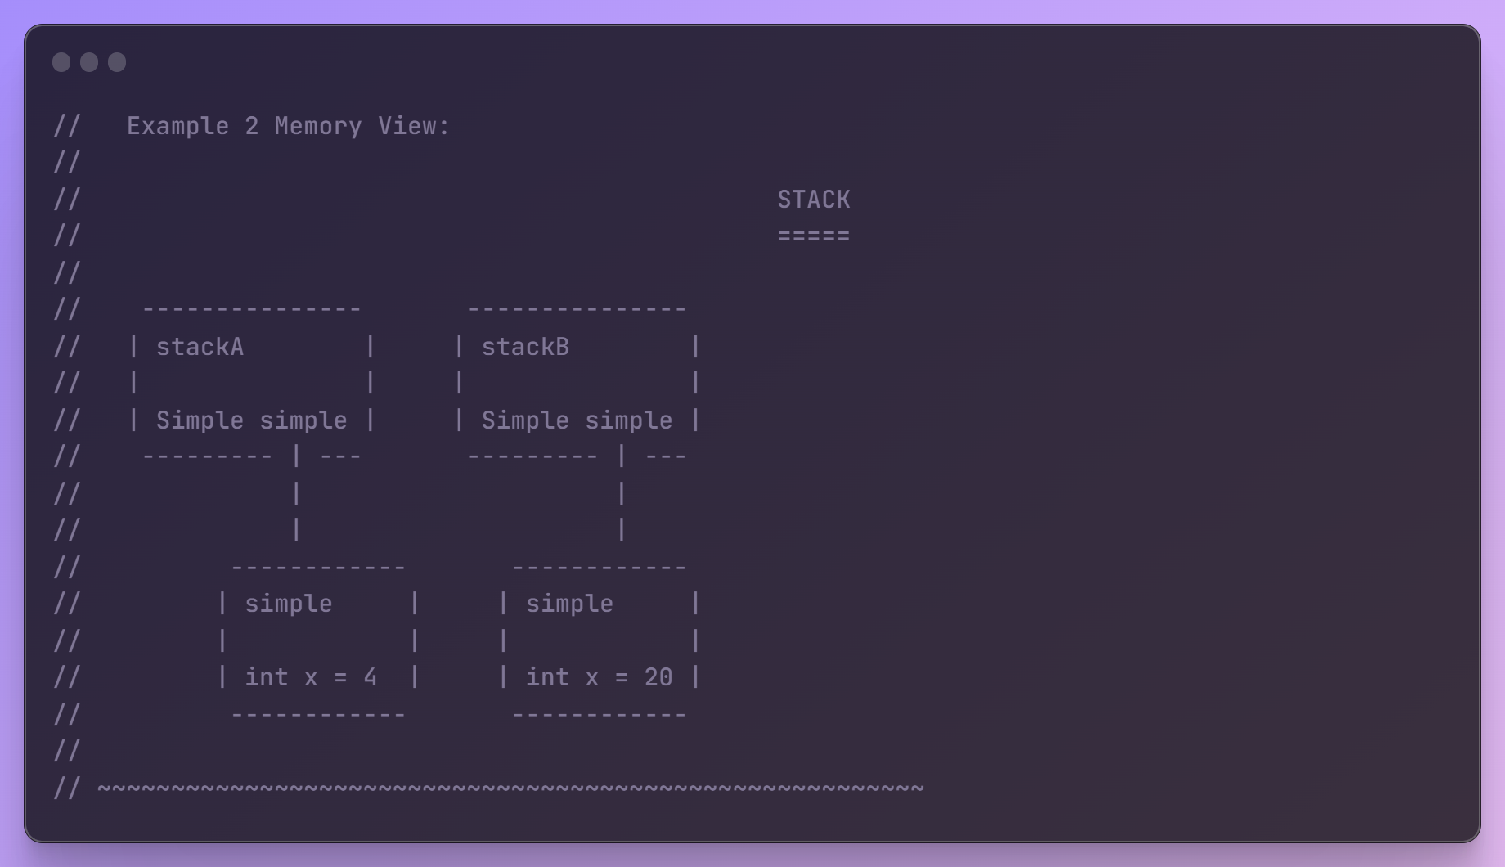

The following showcases the problem with the default copy constructor and object assignment.

NOTE: The solution is to develop your own overloaded copy constructor and assignment operator.

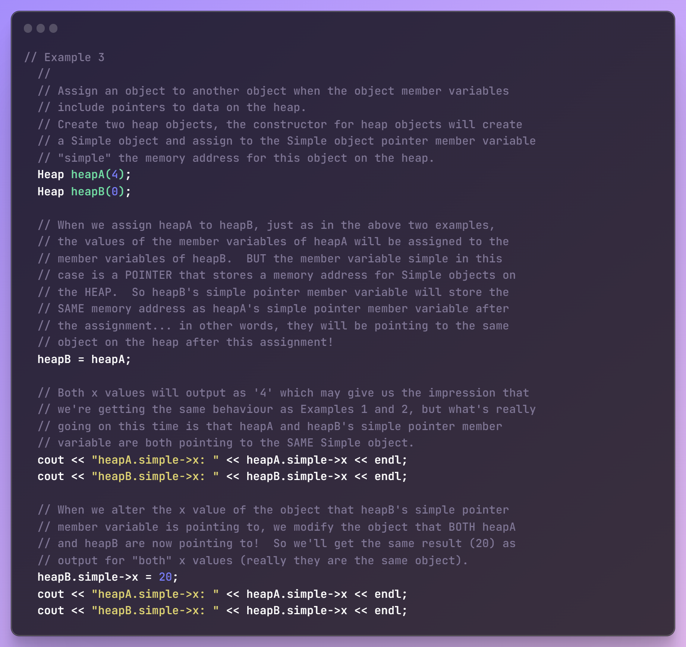

**Memory view:**

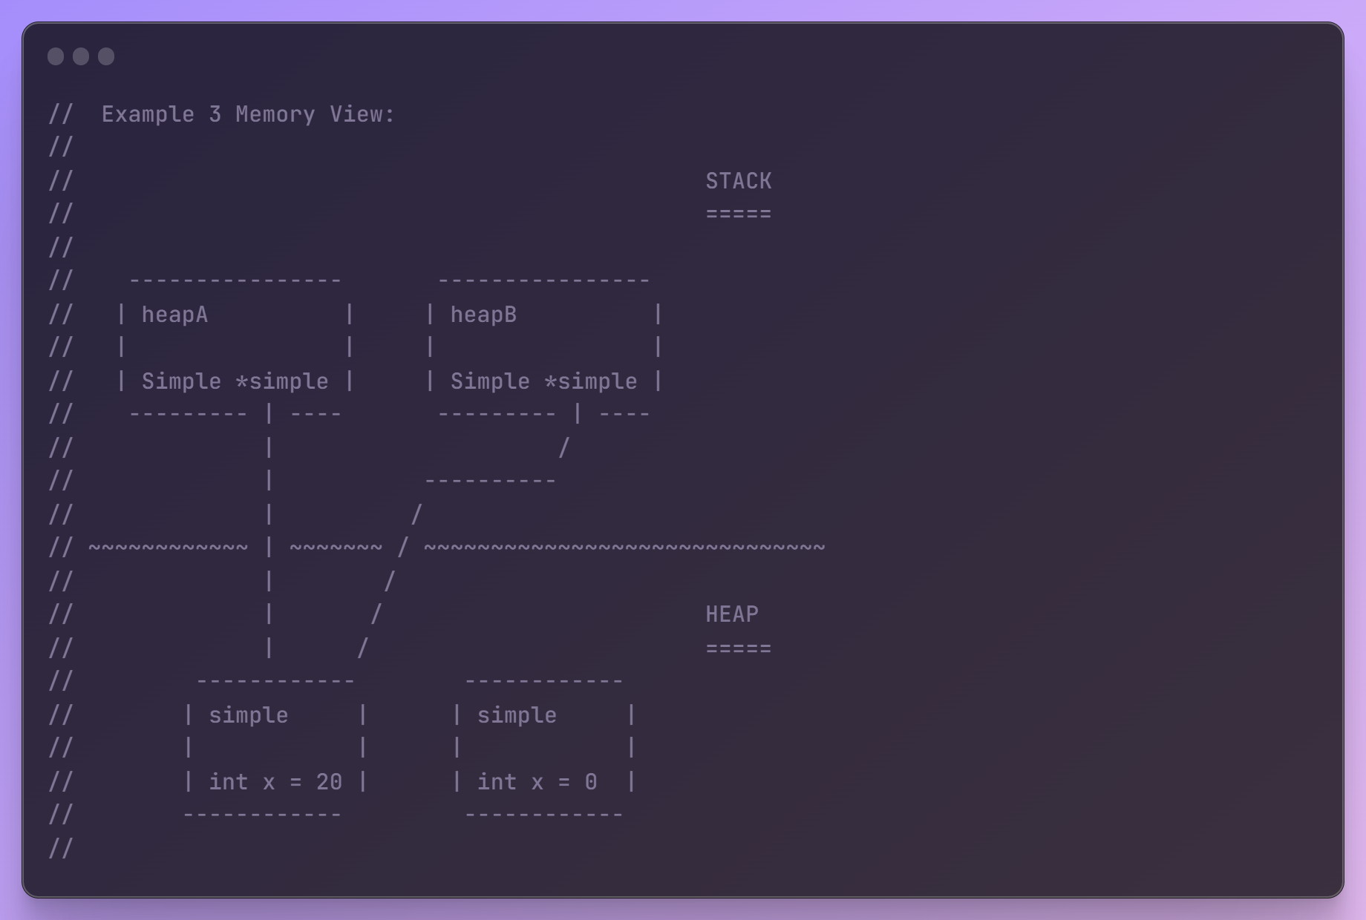

Hence, in summary the issues are:

* + 1. Memory leaks if not handled.
    2. Shallow copy issue
    3. Difficult to be observed in complex class.

When ever there are poiner data members, you will face problme with default copying and asignment. So it is advisable to overload copy constructor and = operator for those cases.

**For example:**

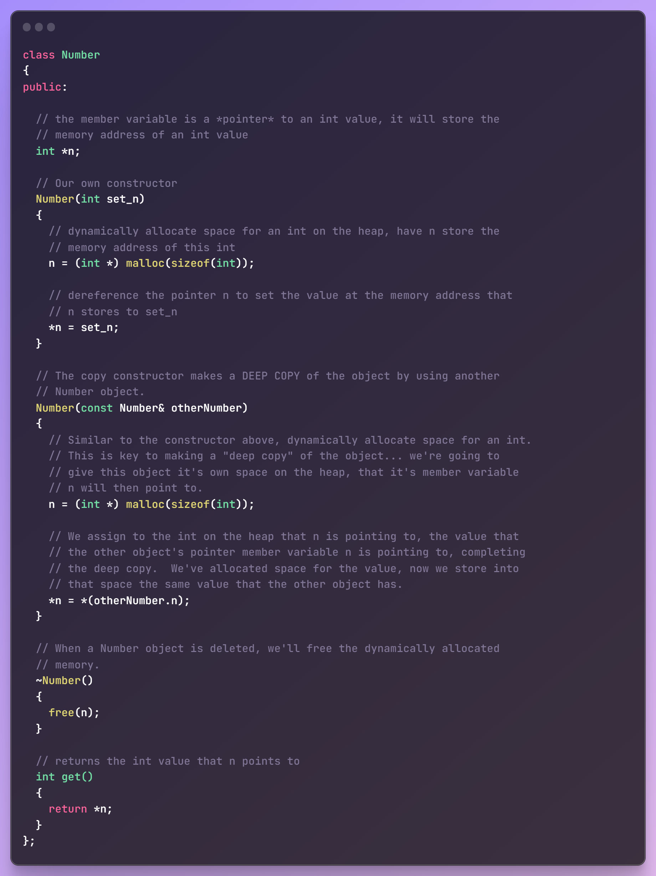

* **Stream Manipulators:**

Hearder invloved for this: **<iomanip>**

**Allows us to alter the output stream setup.**

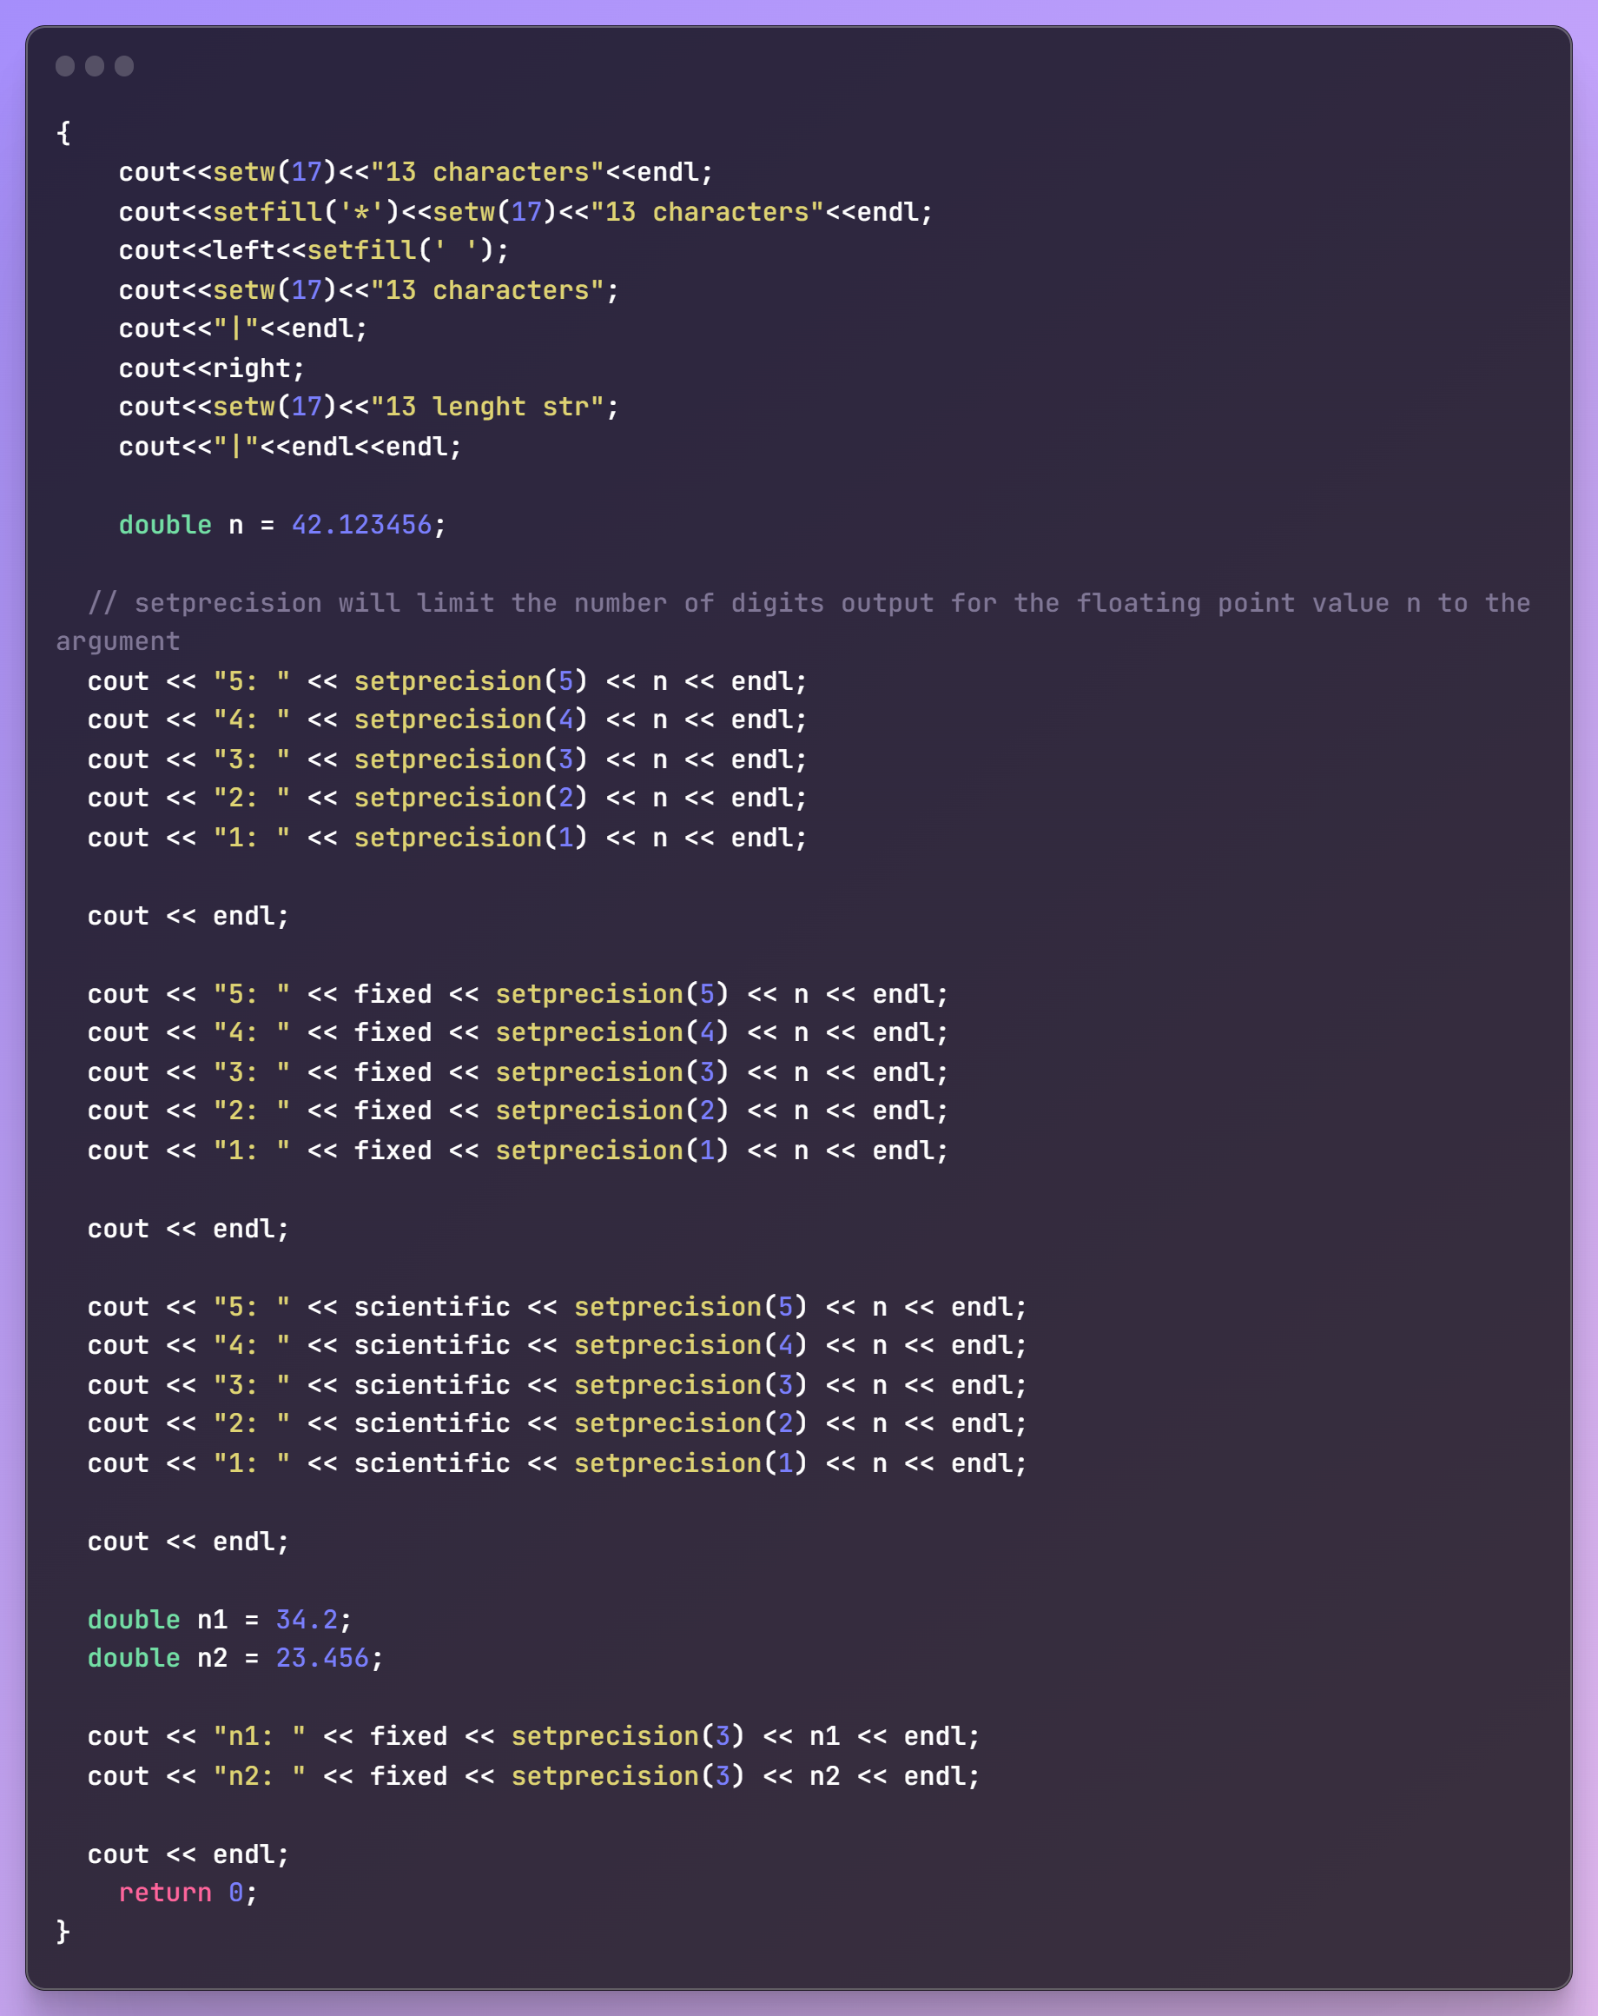

**Output:**

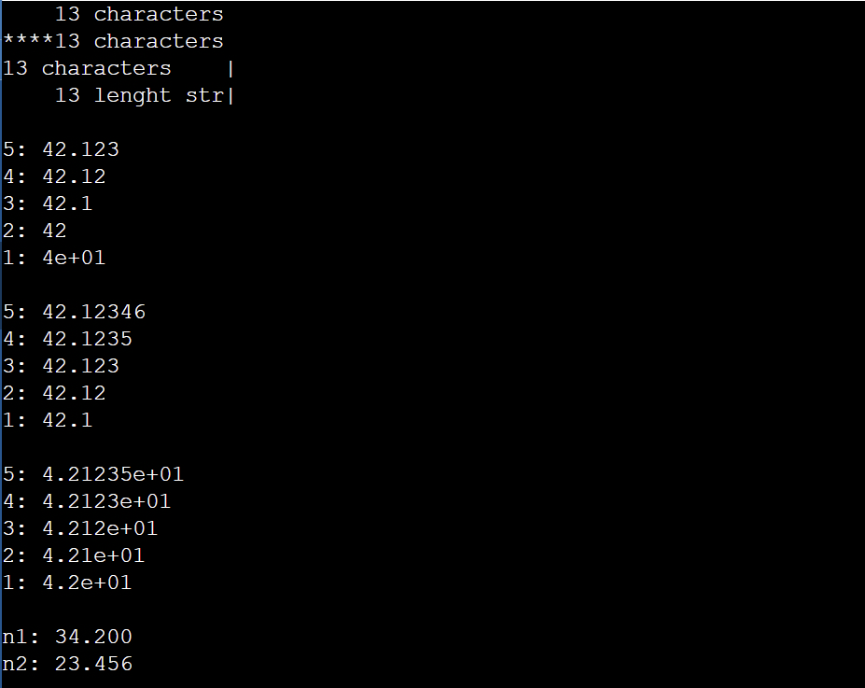

* **MethodChaining:**

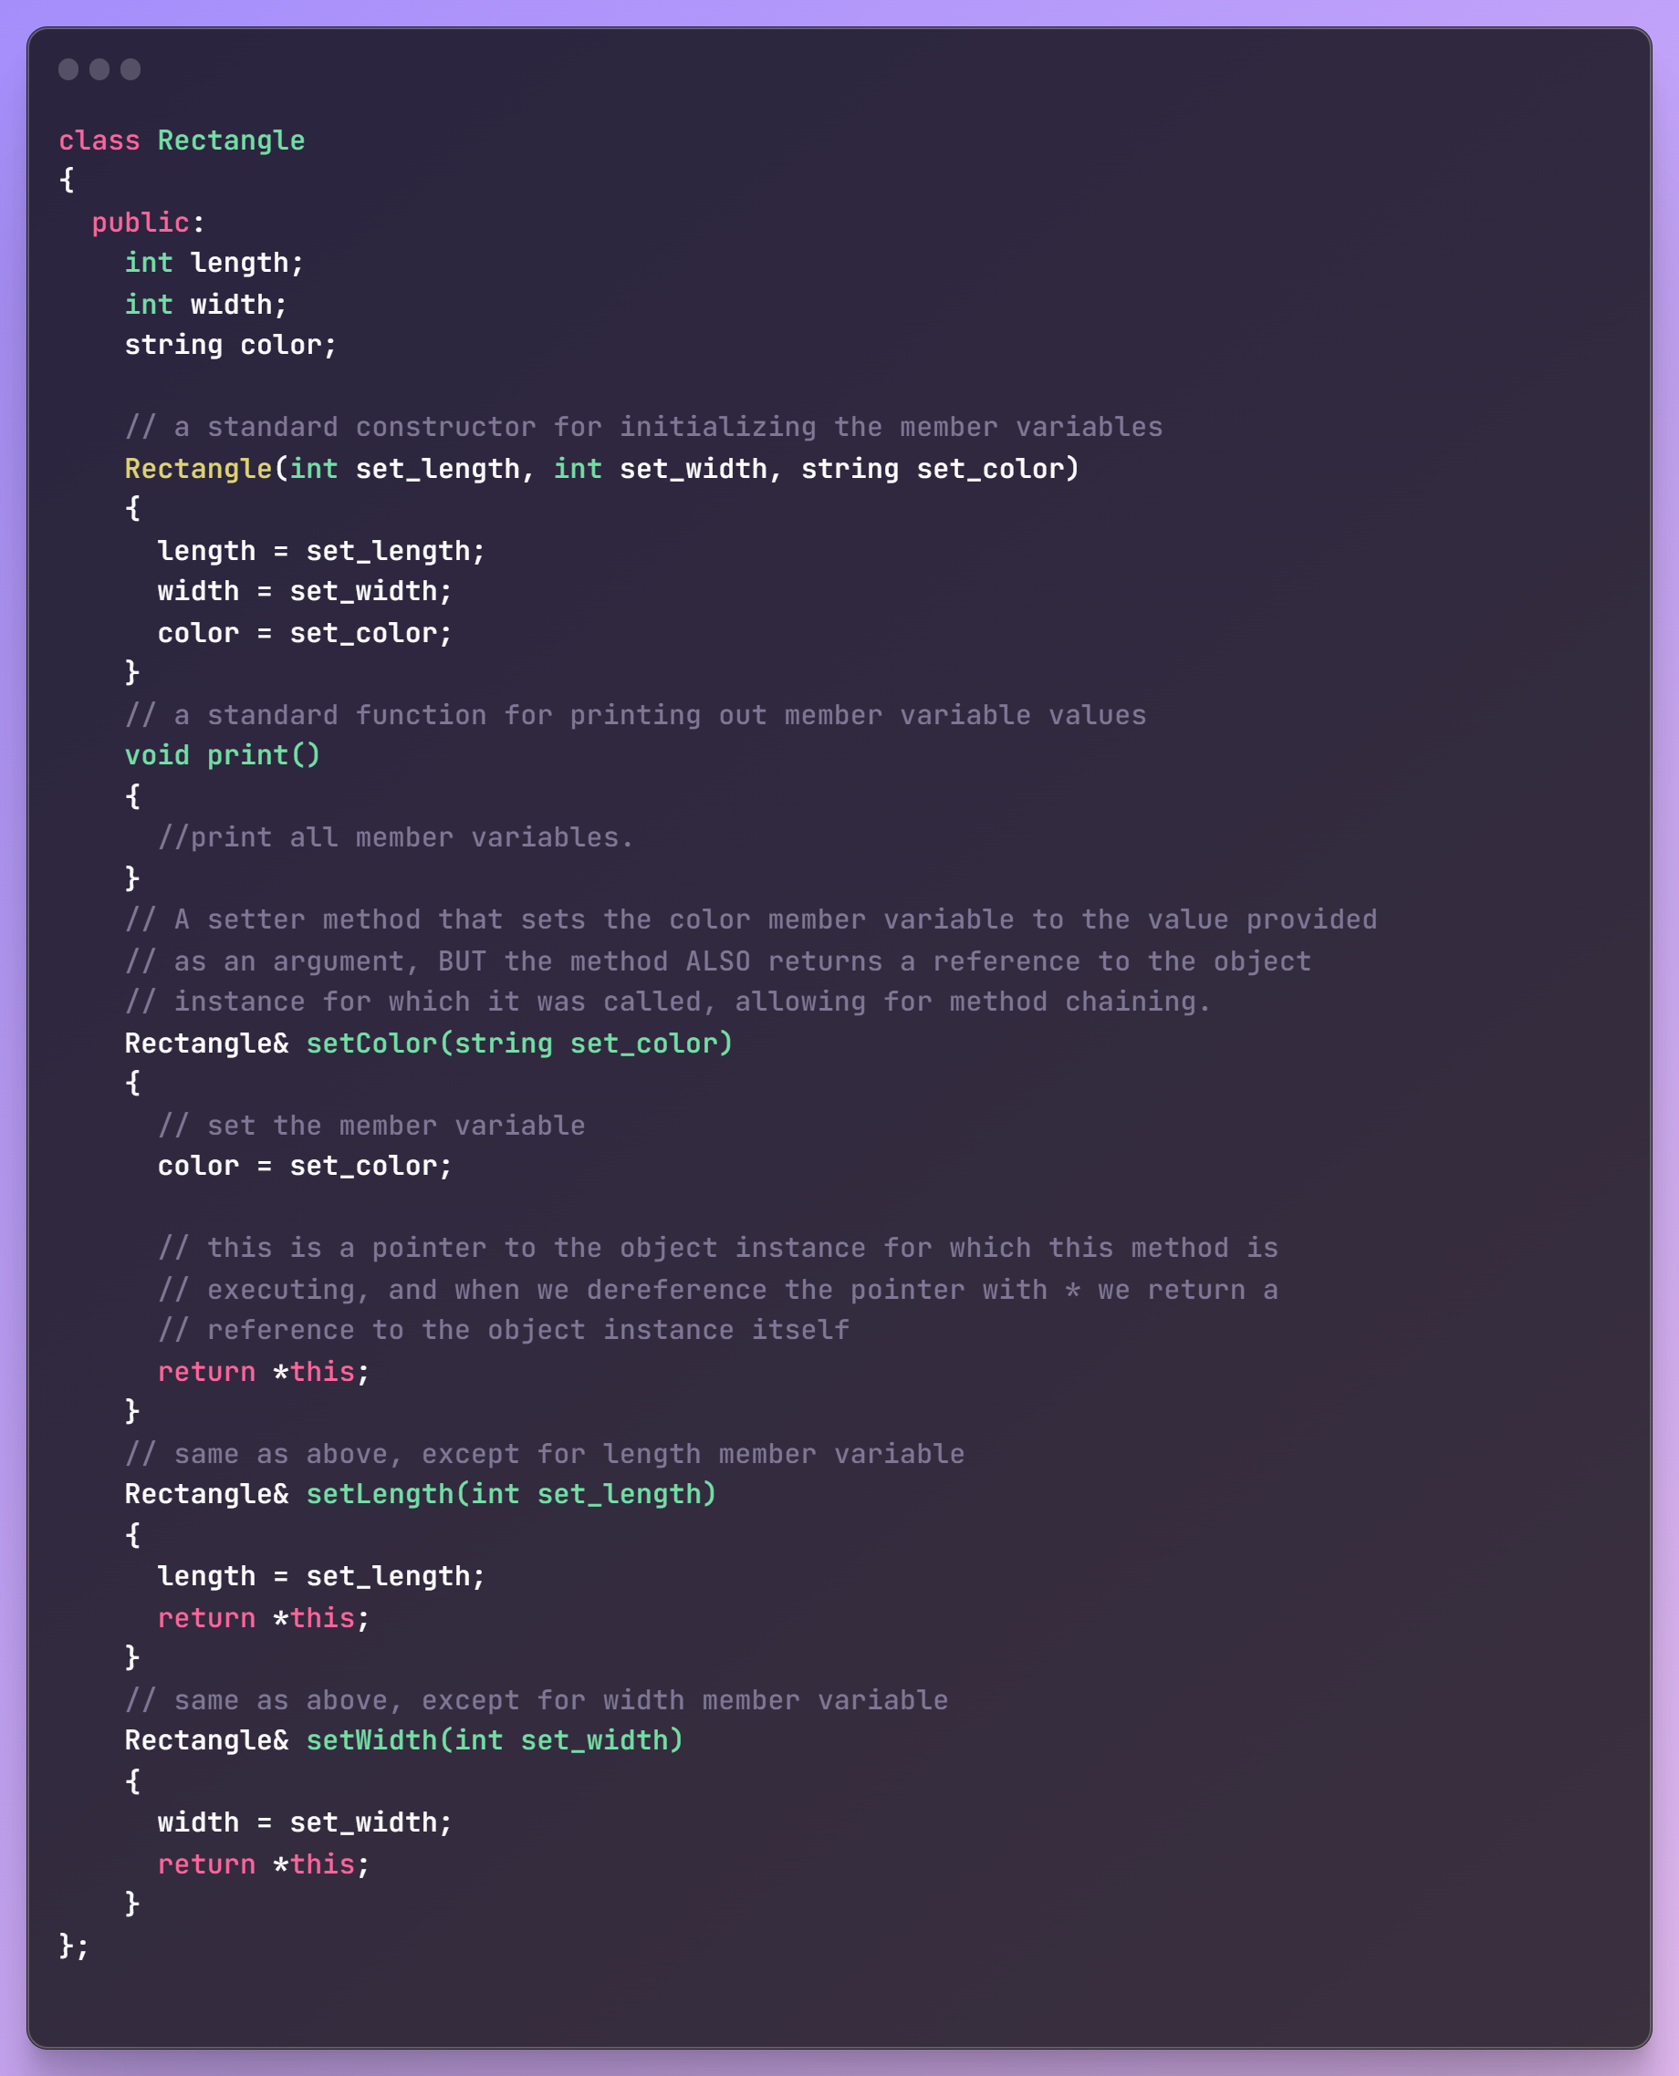

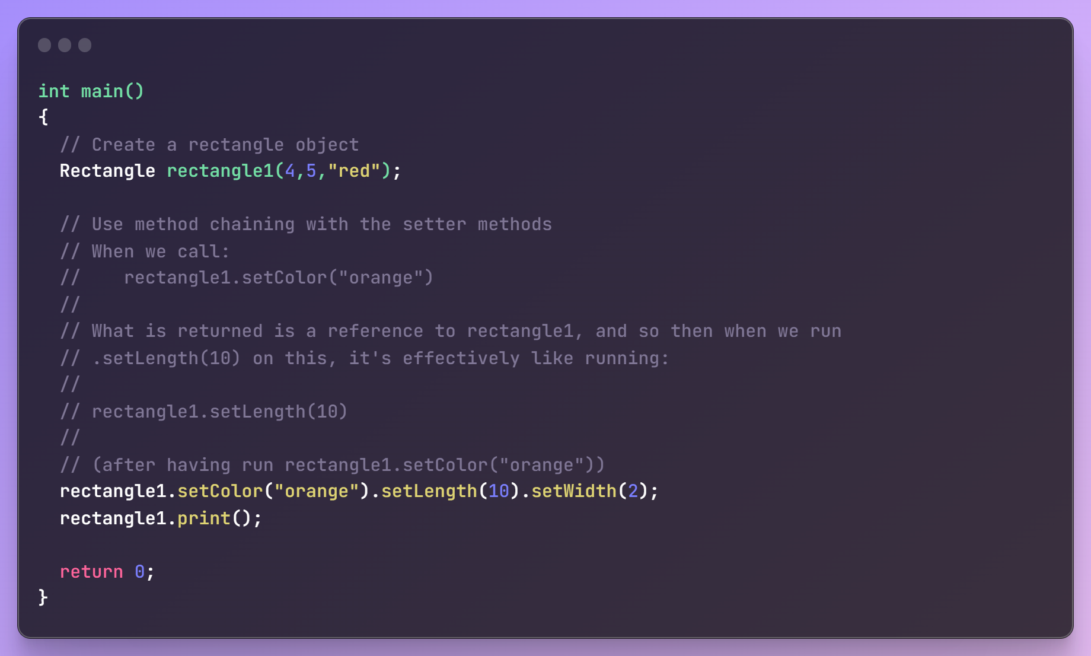

This is how we can make use of method chaining. This is just a way to reduce code and avoid object calling frequently. **We cannot use it is the method is not returning the reference to the object.**

* **Typedef <DT> <alias>**
* **Modern Constructor:**

class MyClass {

public:

MyClass(int param1, double param2) : member1(param1), member2(param2) {

// Constructor body (if needed)

}

private:

int member1;

double member2;

};

* **Initializer list initialization:** All relevant STL containers have been accepted to use initializer list initialization. Apart from this can also be used to initialize public members of a class/struct. If we want to initialize private members from this kind of initialization, we can define our own contructor like this: __init__(const initializer_list<DT> v){ … } //can access elements of initializer_list via iterator.
* **Constructor Preference:** Initializer_list > Normal Constructor > Aggregate initialization.
* **Initializer List initialization mimics python like initialization.**
* Use of for each loop with refefrence argument
* **Use of auto**
* **NULL can be replaced with nullptr (**dedicated to represent pointers**).**
* **enum class**
* **override and final keyword:** In C++11, overide keyword is written when a virtual function is overriden in the child class. Final keywork on the class or the function showcases this class cannot have child or this function cannot be overriden.

**Class class_name final{ } / virtual void break() final{ }**

* **Constructor Delegation:** What if you want to call a constructor inside another constructor of same class.

**Class A { A(); A(int x){ A(); …. } } //This will give an error. To do this we can do like the folowing:**

**Class A { A(); A(int x):A(){ …. } } //Note A() will be called first, before A(int)**

* **delete keyword use for constructor, operator or polymorphic function.**
* **Computation of function in compile time using “constexpr” before function declaration/def.**

**Function Pointers:**

Function pointers in C++ are pointers that point to functions instead of data. They allow you to store the address of a function and call that function indirectly through the pointer. Function pointers can be useful in scenarios where you want to pass functions as arguments to other functions, store functions in data structures, or dynamically select which function to call based on certain conditions. Here is the example to create a function pointer and assign it to a function address.

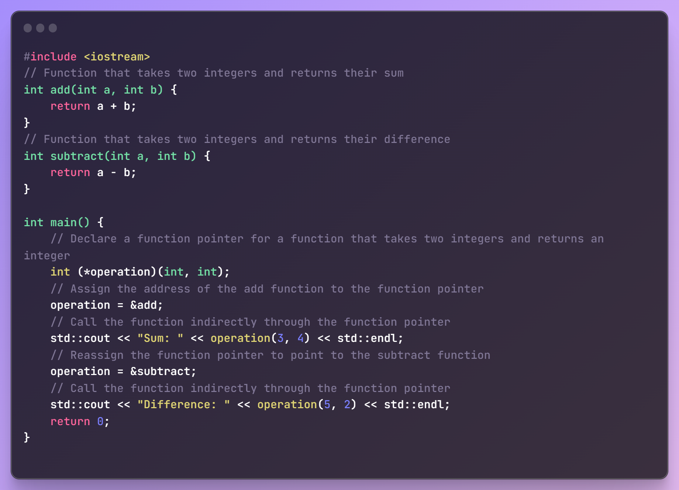

**Functors:**

**Lambda function:** Used for functional programming. Contructs a closure to a function: an unnamed function object which is capable of capturing variables in scope. **Basic syntax:**

**[](<parameters>) { }**

**auto f = [](<parameters>){ }; f(<parameters>);**

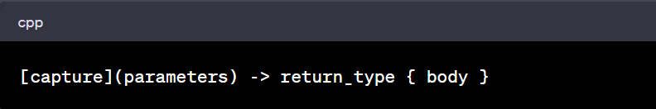

Few simple examples to use lambda functions on algorithm header library functions**:**

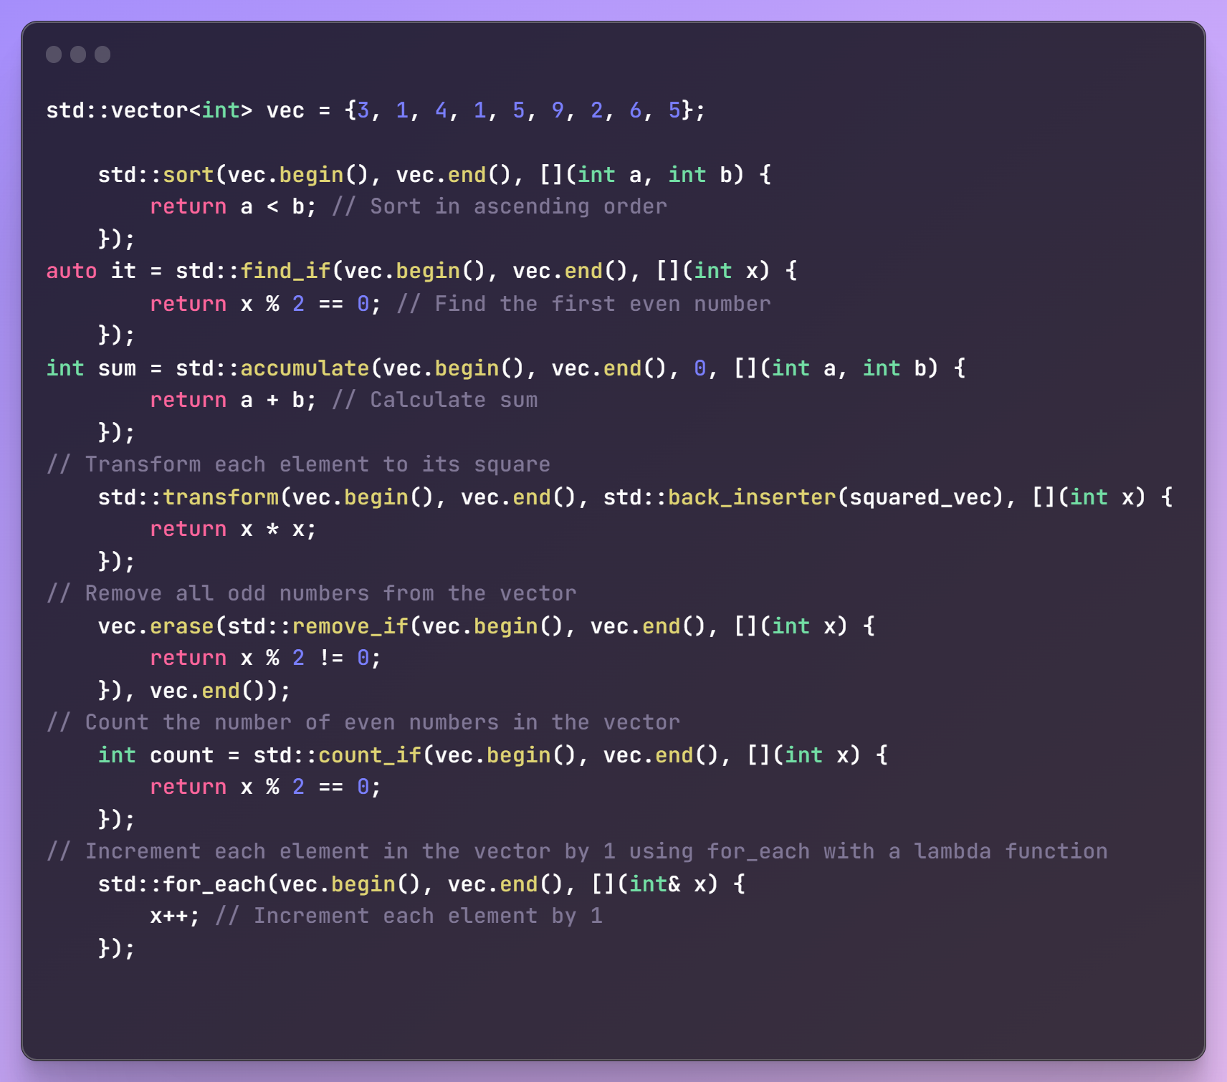

Herer the basic syntax can be either of these 3:

1. Ret_type func(){}

Lib_function(left, right, func_ref);

1. Lib_function(left, right, [](){ ….. });
2. Auto func = [](){…..};

Lib_function(left, right, func)

**Trailing return type:** Adding trailing return types to lambda functions can improve code readability and provide clarity about the return type. They can be useful in situations where the return type cannot be deduced automatically or when you want to provide clarity about the return type to readers of your code. When a lambda is assigned to a variable with auto type, the type of the variable will be deduced from the lambda itself, including its return type. If you specify a trailing return type in the lambda, that type will be taken in the type deduction process. If no trailing return type is specified, the compiler will deduce the return type based on the lambda body.

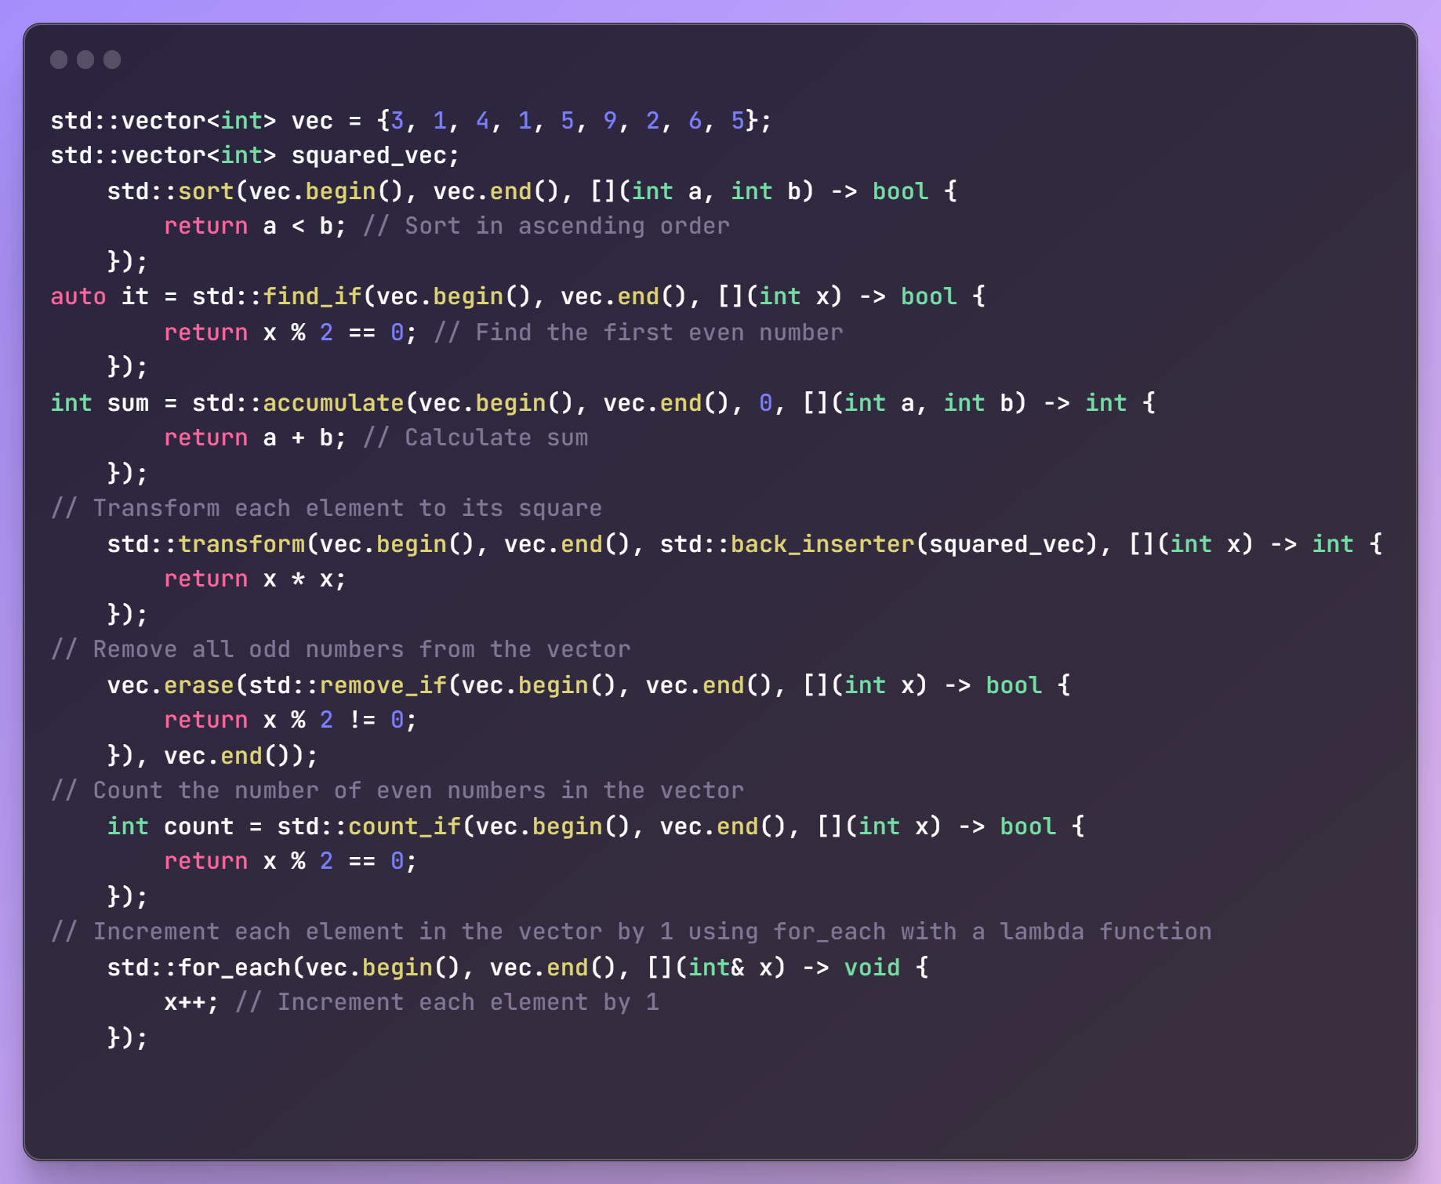

**NOTE:** The variable holding the lambda function is deduced to either a function pointer or std::function<lambda_ret_type()> (which are the same thing). Hence, the given code snippet:

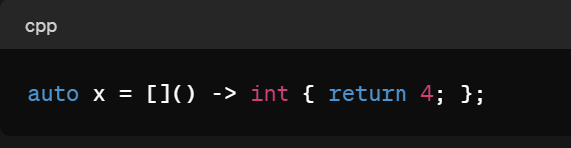

The auto keyword is used to allow the compiler to automatically deduce the type of the variable x based on the lambda expression on the right-hand side. However, if you want to explicitly specify the type of x, you can replace auto with std::function<int()> or a function pointer type. Hence it can be written as:

 OR

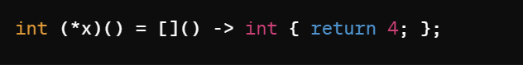

**Capturing in Lambda functions:**

In C++, a lambda function can capture variables from the surrounding scope, allowing it to access and use those variables within its body. This process is known as "capture". Lambda capture provides a onvenient way to work with external variables within the lambda expression, allowing you to use them as if they were local variables. There are two ways to capture variables in a lambda function:

1. By Value: Copies the variable into the lambda. Any changes made to the variable inside the lambda do not affect the original variable in the outer scope.
2. By Reference: References the variable in the lambda. Any changes made to the variable inside the lambda will affect the original variable in the outer scope.

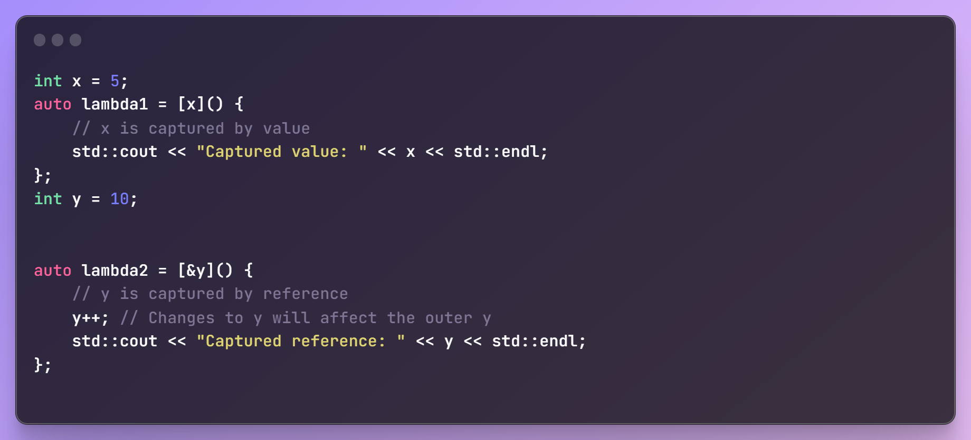

Additionally, you can specify which variables to capture and how to capture them within the lambda's capture list, which is enclosed in square brackets [ ].

[]: No variables are captured.

[x]: x is captured by value.

[&x]: x is captured by reference.

[=]: All variables from the enclosing scope are captured by value.

[&]: All variables from the enclosing scope are captured by reference.

[x, &y]: x is captured by value, and y is captured by reference.

**If you want to enforce mutation on values passed by value/copying, use mutable keyword. This will specify that all the parameters passed in the capture list can be mutated.**

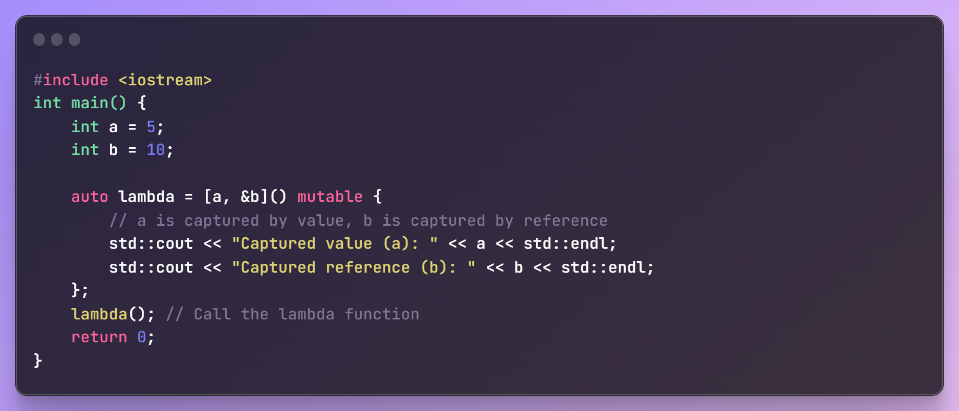

**What is [this] capture?** In C++, [this] is a lambda capture that captures the this pointer of the enclosing class. This allows the lambda function to access member variables and member functions of the enclosing class within its body.

Consider a scenario where you have a lambda function defined within a member function of a class. In this case, if you want the lambda to access member variables or member functions of the class, you can capture the this pointer using [this]. This enables the lambda to have access to the entire state of the enclosing object. Here's an example to illustrate the usage of [this] capture in a lambda function:

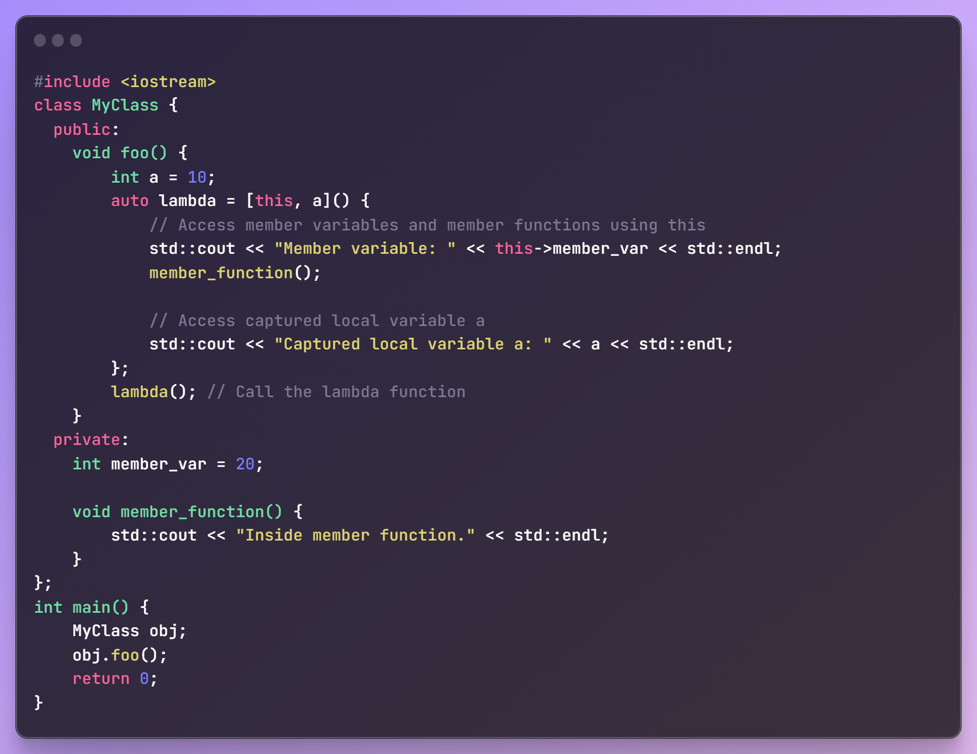

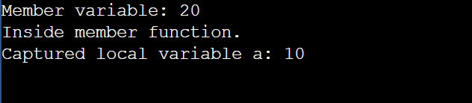

NOTE: Use <https://cppinsights.io/> to generate intermediary code. This will make you understand what actually happens when you use concepts like co-routines, lambdas, vraidic templates.

**Pointer Confusion:**

|  |  |  |
| --- | --- | --- |
| **Declaration** | **Can change value** | **Can change pointer** |
| Int | Yes | N/A |
| const int | No | N/A |
| int* | Yes | Yes |
| const int* (pointer to const int) | No | Yes |
| int* const (const pointer to int) | Yes | No |
| const int* const (const pointer to const int) | No | No |

**Fuction callbacks:** Used for functional programming

**Template Programming (Generics)**

**Exception handling**

Try Catch flow

Structure Member alignment (32bit system)

Dangling pointer

Free Store vs Heap

Pragma once

Preprocessors

**Runtime type identification:**

The typeid operator in C++ allows you to obtain the type information of an expression or a variable at runtime. It returns a **std::type_info** object, which contains information about the type. In this example, typeid(x) returns the std::type_info object representing the type of variable x. The name() member function of std::type_info is used to obtain a human-readable string representing the type name.

**Type Identification:** The std::type_info object returned by typeid contains information about the type, including its name. The name() member function of std::type_info returns a const char* representing the name of the type. Note that the exact format of this string is implementation-defined and may not be human-readable or consistent across compilers.

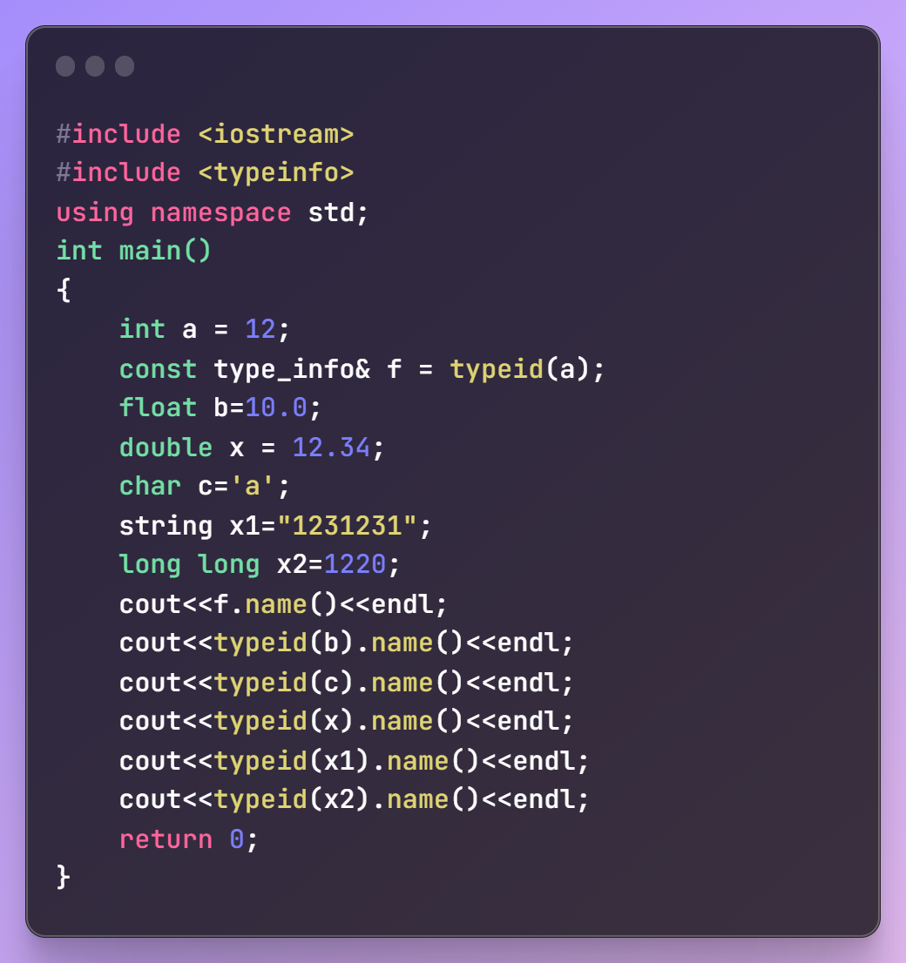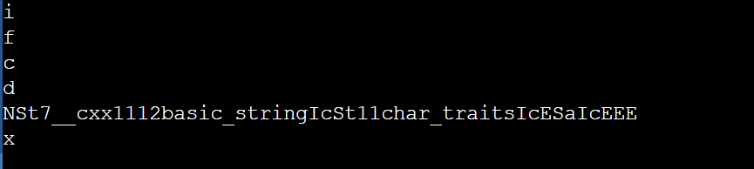

Limitations: The use of typeid is limited to runtime type information. It cannot be used to obtain type information about template parameters or non-polymorphic types. Plus, comparing type names using name() might not always be reliable due to differences in name mangling across compilers and platforms.

**Aliasing:**

* 1. Typedef
  2. Using keyword in function body as typedef.
  3. Templated Aliasing

**Std::algorithm (SORTING):**

What is the difference between

sort(v.begin(), v.end(), [](pair<int,int>& a, pair<int,int>& b){ return a.first<b.first; });

And

sort(v.begin(), v.end(), [](pair<int,int>& a, pair<int,int>& b){ return a.first<=b.first; });

The difference between using < and <= in the std::sort comparator can lead to subtle bugs or unexpected behavior if not understood correctly.

You're sorting a vector of pair<int, int> using a lambda comparator.

1. Using <

sort(v.begin(), v.end(), [](pair<int,int>& a, pair<int,int>& b){

return a.first < b.first;

});

✅ This is correct and recommended. It satisfies the requirement of strict weak ordering, which std::sort expects.

* It returns true if a should come before b.
* If a.first == b.first, it returns false, meaning their order won't be swapped (it's okay to be equal).
* The sort remains stable in terms of logical consistency (though std::sort itself is not stable).

2. Using <=

sort(v.begin(), v.end(), [](pair<int,int>& a, pair<int,int>& b){

return a.first <= b.first;

});

⚠️ This is not valid as a comparator for std::sort. Why?

* It violates strict weak ordering. That is, you could get comp(a, b) == true and comp(b, a) == true when a.first == b.first, which breaks the contract std::sort relies on.
* This can lead to undefined behavior or inefficient sorting

🔍 Example:

pair<int, int> a = {5, 1};  
pair<int, int> b = {5, 2};

comp(a, b) = true (because 5 <= 5)   
comp(b, a) = true (again, 5 <= 5)

Invalid: both can't be "less than" the other

✅ Conclusion:

Always use < (or > if you want descending order).  
Never use <= or >= in a std::sort comparator.

**A stable sort is a sorting algorithm that preserves the relative order of equal elements.**

**🔧 When to Use Stable Sort?**

Use std::stable_sort when:

* You care about the original order of elements with equal keys.
* You're doing multi-level sorting (e.g., sort by age, then by name).

Performance**:**

* std::sort → faster, O(n log n), usually uses introsort (quick + heap + insertion sort).
* std::stable_sort → slightly slower, O(n log² n) worst-case (uses merge sort under the hood).

**Misconception:**sort(v.begin(), v.end(), [](pair<int,int>& a, pair<int,int>& b){ return a.first<=b.first; });

**Whatt I understand is that 2 elements a and b should swap if this lambda returns false. Since it is comparing using <=, is it not stable sort?**

**❓ Does a.first <= b.first make std::sort stable?  
❌ No, because:**

* **std::sort is not a stable sorting algorithm, regardless of what comparator you give it.**
* **Using <= does not make it stable — in fact, it breaks the comparator contract expected by std::sort.**

**🔧 Why is <= a bad comparator for std::sort?**

std::sort requires the comparator to impose a **strict weak ordering**.

[](pair<int,int>& a, pair<int,int>& b){

return a.first <= b.first;

}

This is **not a strict comparison** because it may return true for both comp(a, b) and comp(b, a) when a.first == b.first, which breaks assumptions in the sorting algorithm.If the comparator doesn't meet the requirement, std::sort may behave unpredictably — it doesn't know how to compare "equal" items properly in such a case.

| **Comparator** | **Valid for std::sort?** | **Stable?** |
| --- | --- | --- |
| a.first < b.first | ✅ Yes | ❌ No |
| a.first <= b.first | ❌ No (invalid) | ❌ No |
| a.first < b.first with std::stable_sort | ✅ Yes | ✅ Yes |

So the **sort is only stable if the algorithm is stable**, not because the comparator looks "non-strict" like using <=.

**✅ 1. What algorithm does std::stable_sort use?**

In most implementations (like GCC and Clang), std::stable_sort is implemented using a **modified merge sort**.

However, unlike the basic textbook merge sort:

* It tries to **minimize memory usage** by doing **in-place merging** when possible.
* It doesn't always allocate O(n) extra space — it tries to be efficient.
* But in doing so, **the merge operation becomes more complex**.

**Sorting Algorithms:**

* Standard Merge sort:

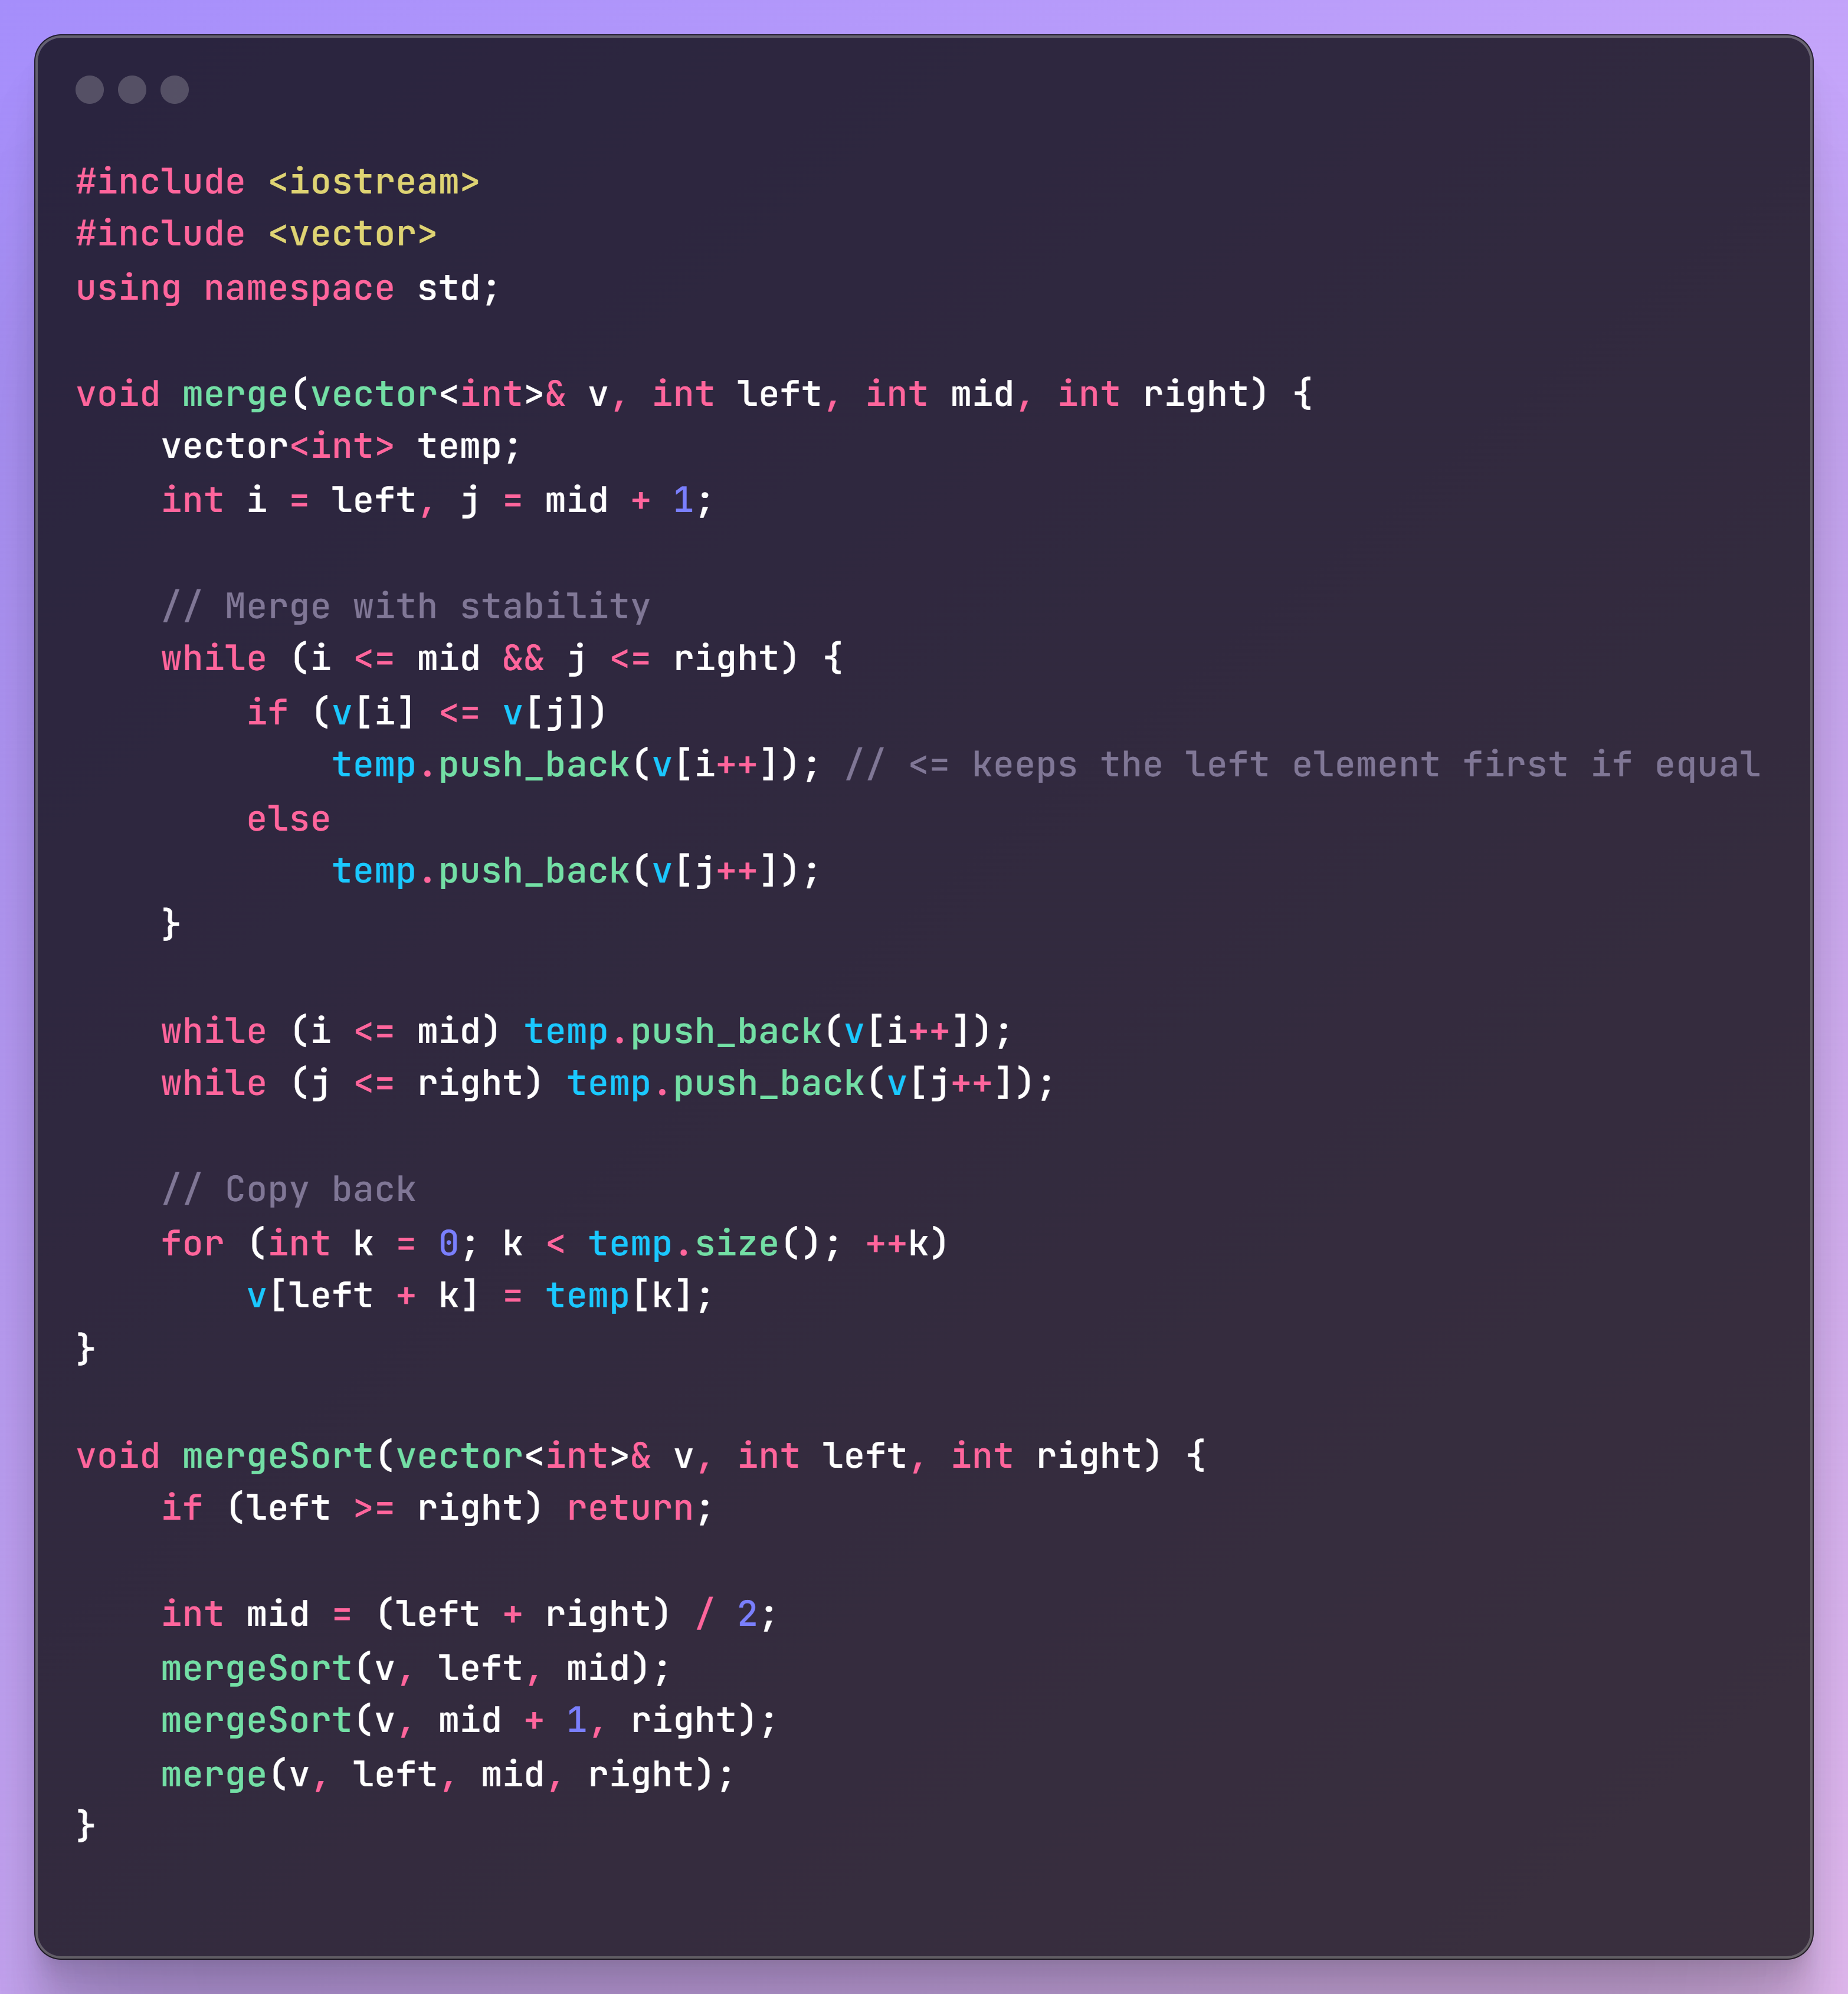

* Stable merge sort

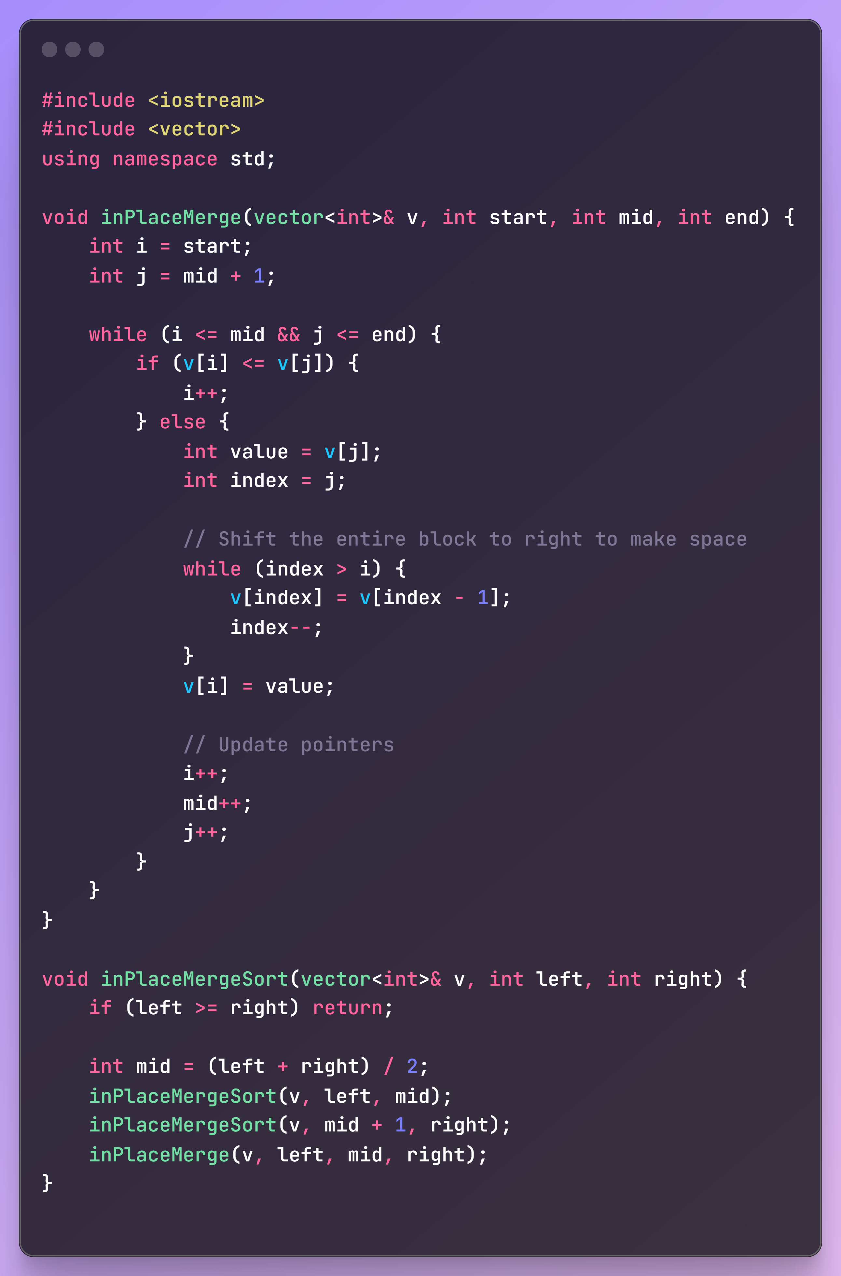

**Operator precedence and Associativity**

**Casting**

**Memory allocation is slow**

**Branch predictor**

**Instruction cache and**

**Enums over Branching**

Avoiding Branching: ternary operator and Enums

**Static Member function:** A function that is used to manipulate or access static member variable. This function cannot acceess non-static member variables. (Globals allowed). Also static member functions can be defined outside the class like:

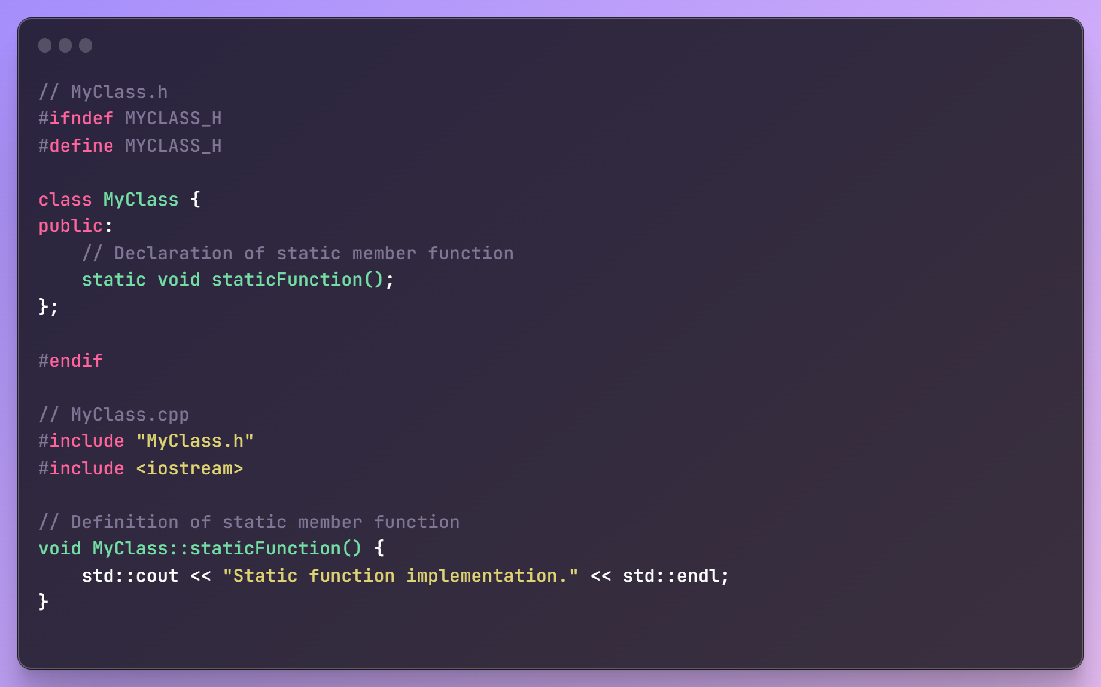

It should be ideally called with class name. For example: **Square::static_function(<args>). Also a private static member function cannot be called outside of the class. In order to be accessed outside of the class, static member function should be defined under “public” access specifier.**

**C++11 features**

1. **All types of initializations.**
2. **Magic Macros:** Predefined macros in c++ that takes up the value from the environment during runtime.

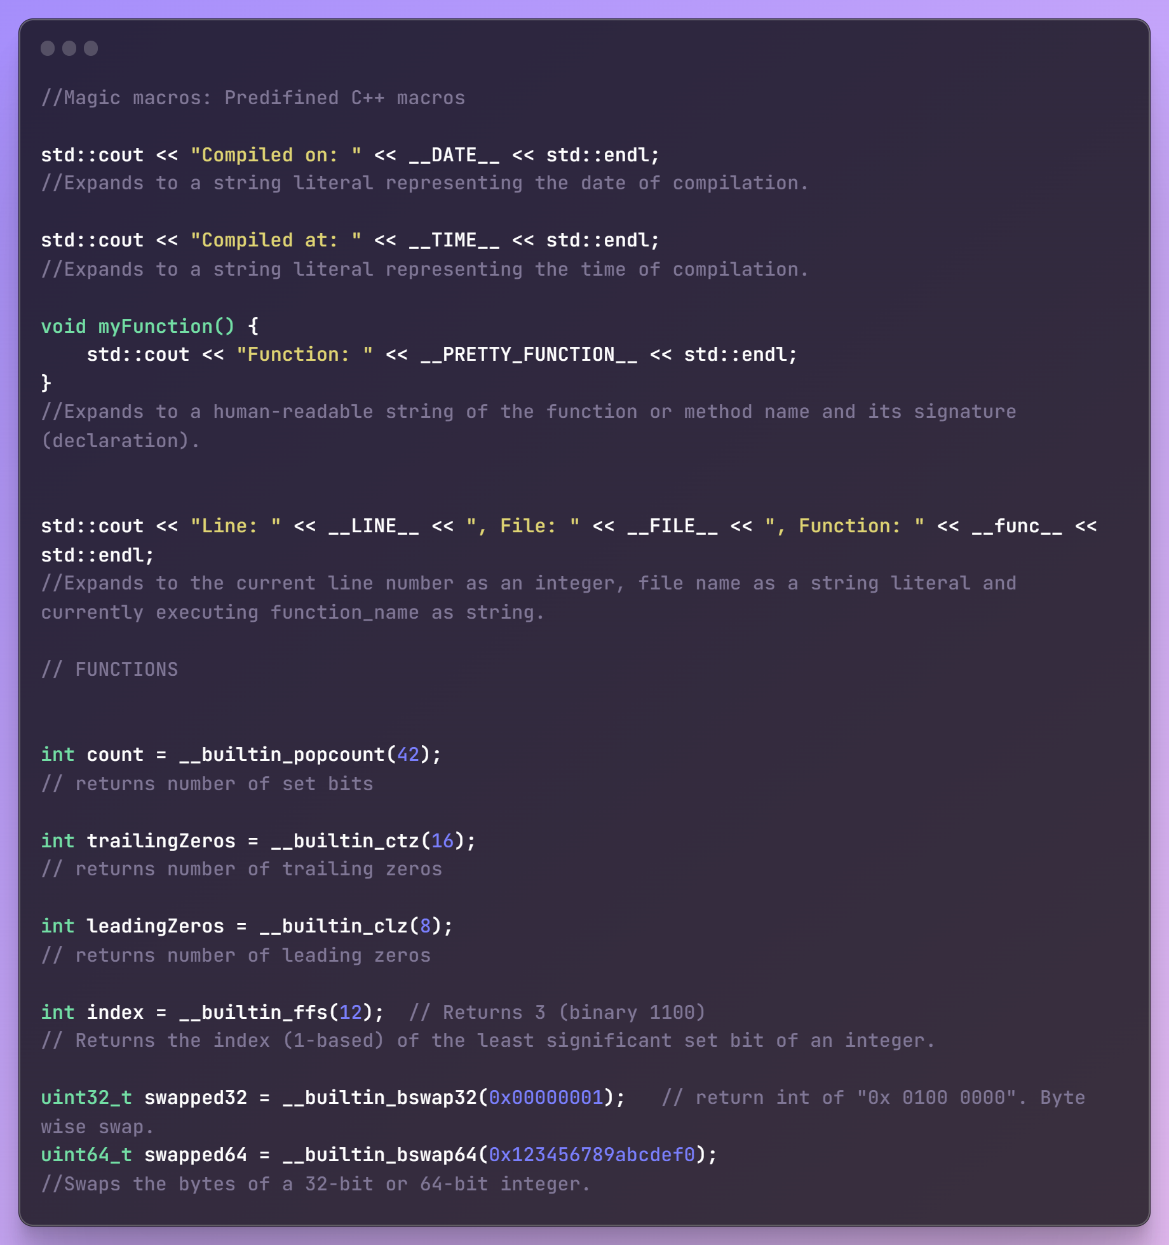

1. **Lambda function return type deduction**
2. **functors**

**C++ 14 features**

1. **Variable template (templated variable)**
2. **Constexpr (relaxed version)**
3. **Variadic arguments and variadic template arguments.**
4. **Trailing return type vs normal return type.**
5. **Smart pointers**
6. **Make_unique()**
7. **Move Semantics**
8. **Binary literals**
9. **Placeholder return type: Return type deduction.**

**C++17 Features:**

1. **Class Template argument deduction (CTAD)**
2. **Destructuring (Binding)**
3. **Std::Future and std::Async**
4. **Parallel Execution**
5. **File System (header file)**

**C++ 20 features:**

1. **Coroutines:**

A coroutine is a function that can suspend execution to be resumed later. Coroutines are stackless: they suspend execution by returning to the caller and the data that is required to resume execution is stored separately from the call-stack.

In the context of C++20 coroutines, the term "stackless" refers to a specific type of coroutine implementation that doesn't rely on the regular call stack to manage its state. Traditional functions use the call stack to store local variables, function call information, and manage the flow of execution. In contrast, stackless coroutines have their own separate stack, often implemented as a heap-allocated structure, to manage their state.

NOTE: Coroutines cannot use variadic arguments, plain return statements, or placeholder return types (auto or Concept).

A function is a coroutine if its definition contains any of the following:

1. **co_await** expression — to suspend execution until resumed
2. **co_yield** expression — to suspend execution returning a value
3. **co_return** statement — to complete execution returning a value

**Coroutine structure:**

Each coroutine is associated with:

1. the promise object, manipulated from inside the coroutine. The coroutine submits its result or exception through this object.
2. the coroutine handle, manipulated from outside the coroutine. This is a non-owning handle used to resume execution of the coroutine or to destroy the coroutine frame.
3. the coroutine state, which is internal, dynamically-allocated storage containing:
   1. the promise object
   2. the parameters (all copied by value)
   3. some representation of the current suspension point, so that a resume knows where to continue, and a destroy knows what local variables were in scope
   4. local variables and temporaries whose lifetime spans the current suspension point.

**Flow:**

When a coroutine begins execution, it performs the following:

1. allocates the coroutine state object using operator **new**.
2. copies all function parameters to the coroutine state: by-value parameters are moved or copied, **by-reference parameters remain references** (thus, may become dangling).
3. calls the constructor for the promise object. If the promise type has a constructor that takes all coroutine parameters, that constructor is called, with post-copy coroutine arguments. Otherwise the default constructor is called.
4. calls promise.get_return_object() and keeps the result in a local variable. The result of that call will be returned to the caller when the coroutine first suspends. Any exceptions thrown up to and including this step propagate back to the caller, not placed in the promise.
5. calls promise.initial_suspend() and co_awaits its result. **Typical Promise types either return a std::suspend_always, for lazily-started coroutines, or std::suspend_never, for eagerly-started coroutines.**
6. when co_await promise.initial_suspend() resumes, starts executing the body of the coroutine.

Our coroutine returns a handle object. This Handle class/struct (“resumable” here) has a promise_type struct (nested class/struct) and this is what it looks like:

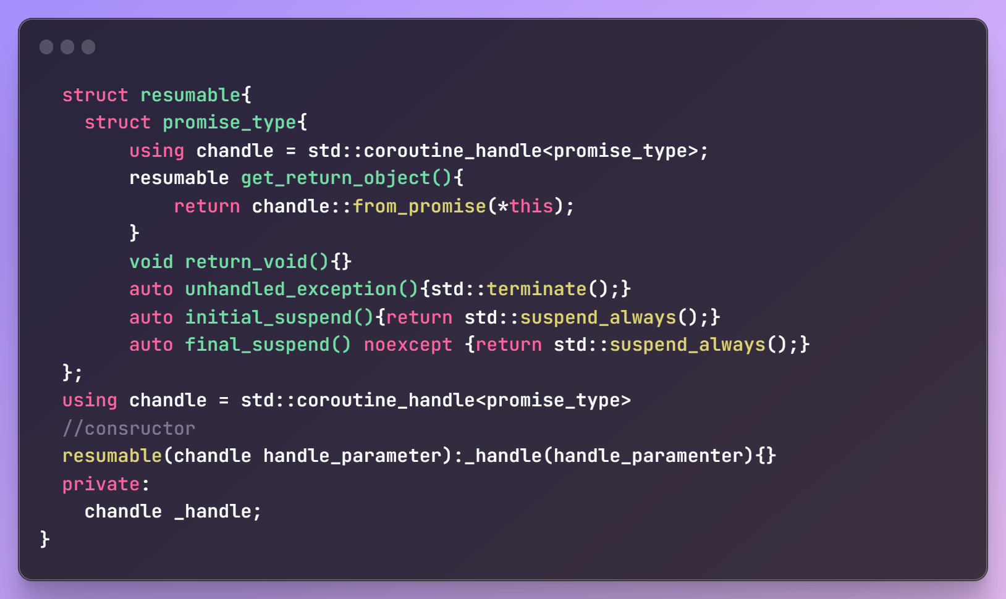

Note that since initial_suspend() function is called everytime we instantiate a coroutine handle, this function will tell if we want the coroutine to pause its execution and use *handle.resume()* from the caller to start coroutine manually {**using return std::suspend_always()**} or start coroutine execution as we instantiate the handle in the caller {**using return std::suspend_never()**}.

**Restrictions on Coroutines:**

Cannot create coroutine in/if:

1. Coroutine cannot use variadic arguments
2. Cannot use constexpr/ condt. constexpr or consteval
3. Cannot have auto/decltype(auto) return type. **But auto with a trailing return type is valid.**
4. Main function cannot be a coroutine.
5. Constructors and destructors cannot be coroutine.
6. Cannot have plain “return” statements.

Allowed rules:

1. Can be a free standing subroutine.
2. A member function of a class
3. Virtual function. Needs to be derived and override in the child class.
4. Lambda function.
5. Static coroutine. (Member function or stand alone)

Lazily and eagerly started coroutine

The coroutine handle has 3 template specializations: void, promise_type and std::noop_coroutine_promise. Lets first focus only on void and promise_type speciaizations. **Rest we will do later.**

Then our overall handle, coroutine and caller will look like:

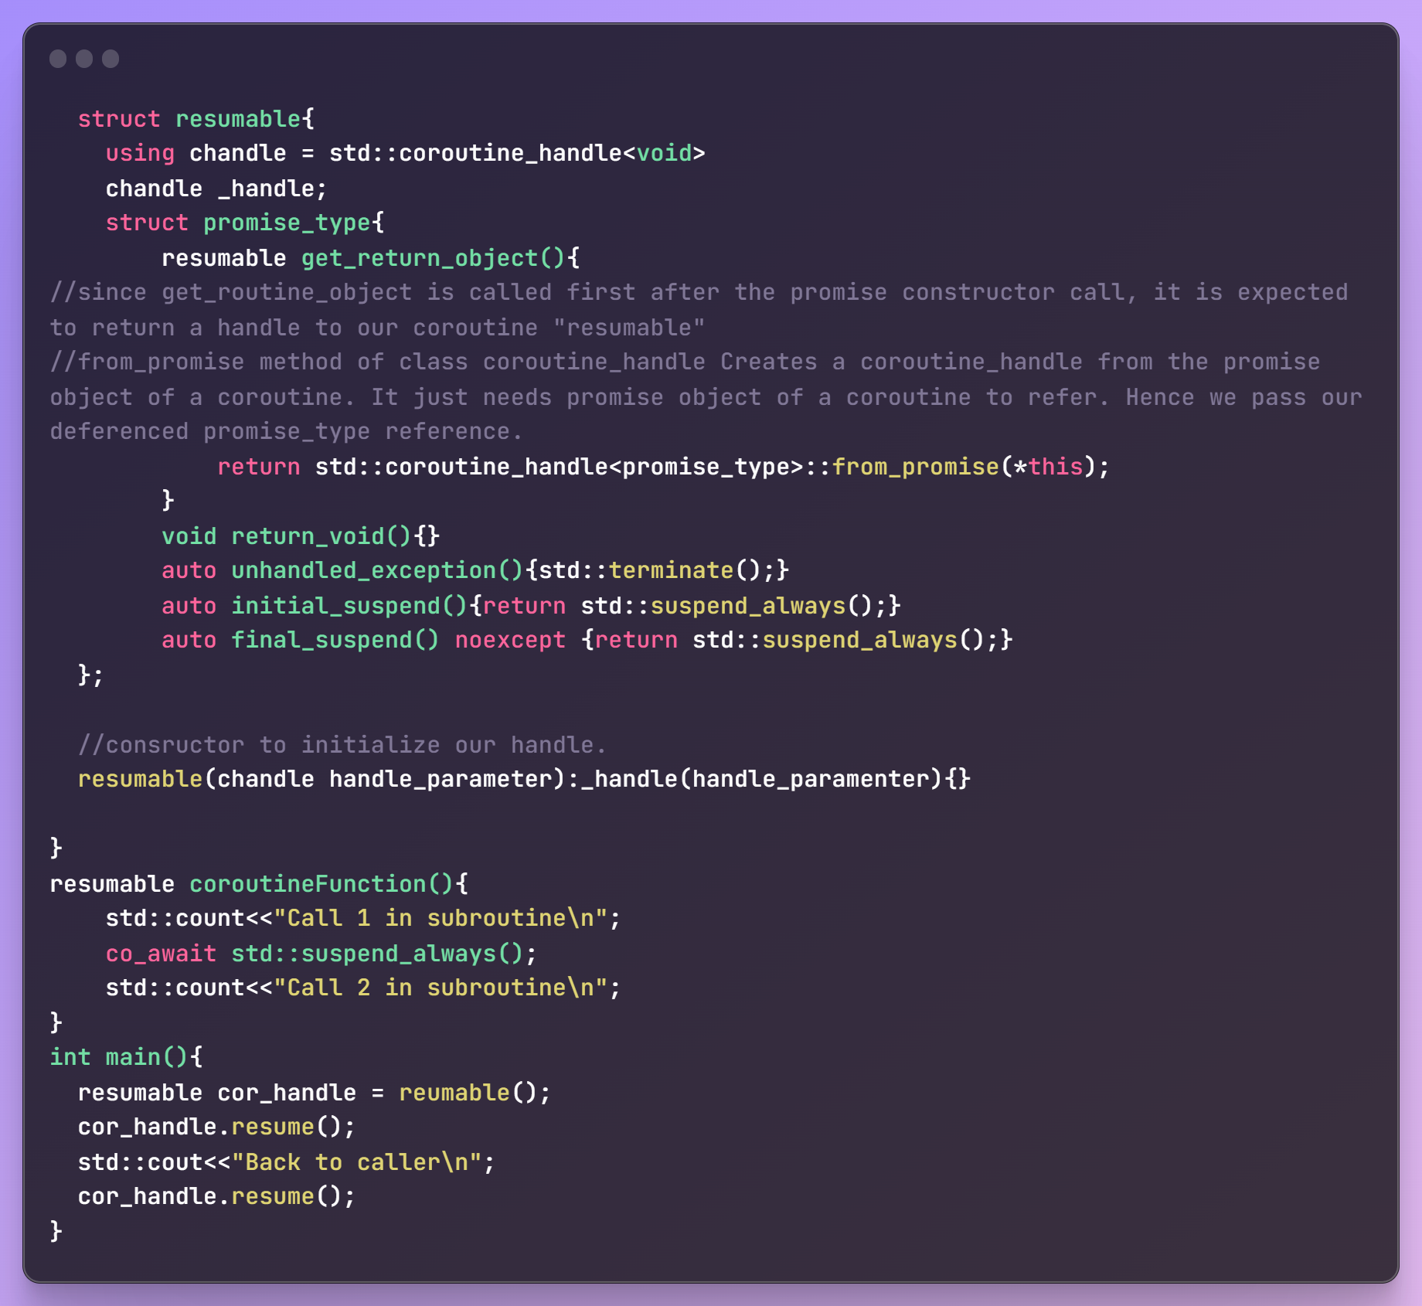

**Coroutines with co_yield:** How to get the processed value/values post coroutine completion.  
For this we need to setup the desired variable (initialize) it in the promise struct/class and use a yield_value method (with return type set as auto) assign our calculated value to the setup variable. This value can later be accessed by the coroutine caller function by a custom getter method which can access promise object’s class member via the coroutine handle. NOTE that the handle template type must not be void now. It can be promise_type or std::noop_coroutine_promise.

Coroutine handle has a promise() method which return refernce to our promise object.

Here a sample code to see **how coroutine work in presence of a co_yield statement.**

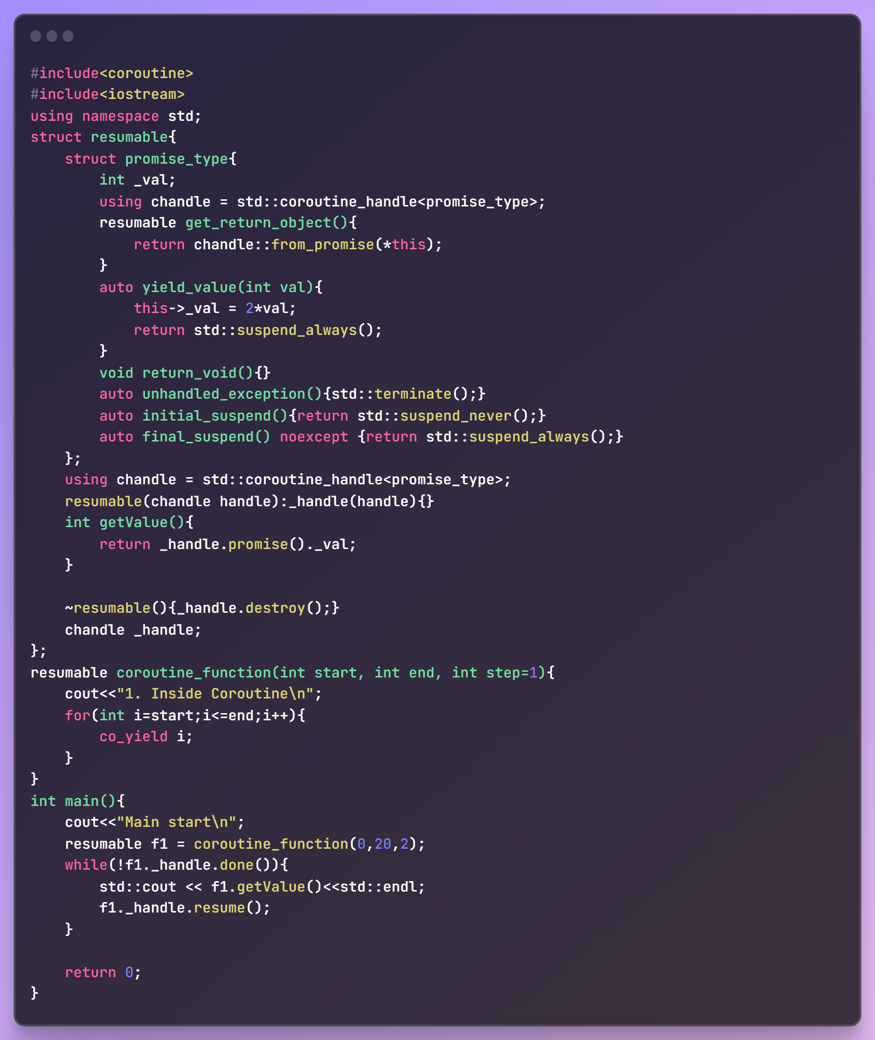

**A sample code to see how can caller access data member of a coroutine:** Using coroutine handle and it’ promise() function which return a reference to the promie object.

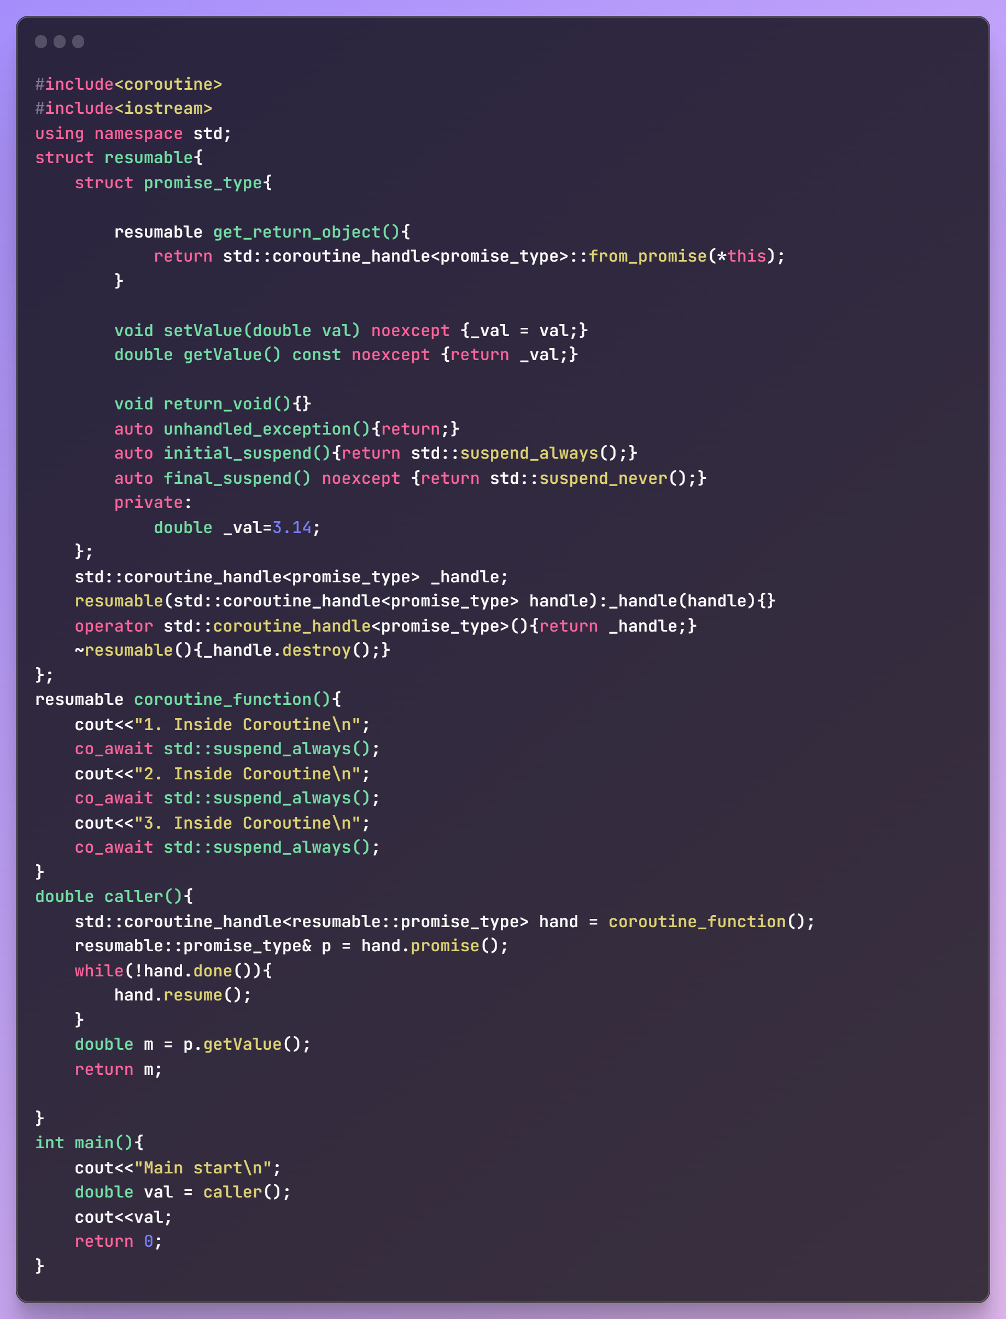

This will print the flow statements as expected but at the end it will output the value 3.14 which was captured in the caller.

**Coroutines with co_return statements. There can be of 2 type: Void returning coroutine and some value returning coroutine.**

* **Void returning** coroutine: requires you to implement a “return_void()” function in the promise type definition with a return type of void. Here’s an example:

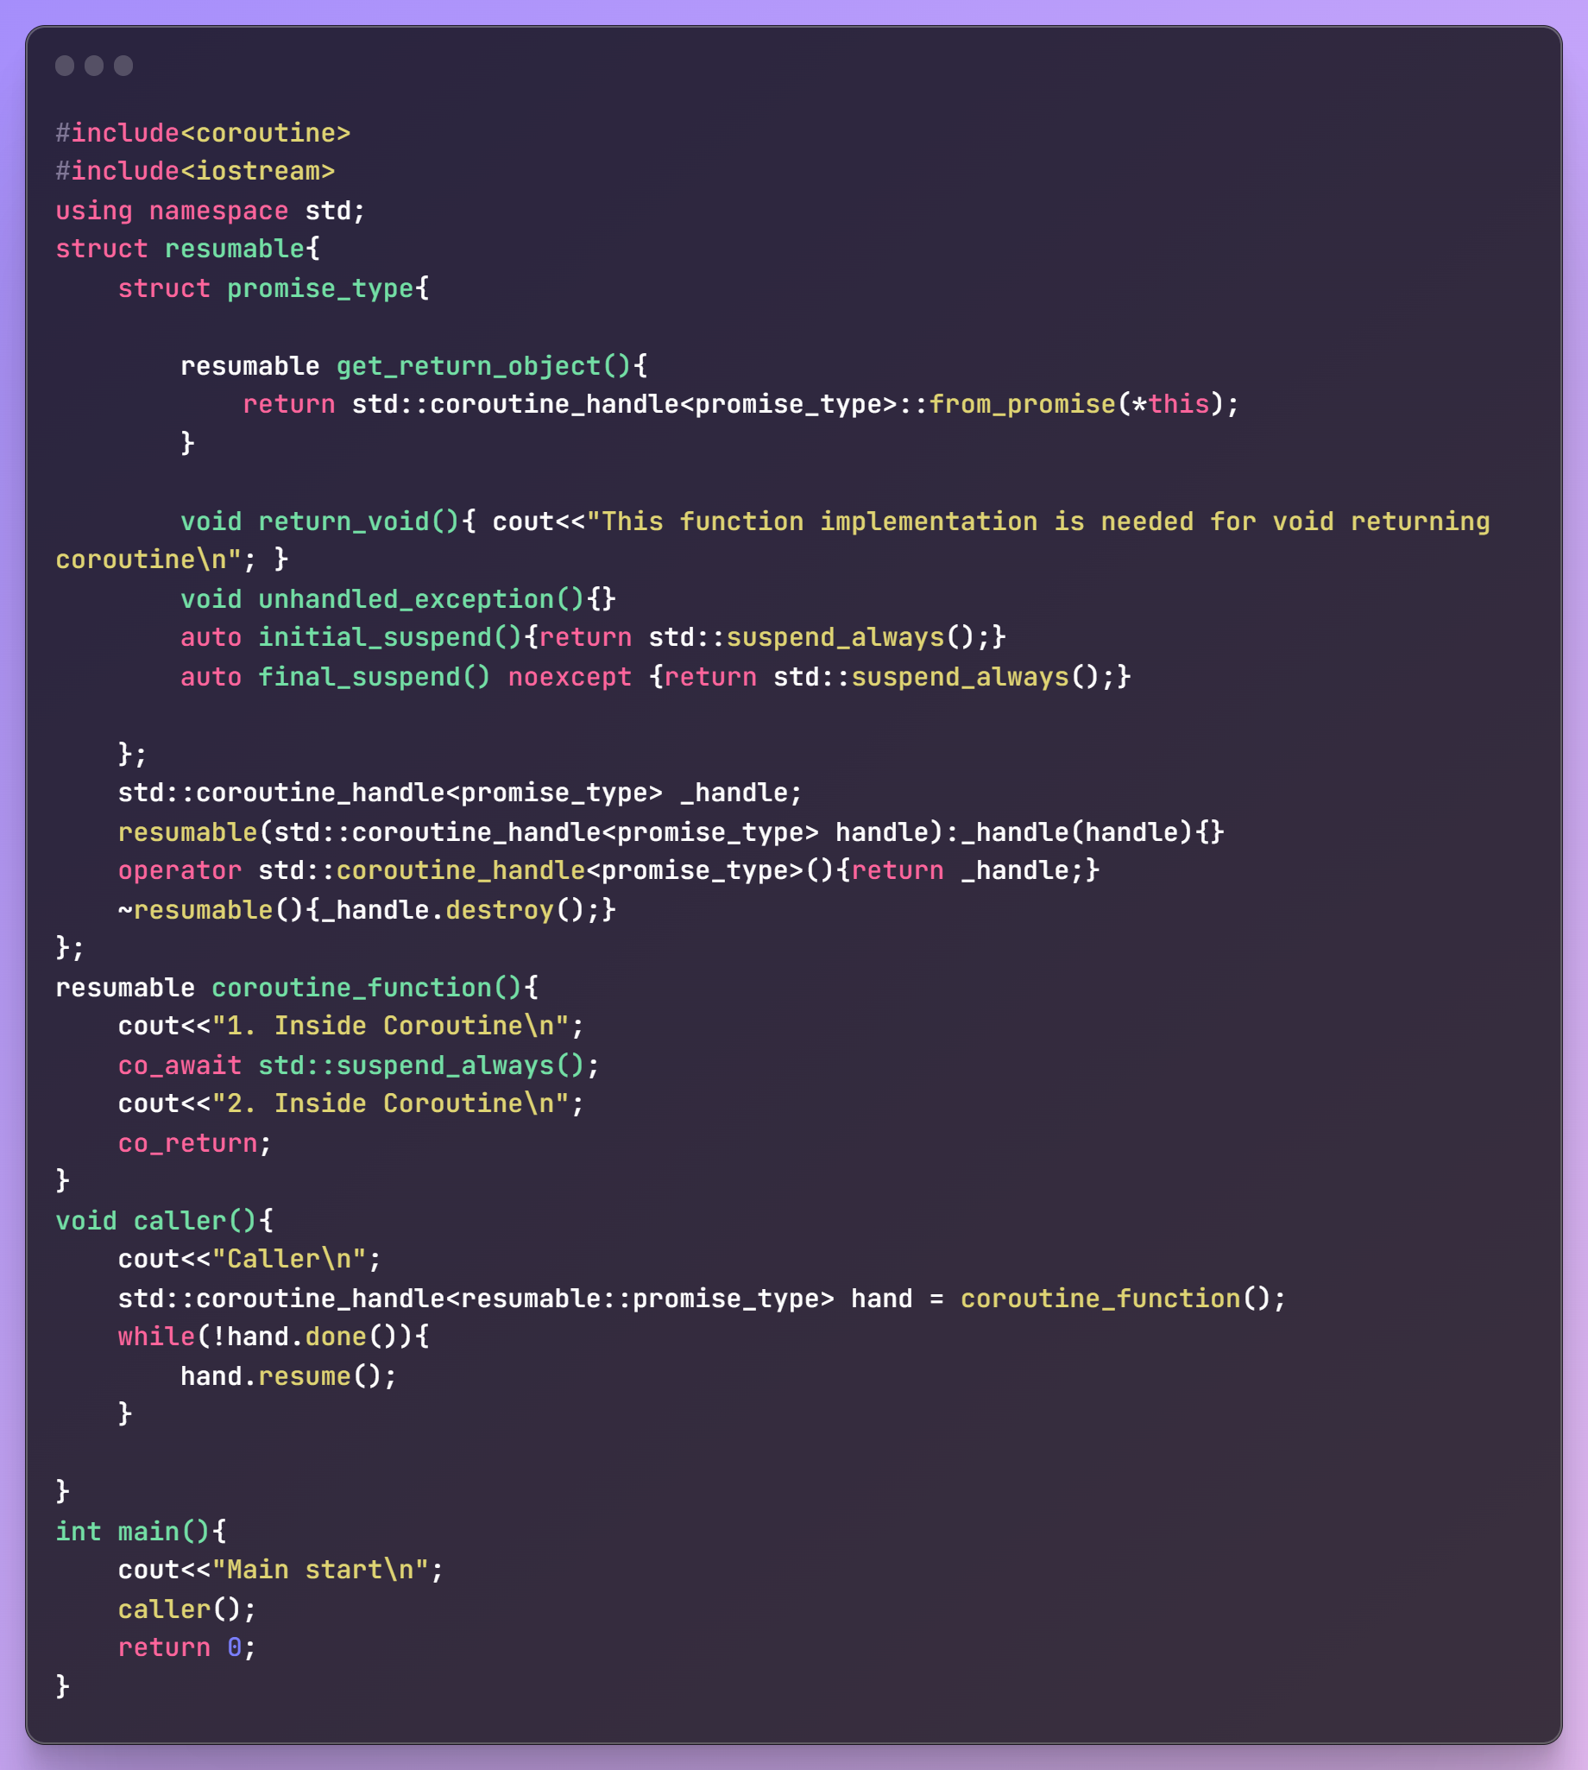

* **Value returning** coroutine: Analogus to some function returning a evaluated value. Requires you to implement a “return_value( ___ )” function in the promise_type struct.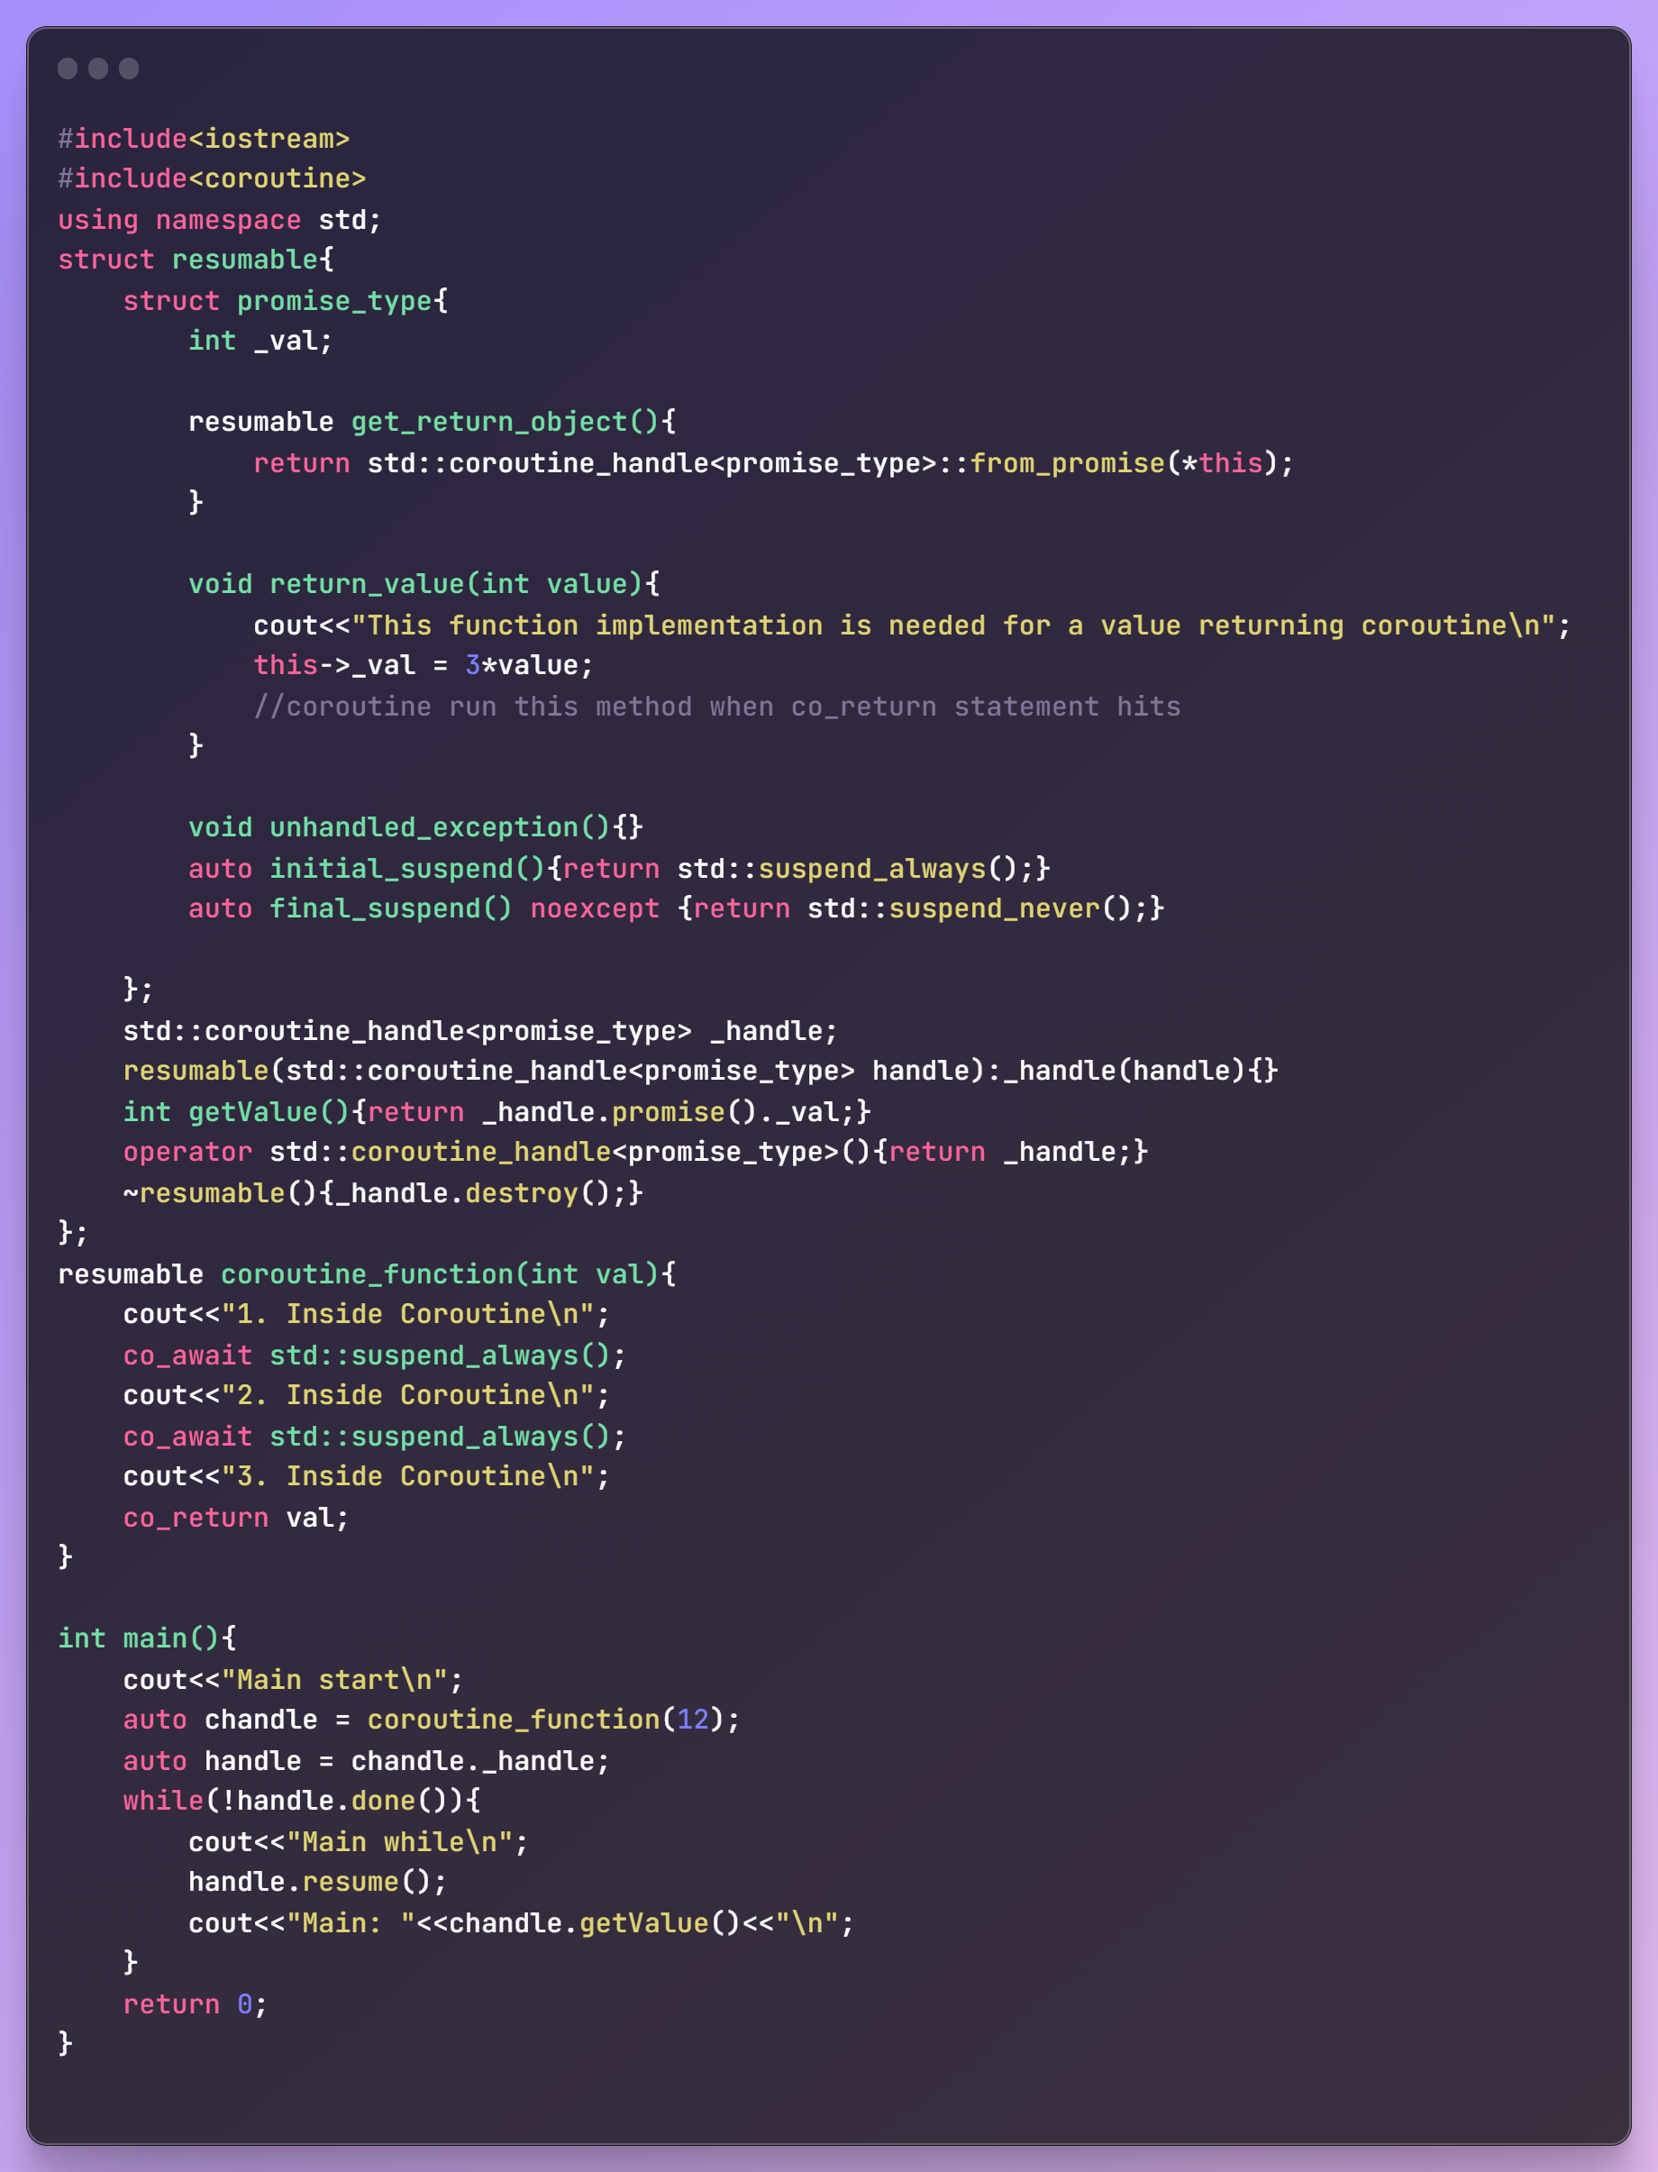

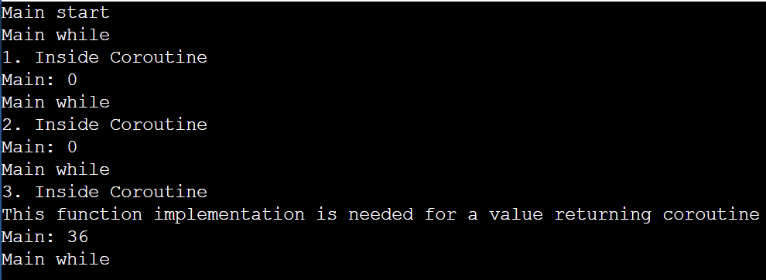

**Creating custom Awaiter/Awaitables:** Note that we have till now used std:: suspend_always() and std:: suspend_never(). But what are they?

suspend_always/ suspend_never is an empty class which can be used to indicate that an await expression always suspends/never suspend and does not produce a value.

suspend_always and suspend_never are two special types in C++20 coroutines that provide default behavior for the suspension of a coroutine. They are used in the initial_suspend and final_suspend functions within the promise type of a coroutine.

**Definition:**

**struct suspend_always {**

**constexpr bool await_ready() const noexcept { return false; }**

**constexpr void await_suspend(std::coroutine_handle<>) const noexcept {}**

**constexpr void await_resume() const noexcept {}**

**};**

**struct suspend_never {**

**constexpr bool await_ready() const noexcept { return true; }**

**constexpr void await_suspend(std::coroutine_handle<>) const noexcept {}**

**constexpr void await_resume() const noexcept {}**

**};**

**How They Work Internally**:

await_ready():

await_ready is called by the compiler to check whether the coroutine should be suspended immediately.

For suspend_always, it always returns false, indicating that the coroutine should be suspended.

For suspend_never, it always returns true, indicating that the coroutine should not be suspended.

When creating your own custom awaiter or awaitable type in C++20, you'll need to implement the await_ready, await_suspend, and await_resume functions. These functions define the behavior of your awaiter and how the associated coroutine interacts with it. Here's a brief overview of each function:

**await_ready:**

**Purpose**: Determines whether the coroutine should be suspended immediately or if it can continue its execution without suspension. This function is called by the compiler to decide whether to suspend the coroutine at the point of the co_await expression.

**await_suspend:**

**Purpose**: Specifies what should happen when the coroutine is about to be suspended.

Behavior:

If you want to perform some action when the coroutine is about to be suspended (e.g., interacting with an external resource), you would typically return a std::coroutine_handle representing the continuation.

If no additional action is needed, you can return void.

This function is called by the compiler when the coroutine is about to be suspended, and it can be used to customize suspension behavior.

**await_resume:**

Purpose: Specifies what should happen when the coroutine is resumed after suspension.

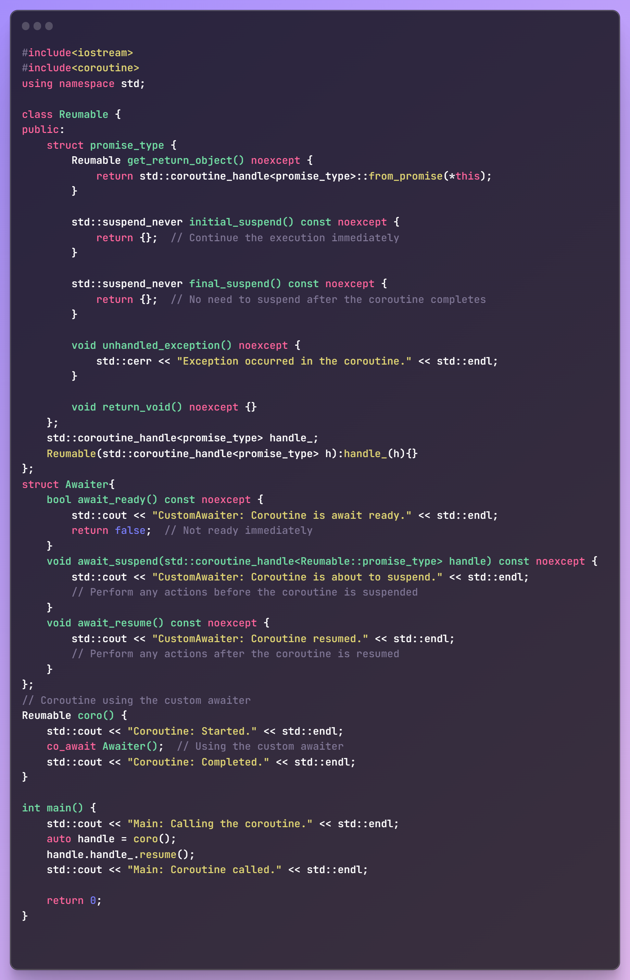

1. **Spans:**
2. **oprtional**
3. **Atomic References**
4. **Concepts**
5. **Ranges**
6. **Spaceship operator**
7. **Modules**
8. **Reflection**
9. **Expected**
10. **Varirant**

**C++ 23 Features**

**C++ to Assembly: godbolt.com**

**Template MetaProgramming:**

**HFT topics:**

* Const and const_cast<T>

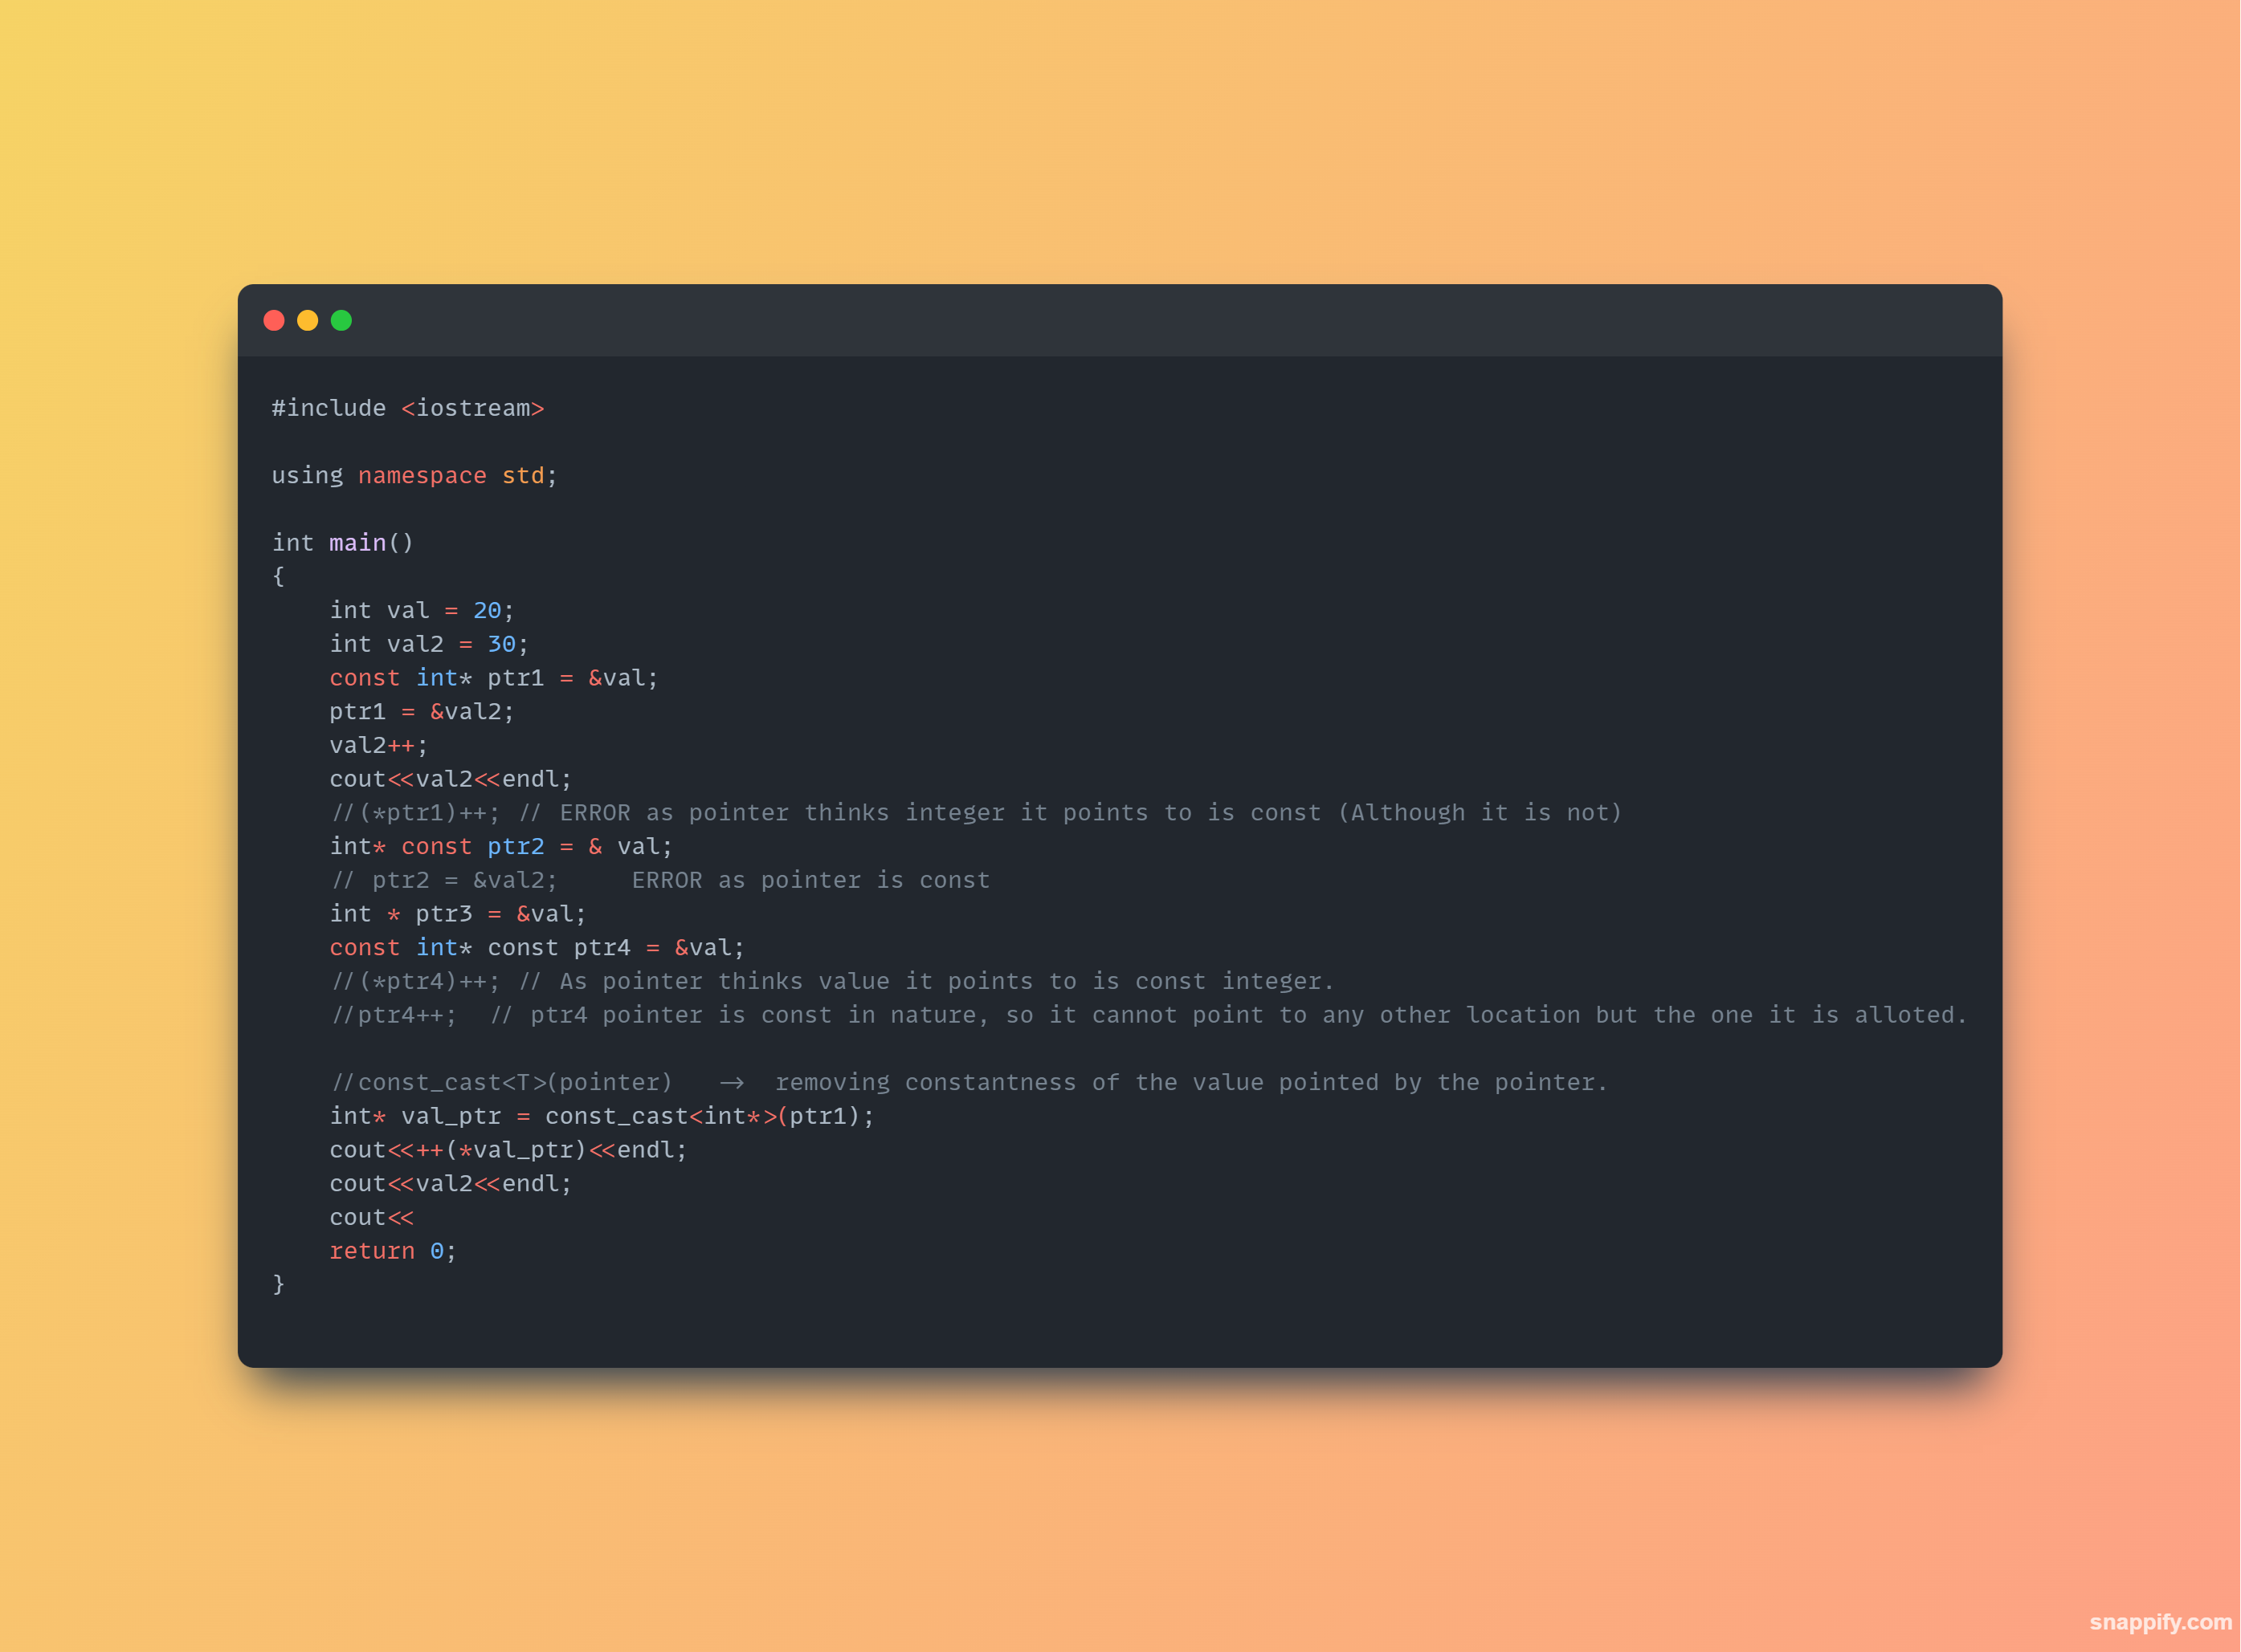

* **Difference between std::exit(), std::abort() and return() in c++:**
  + std::exit( status_flag_int ) and std::abort() are used to terminate the entire program. std::exit() allows you to specify an exit status code and performs memory cleanup (globals, allocated and statics), while std::abort() forcefully terminates the program without specifying an exit status code and without performing memory cleanup. The return statement is used to exit from a function and return a value to the caller, and when used in main(), it serves as a way to specify the program's exit status code to the OS (0 exit status code is considered to be a successful exit).
* **Custom terminate handler:** When a process encounters an unhandled exception, it will cause the program to terminate. But this will cause the program to abort abruptly. But if you want to handle somethings before exiting (in only abrubt termination case) we can have a custom terminate handler function which can be called like:

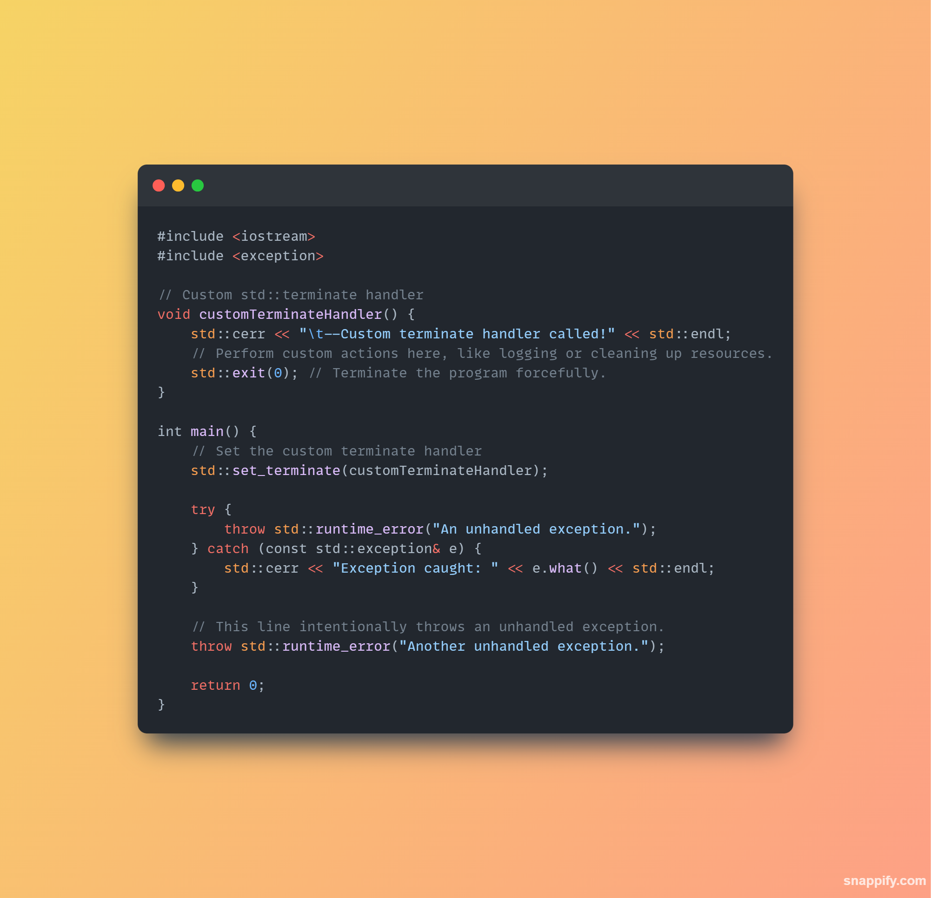

**C++11 Concurreny Notes:**

**Before c++11 standard, why was it difficult to support multi threading? How boost threading was utilized and why was compiler variability and platform dependency was a problem for c++ programmers?**Before the **C++11 standard**, supporting multithreading in C++ was **difficult and error-prone** due to the **lack of a standardized threading model** in the language. Here's a breakdown of why that was the case, how libraries like Boost helped, and what made compiler and platform dependencies problematic:

**🚫 Why C++ Before C++11 Had Poor Multithreading Support**

1. **No Standard Thread Library**
   * The C++ language had no built-in support for threads, mutexes, condition variables, or atomic operations.
   * Developers had to rely on **platform-specific APIs**, like:
     + pthread on POSIX systems OR CreateThread on Windows
   * This meant **non-portable** code—difficult to maintain and share.
2. **No Memory Model**
   * C++ lacked a formal **memory model** before C++11, so there were **no guarantees** about:
     + Visibility of memory changes across threads
     + Ordering of reads/writes
   * Compilers could make optimizations that **broke** multithreaded behavior.
3. **Manual Workarounds**
   * Writing portable and correct multithreaded code meant manually abstracting over OS APIs or duplicating code paths.
   * Resulted in fragile, hard-to-debug code with race conditions and undefined behavior.

**⚙️ How Boost Helped (Boost.Thread)**

1. **Portable Abstraction**
   * Boost.Thread offered a high-level, platform-independent interface to thread creation, synchronization (mutexes, locks), and condition variables.
   * This allowed developers to **write multithreaded code** without worrying about the underlying OS.
2. **Reference Model for C++11**
   * Boost.Thread served as a **basis and inspiration** for the C++11 <thread>, <mutex>, and <condition_variable> libraries.
   * Many C++11 features came directly from Boost designs.
3. **However:**
   * Still needed the Boost library to be installed and compiled correctly.
   * Could not resolve fundamental issues like **lack of memory model**, since that required language-level changes.

**🧩 Why Compiler Variability and Platform Dependency Were a Problem**

**Different Thread APIs**

* + Each OS had its own system call interface, types, and semantics.
  + A thread-safe codebase on Linux might **crash or behave differently on Windows**.

**No Unified ABI or Memory Semantics**

* + Compiler vendors implemented **different behaviors**, optimizations, and alignments.
  + Some compilers did not align well with system threading libraries.
  + Developers had to **ifdef** their way through portability:

#ifdef _WIN32

// Windows thread code

#else

// POSIX pthread code

#endif

**Hard to Reason About**

* + Without a language-defined memory model, compilers might **reorder** memory accesses in ways that made multithreaded bugs **invisible** on one compiler but **crash** on another.

**✅ What C++11 Fixed**

* Introduced std::thread, std::mutex, std::lock_guard, std::condition_variable, std::future, etc.
* Added a formal **memory model** and **atomic operations** via <atomic>.
* Portable, consistent, safer multithreading across all platforms and compilers.

**🧠 Before C++11: No Official Memory Model**

* **C++98/03 had *no defined memory model*** for multithreaded programs.
* That means:
  + The language **did not guarantee** how memory operations (reads/writes) behave between threads.
  + It assumed a **single-threaded environment**.
* Compilers could **freely reorder instructions** for optimization, without considering multithreaded correctness.
* Synchronization depended **entirely on platform-specific APIs** (like pthread_mutex_lock), and compilers weren’t aware of their effects.
* Result: You could write multithreaded code, but correctness depended on:
  + The compiler not optimizing too aggressively.
  + Platform quirks.
  + Undefined behavior lurking without warning.

**🔥 Example of the Problem:**

bool ready = false;

int data = 0;

void producer() {

data = 42;

ready = true;

}

void consumer() {

while (!ready);

std::cout << data << std::endl;

}

* Without a memory model, compiler might **reorder** data = 42 and ready = true.
* The consumer thread might see ready == true but still read garbage from data.

**✅ C++11 and Later: Defined Memory Model**

C++11 introduced a **formal memory model**, inspired by Java and decades of hardware/compiler research.

**Key Concepts Introduced:**

1. **<atomic> and std::atomic<T>**
   * Ensures atomic operations (no race conditions).
   * Provides **memory orderings**: relaxed, acquire, release, seq_cst (sequentially consistent).
2. **Sequencing Rules and Visibility**
   * Guarantees when and how writes by one thread become visible to another.
   * Prevents unsafe reorderings if atomic variables and synchronization are used correctly.
3. **Defined Behavior for std::mutex, std::thread, etc.**
   * Mutex lock/unlock acts as synchronization points.
   * std::thread guarantees happen-before relationships.

**🕹️ Modern Memory Orderings in C++11+ (via <atomic>):**

| **Memory Order** | **Guarantees** | **Use Case** |
| --- | --- | --- |
| memory_order_relaxed | No ordering, just atomicity | Performance-critical counters |
| memory_order_acquire | Ensures reads/writes before load are visible | Consumer reads after flag check |
| memory_order_release | Ensures writes before store are completed | Producer writes before flag set |
| memory_order_acq_rel | Combines acquire & release | Locks, atomic swaps |
| memory_order_seq_cst | Strictest, total global order (default) | Simpler reasoning, safest |

**Compiler and Preprocessor methods for optimization:**Here’s a concise list of actions or methods the **compiler** and **preprocessor** may take to optimize code:

**🔧 Preprocessor Actions:**

1. Macro expansion
2. File inclusion (#include)
3. Conditional compilation (#if, #ifdef)
4. Constant folding via macros
5. Code elimination via #ifdef logic

**🚀 Compiler Optimization Techniques:**

**✅ General Optimizations:**

1. Constant folding
2. Constant propagation
3. Dead code elimination
4. Inlining functions
5. Loop unrolling
6. Loop invariant code motion
7. Strength reduction
8. Common subexpression elimination
9. Register allocation
10. Instruction scheduling
11. Branch prediction optimization
12. Tail call optimization

**🔁 Loop Optimizations:**

1. Loop fusion
2. Loop fission
3. Loop interchange
4. Loop tiling (blocking)

**📦 Memory & Cache Optimizations:**

1. Data locality optimization
2. Structure padding and alignment
3. Cache prefetching
4. Escape analysis

**🧵 Parallelism & Vectorization:**

1. Auto-vectorization (SIMD)
2. Instruction-level parallelism
3. Function multiversioning

These techniques vary in aggressiveness depending on flags like -O1, -O2, -O3, or -Ofast in compilers like GCC and Clang